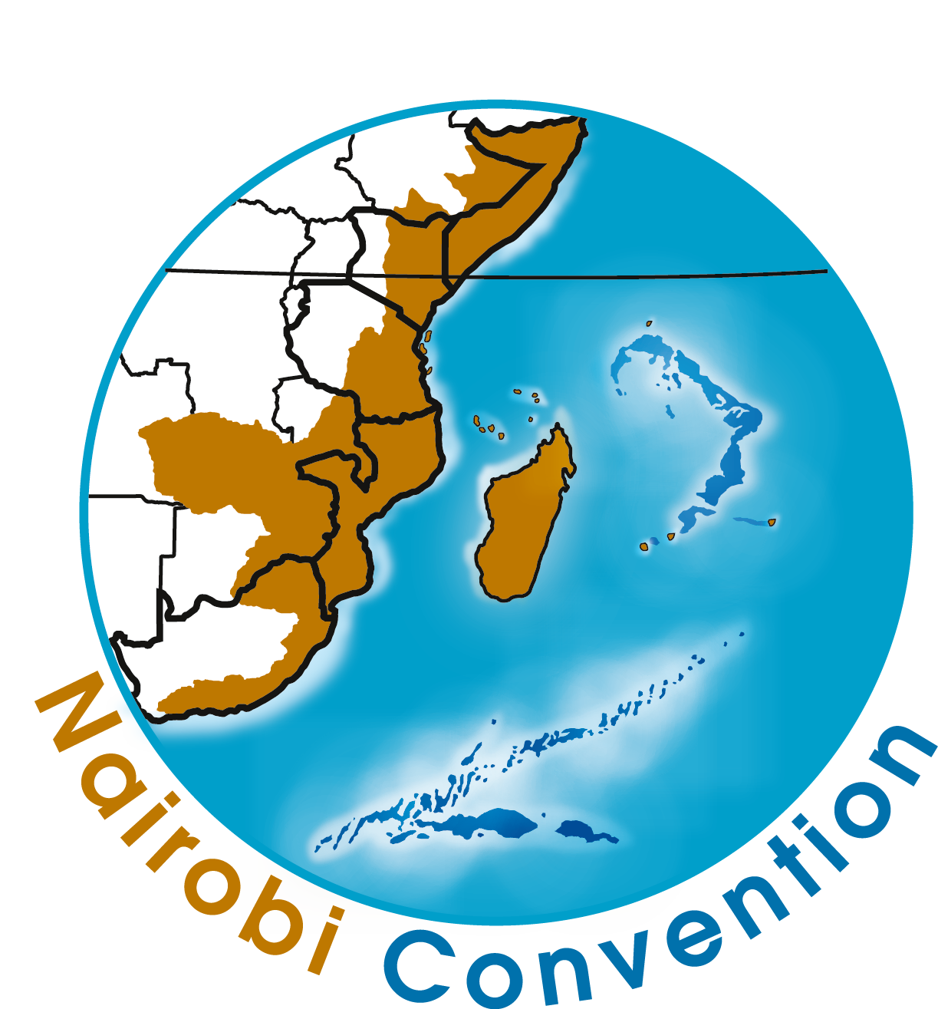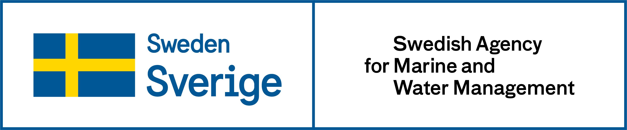
WIO Symphony user manual
Manual edition: 19 December 2025
WIO Symphony version: Symphony 1.22.0

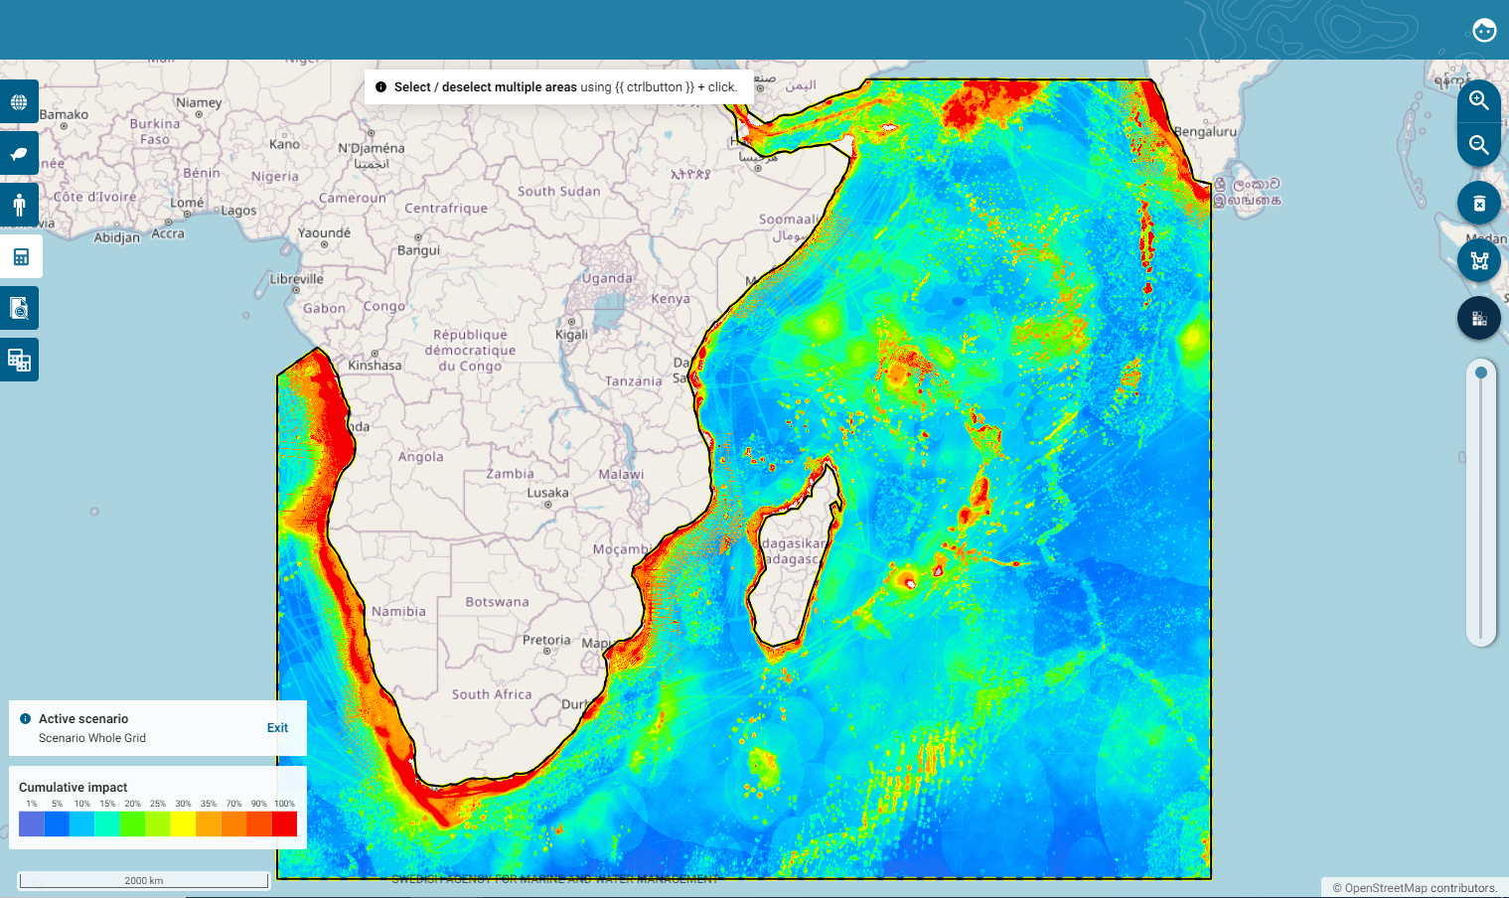
WIO Symphony stands for the Western Indian Ocean Symphony. It is a co-developed tool for the assessment of combined, or cumulative, environmental impact of different human activities across vast ocean spaces. This open-source tool is useful for MSP, marine spatial planning, and other area-based management.
For quick start go to chapter 4. Before using the tool.
You can access the tool at WIO Symphony.

Content
1. Purpose, principles, partnership 4
1.1 Co-developed widely 4
1.3 The Nairobi Convention manages and updates 4
1.4 Financed by Sweden, Sida, GEF, and in-kind 5
2. WIO Symphony method and analyses 6
2.1 Method 6
2.2 Basic equation 7
2.3 Further analyses: rarity, one-over-many, and scenario comparisons 8
3. Main ingredients: ecosystem components, pressures, sensitivities 9
3.1 Ecosystem components 9
3.2 Pressures 9
3.3 Sensitivity scores 10
3.4 Uncertainties and limitations 10
3.5 Tool implementation and access 10
4. Before using the tool 11
4.1 Use WIO Symphony alongside other methods 11
4.2 Use at an appropriate scale – most suitable for large areas 11
4.3 Carefully consider what to analyse: Types of analysis and elements to include 11
4.4 Feedback us your critique 12
5. User manual 13
5.1 Support 13
5.2 Change language 13
5.3 See software version 13
5.4 Important notes before composing Symphonies 14
5.2 Boundary polygons 17
5.3 View data layers 20
5.4 Notes on individual data layers 22
5.5 Calculate cumulative impact 23
5.6 Cumulative impact Calculation Report 28
5.7 Erase and reset 34
5.8 Create and analyse scenarios 36
5.9 Compare two scenarios 41
5.10 Compound comparison 47
5.11 Select, Merge or Split several polygons 49
5.12 Analyse several polygon areas 52
5.13 Batch analysis 55
6. Further analyses 60
6.1 MINISYM – analysing individual pressures 60
6.2 Rarity-adjusted cumulative impact 65
6.3 Screen for Suitable Locations for new activities 68
6.4 Choose and Edit Matrix 71
7. Updating and new data 75
8. References 76

Cite as:
WIO Symphony. 2025. WIO Symphony user manual, release 1.22.0. Nairobi Convention and Swedish Agency for Marine and Water Management. Nairobi.

1. Purpose, principles, partnership
When marine spatial planners and managers work across large geographies, it becomes difficult to account for the vast array of marine animals, plants, and human activities. Thus, it can be challenging without support from data and computational tools. From a bird’s eye perspective, the WIO Symphony tool serves as a means for understanding the combination of numerous human activities affecting multiple parts of nature, all at the same time. This is called cumulative impact assessment.
Marine planners and managers who have access to the tool will obtain an overview of existing ecosystem components and pressures, as well as current environmental impact in their area of interest. This brings science closer to management and may support ocean governance, specifically ecosystem-based marine spatial planning (MSP).
The purpose of WIO Symphony is to facilitate informed and transparent decision-making that leads to sound and sustainable use of marine resources, and, in turn, support wealth and socio-economic development in the Western Indian Ocean region.

1.1 Co-developed widely
The WIO Symphony tool was co-developed on the request by the Nairobi Convention. The work was initiated in 2019 and the tool is available since late 2022. The co-development was led by a Swedish team in partnership with the MSP technical working group (TWG) of the Nairobi Convention, including two representatives from each of the 10 member states (Comoros, France, Kenya, Madagascar, Mauritius, Mozambique, Seychelles, Somalia, Tanzania, and South Africa). The Swedish team was led by the Swedish Agency for Marine and Water Management (SwAM), in partnership with the Geological Survey of Sweden (SGU), the Swedish University of Agricultural Sciences (SLU), and Gothenburg University (GU). Technical support was provided by a large group of regional and international experts, with approximately 100 professionals from 14 countries contributing to WIO Symphony’s development.
1.2 Open and transparent
All components of the WIO Symphony tool are based on the principles of transparency and open data sharing.
- Data layers and metadata is available for download at GitHub: WIO Symphony.
- Links to underpinning data and models are freely available at GitHub: WIO Symphony.
- The tool’s software code is available at GitHub: MSP Symphony.
- WIO Symphony is also described on SwAM’s web page and discussed on GitHub Wiki.
Summary of metadata is also displayed in the tool, as well as contributor acknowledgements.

1.3 The Nairobi Convention manages and updates
Although all components of the tool are open access, the WIO Symphony is hosted on the Nairobi Convention’s server, who is also the acting owner of the WIO Symphony application. The Nairobi Convention Secretariat is responsible for managing the tool, including maintenance and update procedures.

1.4 Financed by Sweden, Sida, GEF, and in-kind
The bulk of finances behind the WIO Symphony development have been provided by the by the Government Offices of Sweden through the bilateral program for environment and climate collaboration and Sida, the Swedish International Development Cooperation Agency through the SwAM Ocean program, as well as the Nairobi Convention in turn supported by the Global Environment Facility, especially the SAPPHIRE project.
Numerous institutions have contributed in-kind with expert staff and some individuals have contributed on voluntary basis.

2. WIO Symphony method and analyses

2.1 Method

Rationale for cumulative impact assessment
The rationale behind cumulative impact assessment is to emphasise the combined effect of many different sources on many different parts of the environment. Cumulative impacts – positive or negative, direct and indirect, long-term and short-term – arise from a range of activities throughout an area or region, where each individual effect may not be significant if taken in isolation (European Commission, 1999). However, the cumulative impact calculated in WIO Symphony does not explicitly consider temporal, time-dependent, aspects. Nor does it explicitly consider positive impacts. These and other caveats are discussed in this manual.

Symphony is used for ecosystem-based MSP in Sweden
The WIO Symphony tool is directly based on the Swedish Symphony tool used within Swedish MSP (Hammar et al. 2020). Being responsible for ecosystem-based MSP in Sweden, the Swedish Agency for Marine and Water Management (SwAM) developed and used Symphony as a tool for integrating cumulative impact assessment in the planning process. In Swedish MSP, Symphony was used for:
- planning-integrated comparison of environmental impact of different planning alternatives,
- identification of areas in need of measures for environmental precaution, and
- as a basis for the Strategic Environmental Assessment (SEA) of the MSP.
It has also been used in support of marine protected areas (MPA).

Methods originates from Halpern et al. 2008
The method originates from the previous work by Halpern et al. (2008). Halpern presented a transparent and useful way of estimating cumulative impacts on global scale, based on maps representing marine ecosystems, pressures from human activities, and sensitivity scores indicating how sensitive each ecosystem is to each pressure.

Method expansions: scenario comparisons and specific taxa
This basic method has been adopted for WIO Symphony, which differs from the original work in two essential ways:
- WIO Symphony is a more dynamic tool that allow scenario comparisons. This means that the tool can produce assessments of planned activities, which is at the core of MSP and may also be useful for other marine management. Scenario comparisons in cumulative impact assessments are distinctive for the Symphony applications.
- WIO Symphony includes representation of both marine habitats/ecosystems and individual marine taxa/species, whereof only the former was included in the original method by Halpern et al. To include both specific taxa and general habitats/ecosystems in the same analysis can be difficult to interpret, like comparing apples and pears. Therefore, to be considerate, the default setting in WIO Symphony is to include only habitats/ecosystems. Yet often there is merit to include individual taxa in the same analysis or study the cumulative impact on a single taxon alone. It gives you more details on specific animals. Inclusion of taxa are common in cumulative impact assessments applications.
The Halpern method for cumulative impact assessment has also been implemented by the Helsinki Commission (HELCOM 2018), for environmental status assessment and other means of marine planning and management. Several independent reports and scientific studies have applied the same method (Korpinen & Andersen 2016; Depellegrin et al. 2017; Fernandes et al. 2017; Andersen et al. 2020).

2.2 Basic equation
Cumulative impact (I) is calculated by:
$$I_{sum}= \sum_{i=1}^{n}{\sum_{j=1}^{m}{P_{i}}{×E}_{j}×S_{i,j}}$$
Equation 1:

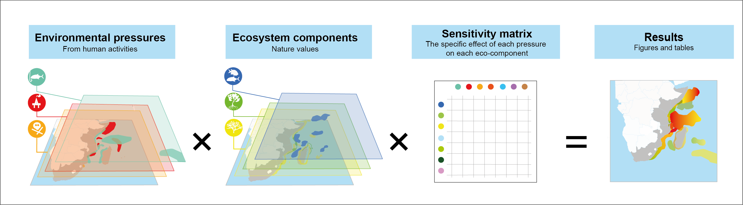
where E is ecosystem components, P is pressures from human activities, and S denotes the sensitivity score. The numbers of ecosystem components and pressures are derived from the underpinning data layers (maps), which are all scaled between 0 and 100. The sensitivity score is derived from a sensitivity matrix scaled between 0 and 1. See figure below.

Calculation of cumulative impact is the default setting in the WIO Symphony tool, and it represents the straightforward estimate of how all human activities are affecting the entire marine environment. Very abundant ecosystems and species will hence have a strong influence on the results, if they are at least somewhat sensitive to pressures in the area. See chapter 5.5.
A meaningful aspect is that the cumulative impact result is broken down into flow charts indicating how each pressure contributes to the impact of each ecosystem component. See chapter 5.6.

2.3 Further analyses: rarity, one-over-many, and scenario comparisons
The WIO Symphony tool enables the comparison of different scenarios, showing how environmental impact increase or decrease at each location based on the changes simulated from marine management measures or marine planning priorities. See chapter 5.8 and 5.9.
WIO Symphony is not restricted to estimates of full cumulative impact. It also enables tailor-made analyses of how selected pressures impact one or several selected ecosystem components, or vice versa – these one-over-many analyses are called MINISYM. These can be meaningful for understanding the threats to particular species and ecosystems, or for learning how a particular pressure or sector impact the environment in different areas. See chapter 6.1 and 6.2.
Moreover, it is also possible to calculate rarity-adjusted cumulative impact, which means that the impact on each ecosystem component is divided by the commonness of the same ecosystem component, defined as the total sum of the ecosystem component in the area of interest. The rarity-based cumulative impact is interesting from an ecological and conservation-oriented perspective, as it highlights impacts on rare species or ecosystems. See chapter 6.2.

3. Main ingredients: ecosystem components, pressures, sensitivities
The main contents of WIO Symphony are ecosystem components (nature values), pressures from human activities, and sensitivity scores. These have been selected by the regional and national expertise from the Western Indian Ocean through processes of workshops and questioners.

3.1 Ecosystem components

Ecosystem components represent value
Ecosystem components represent valuable parts of the marine environment. Each ecosystem component is a map in WIO Symphony. The map indicates the distribution or potential distribution of the corresponding ecosystem component. Pixels of the map have values from 0 to 100, where 0 means that the pixel is not important for the ecosystem component and 100 means that the pixel is fully covered with, or in other ways highly important for the ecosystem component.
0 = not important
100 = fully covered or highly important
WIO Symphony includes 52 ecosystem components, available as modelled data layers (maps) in the tool. They are split into two categories: habitats and taxa.

Habitats represent environments - taxa represent important animals
Habitats refer to environments and include all animals and plants typically associated with this environment. For instance, seagrass meadows with all associated invertebrates, fish, turtles, birds, and mammals. The original method by Halpern et al. (2008) includes only habitats. Likewise, in WIO Symphony only habitats are included by default.
Taxa refers to groups of animals (or other organisms). It can be types of fish or mammals who are considered important from a social, economic, cultural or ecological perspective and which needs to be addressed separately. Taxa are not pre-selected for cumulative analyses in the default mode of the WIO Symphony but can be easily added either together with the habitats, creating a mixed model, or in isolation for studies on the impact on those specific taxa.

Tropical and temperate ecosystem components
Some ecosystem components are also divided into tropical and temperate habitats. This is because tropical and temperate environments may differ considerably in their sensitivity to various pressures. When using the tool, it is often reasonable to include both categories since solely tropical areas will not contain any data of temperate habitats, and vice versa. In transition areas, both tropical and temperate ecosystem components are present.

3.2 Pressures
Human pressures are emissions, harvest, or changes caused by human activities. Each pressure is a map in WIO Symphony. The map indicates the intensity of the pressure, such as fishing intensity or underwater noise level. Values range from 0 to 100 in each pixel, where 0 indicates zero or insignificant levels of the pressure, whereas 100 indicates very high intensity.
0 = zero or insignificant
100 = defined maximum intensity or highest plausible intensity
Typically, pressure value 100 is equivalent to a defined and quantifiable level of pressure, such as “a day-frequent exposure to 140 dB re 1 µPa underwater noise level at 200 Hz”. WIO Symphony contains 48 different pressures, whereof most, but not yet all, are represented as pressure data layers (maps) in the tool.

3.3 Sensitivity scores
Sensitivity scores denote how sensitive each ecosystem component is to each pressure. The sensitivity is a scale from 0 to 1 with six pre-defined categories. Value 0 indicate no or insignificant effect, while 1 means complete destruction of the habitat or taxa individuals. Between these extremes are stress, injury and occasional death or partial destruction.
0 = insignificant effect
1 = complete destruction
With 52 ecosystem components and 48 pressures, a total of nearly 2 500 sensitivity scores are needed (52 × 48 = 2 496). With such a great number of sensitivities, judgement of experts is needed as it is not deemed possible to rely solely on published literature.
The sensitivity scores are derived from an expert panel of the Western Indian Ocean including around 50 scholars and managers, whereof about half have contributed more actively.

3.4 Uncertainties and limitations
The WIO Symphony tool is meant for use at screening level and for strategic decision making. The uncertainties in data and limitations of the method should always be remembered. The metadata explains the uncertainties, limitations and gaps in the underlying data/models.
The underpinning models, currently 88 pieces, are based on open-source data. The basic method (chapter 2) does not account for:
- temporal variation
- connectivity
- food-web interactions
WIO Symphony is not suitable for use at high spatial resolution and does not replace the need for detailed mapping and in-depth studies.

3.5 Tool implementation and access
WIO Symphony tool is operating at the server of the Nairobi Convention. All member states of the convention, and invited partners, have access to the tool and data. Temporary or permanent log-in to the implemented tool can be achieved by the Nairobi Convention Secretariat, and underpinning data are open-source and accessible. The tool software code is also open source and available for anyone at GitHub.

4. Before using the tool

4.1 Use WIO Symphony alongside other methods
WIO Symphony is one tool of many, and focuses solely on addressing environmental impact.
It does not include socio-economic parameters or sector conflicts. It also does not replace or reduce the need for ordinary environmental impact assessments (EIA) and scientific studies.
It provides a valuable overview, helping the user to see the bigger picture and frame more detailed studies.

4.2 Use at an appropriate scale – most suitable for large areas
WIO Symphony covers a large extent, approximately 9 percent of the world’s oceans, from the southern tip of India in the east, to the western coast of Africa. The resolution is 1 km x 1 km, which is very high relative to this extent.
This resolution is intended to support regional and potentially national plans. However, some of the layers are based upon data with a resolution poorer than 1 km. Users should, therefore, be careful when using WIO Symphony outputs at smaller, local scales.
In general, the smaller your analysis, the more likely it is to contain artifacts or noise from the spatial models used to produce each layer. If you are working at smaller scales, we strongly recommend that you inspect the metadata of the layers you are including in your analysis to determine if they are appropriate to include.
The smaller area you choose to analyse, the less accurate overview you get from the analysis, due to the very large grid, spanning approximately 9 percent of the world’s oceans, and the pixel size of 1 x 1 km. This should be remembered in relation to the scale you are working with. For example, a result from a small bay should be interpreted with high caution.
The smaller area you choose to analyse, the less accurate overview you get from the analysis, due to the very large grid, spanning approximately 9 percent of the world’s oceans, and the pixel size of 1 x 1 km. This should be remembered in relation to the scale you are working with. For example, a result from a small bay should be interpreted with high caution.

4.3 Carefully consider what to analyse: Types of analysis and elements to include
Before conducting an analysis, carefully decide which pressures and ecosystem components you wish to include. The default settings offer a solid starting point, but you may wish to customise the analysis in certain cases. Also, consider alternative types of analyses you may wish to conduct. You have the options to select among different algorithms and you can perform a full cumulative analysis or focus on “one-over-many" approaches (MINISYM). To identify more suitable locations for a specific sector, try adding specific pressures throughout the area and observe where the impact is minimised. If you work on Marine Spatial Planning (MSP), you will likely want to compare different scenarios, which you could simulate carefully based on your planning framework. Additionally, conducting various well-organised analyses often improve understanding. Be sure to rename your scenarios to keep track of them throughout the process.

4.4 Feedback us your critique
Constructive critique improves the quality and transparency of WIO Symphony. Data layers in the tool will always have room for improvement.
The WIO Symphony team urges you as users of the tool to come with input on improvements, whether it is something specific such as a data layer within your expertise, or improvement of the tool itself.
Contact us with your experiences, solutions, best practices, or feedback through the email wiosym@nairobiconvention.org, or at GitHub: WIO Symphony.

Examples of critique that have led to improvements
You can see examples of critique that have led to revisions are data layers that were constructively criticised during first tests and tutorials in this table:
Data layer | Critique | Action
Algae farming | Data accidentally include both algae farms and mariculture | Revised in April 2023
Mariculture | Not populated with data (see above) | Revised in April 2023
Cold coral reef | Depth limit is currently too shallow (40 m), to be moved to deeper colder water | Revised in April 2023
Penguin feed ground and fur seals | Models erroneously extend far into tropical waters | Revised in April 2023
Whale shark | Unreliable peak by Cape town | Revised in April 2023
Baleen whales | Missing available data | Revised in April 2023
Temperature rise | Overestimate the impact | Revised in September 2024
Ocean acidification | Overestimate the impact | Revised in September 2024
Sea level rise | Overestimate the impact | Revised in September 2024

5. User manual
This manual version of 19 December 2025 is based on the software version 1.22.2.
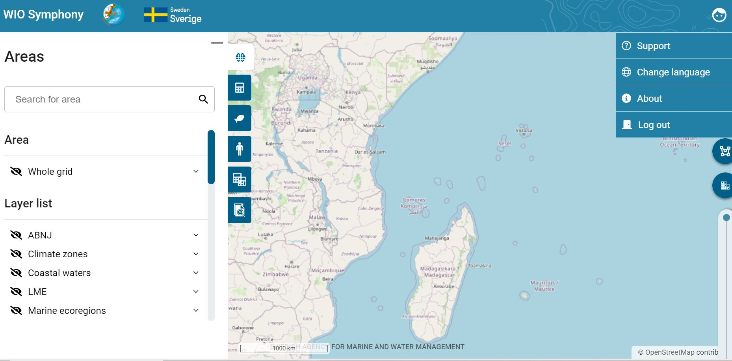

5.1 Support
Find the latest version of this manual by clicking the user icon , then click Support 
(The previous manual version to this was one was from 13 December 2023 and based on the
software version 1.14.2. That manual was in turn based on the initial WIO Symphony manual
version from 30 November 2022, based on the software version 1.6.0.

5.2 Change language
WIO Symphony is available in three languages:
-  English
-  French
-  Swedish
Change language by clicking the user icon , then click Change language .

5.3 See software version
Click the user icon , then click About  to see which software version you have.

5.4 Important notes before composing Symphonies

Web browser can matter
The web browser can matter for the tool’s performance. If your screen or the functionality appears wrong or incomplete, please try another browser. Google Chrome typically works.

Refresh page cache can help
Whenever something does not work, try to refresh the web page with deleted cache. Refresh the page, either by ctrl + shift + R or ctrl + F5. This is always recommended when using WIO Symphony again after periods of inactiveness. By doing this, you make sure recent updates to the tool are incorporated to your analysis. This is especially important when you want to start over or begin a new analysis.
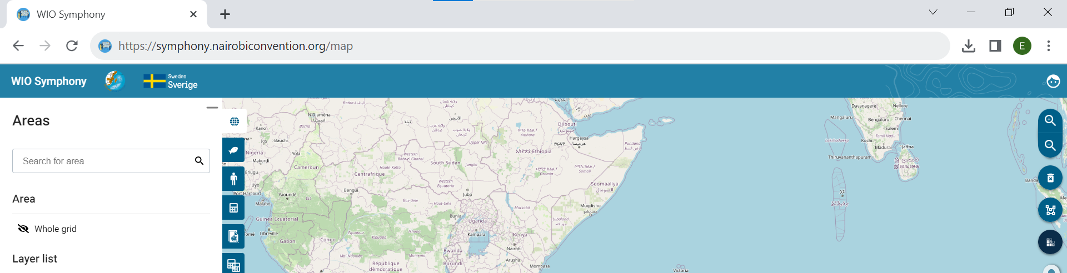

Use at an appropriate scale – large areas
WIO Symphony is designed for regional or national planning, as noted in Section 4.2. The tool may be less useful when planning for areas smaller than 1 km – such as narrow bays or small islands – as these areas will be represented by a single pixel. It is challenging to give a specific area size limitation, although larger areas generally yield more accurate spatial patterns of ecosystems, pressures, and impacts.
As a rule of thumb, avoid analysing areas smaller than 250,000 km² (250,000 pixels), which is equivalent to an area of 500 x 500 km.
Some layers, such as those representing coral, have finer resolutions, but WIO Symphony is still best suited for analysing vast areas. The smaller the area selected, the less accurate the overview becomes. If you wish to analyse areas smaller than 250,000 km², please inspect the metadata of the layers you intend include to ensure they are appropriate to use at that scale.

Smaller areas Better for Practice
Analysing the Whole grid or other very large areas takes time and consumes disk space. Stick
to smaller areas when practicing.

Customise Colour Scale for Clarity
The colour scale for cumulative impact ranges from transparent and blue to orange and red. In the default setting, the red colour corresponds to 90-100% of the maximum cumulative impact value in your analysis. When analysing large areas that include both coastal and offshore waters, it is likely that much of the offshore area may remain transparent, as higher cumulative impact scores tend to occur in coastal, shallow waters. To create a more visually informative image, consider customizing the colour scale. This scale is relative and will not affect your results. For further details on customization options, see chapter 5.5.

The return symbol takes you to main menu
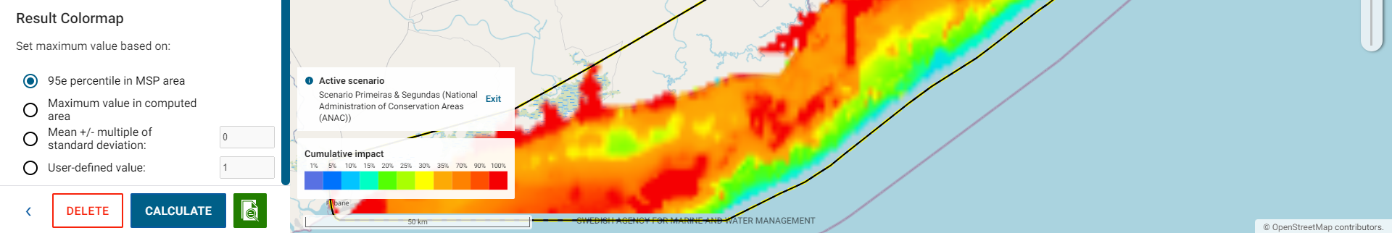
When working in a scenario or calculation, you sometimes might feel stuck to those menus. The blue left-pointing arrow in the bottom left corner will take you back to the main menu.

Clear the map
Clear off the colour map by pressing the bin symbol to the right, below the magnifier glasses.
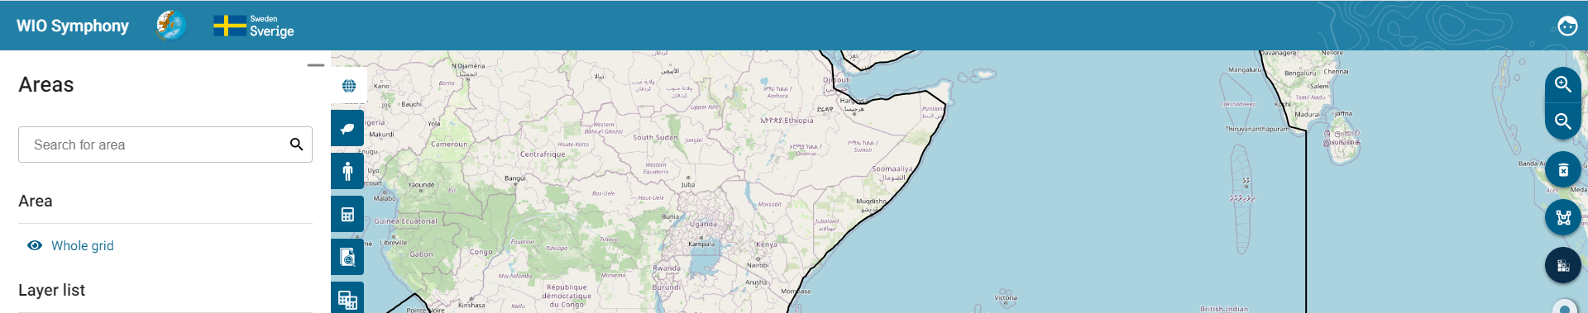

Zoom, Edge smoothing and transparency
Zooming in/out on the map is possible by scrolling the mouse wheel or use the magnifier glasses. Pixel/edge smoothing (anti-aliasing) can be toggled on or off in the map overview by clicking the pixel symbol below. This makes the pixels smoothened or exact. A bar that sets the transparency of the background map is adjustable on the bar below.
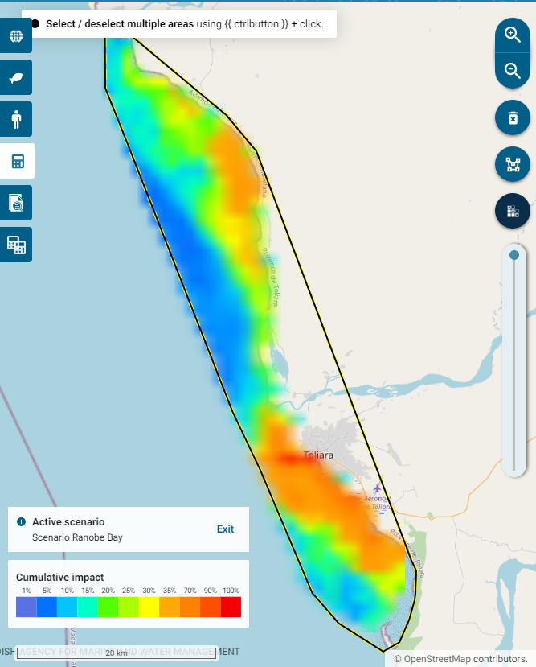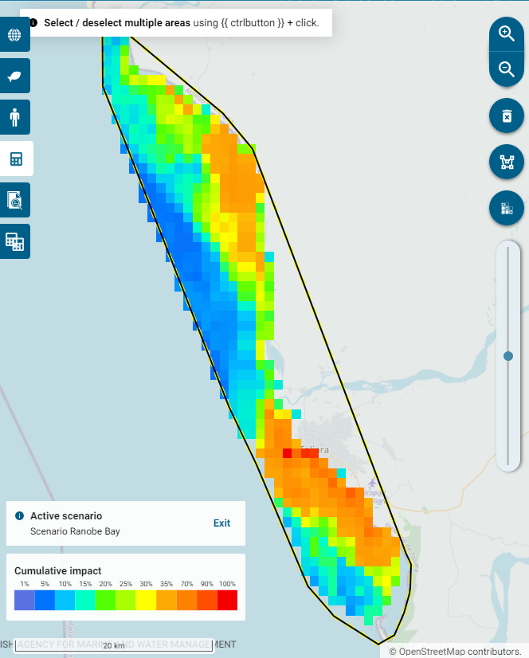

5.2 Boundary polygons
The main page, shown below, appears when you log in to the tool, or when you navigate back to the Areas tab (the globe symbol). Boundary polygons are essential for all analyses in WIO Symphony. The tool includes several of pre-loaded shapefiles that can be used. You activate a boundary polygon by unticking the eye symbol. By clicking the arrow button next to the list of areas, you will get an extended list of the included sub-areas in that categories that you can choose directly from.
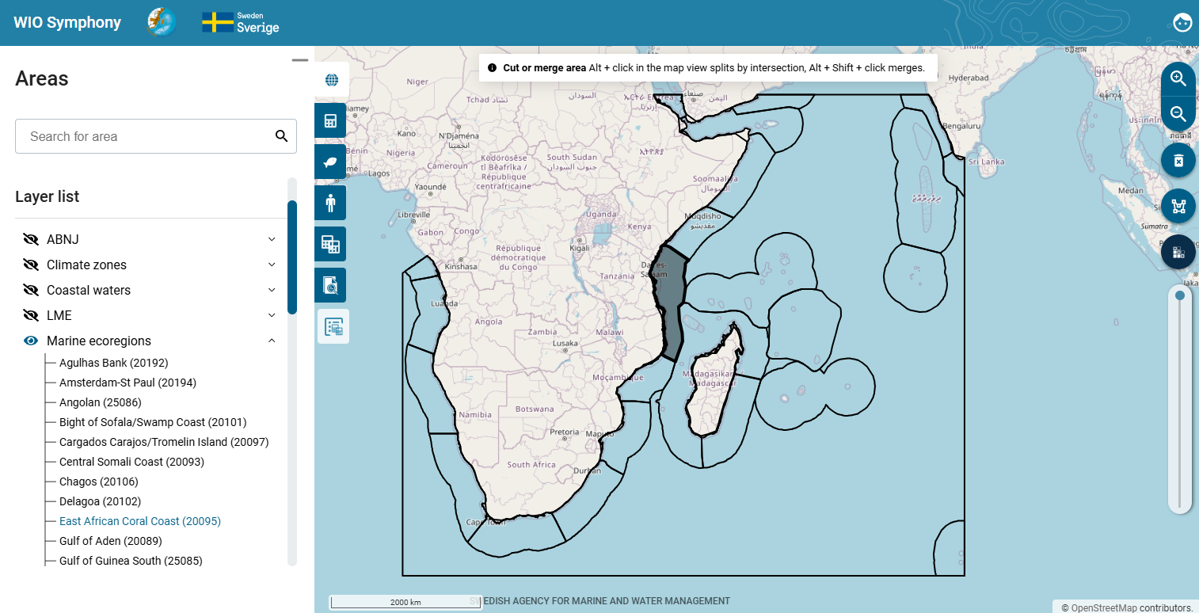
The Whole grid area represents the full WIO Symphony grid. This grid, or bounding box, spans the Western Indian Ocean and part of the South-Eastern Atlantic. Calculations within this Whole grid area is computationally intensive and consume a lot of space on your user’s memory. For most analyses, it’s more efficient to target smaller areas. Pre-loaded polygons include;
Natural boundaries
- Climate zones (tropical, temperate)
- LME (2017) (large marine ecosystems)
- Marine ecoregions (from Spalding et al. 2007)
Other
- ABNJ (Areas Beyond National Jurisdiction)
- National waters (all water except ABNJ)
- Coastal waters (coastline +2 nautical miles)
- Protected Areas Marine (2023) (these areas partly but not fully correspond to existing MPAs)
You can create custom boundary polygons by using the draw-polygon button. Note that you may click on the land or outside of the Whole grid area when drawing polygons. However, since the data is only available within the Whole grid, the sections of your polygon that are outside the grid will not contain data in calculations. Ensure that at least part of your polygon is within the Whole grid. Your created polygon will be saved under User-created Areas.
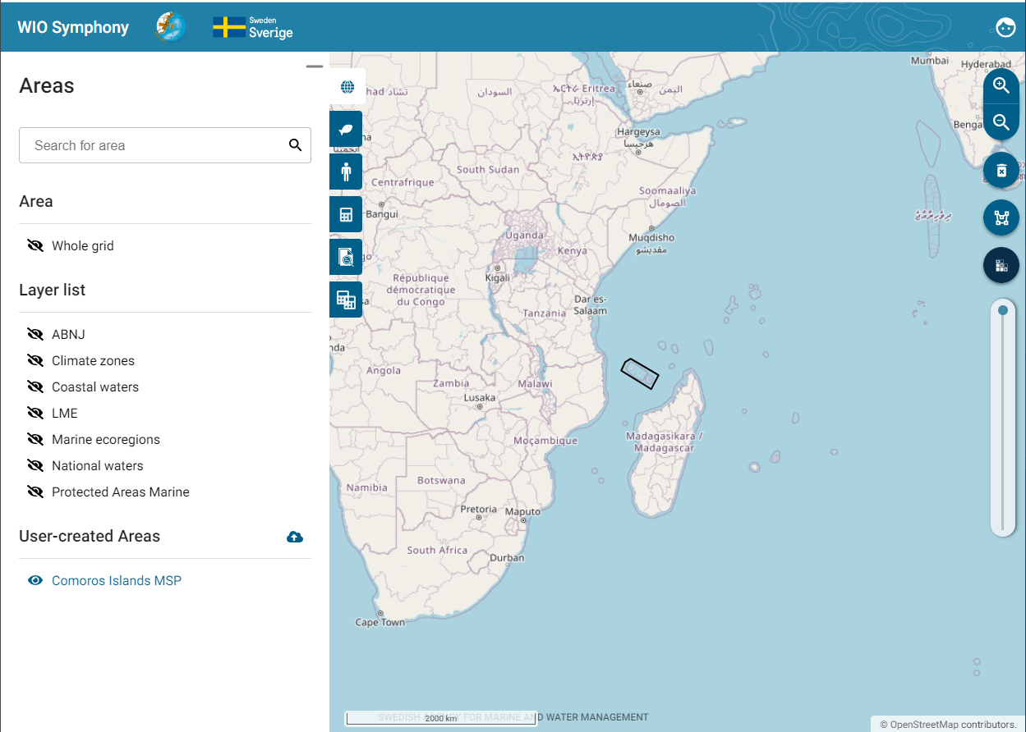
It is also possible to upload new boundary polygons using the Upload new area symbol. Note that the file will be in a GeoPackage (gpkg) format. Similar to drawing your own polygon directly in the tool, your imported polygons will not be cropped to the Whole grid, but the tool will only calculate pixels within the grid. However, it is encouraged to crop your polygons before importing them in to the tool. This is solved by cropping your shape file with the WIO Symphony boundary box (same extent as the Whole grid). The boundary box is available and can be requested from wiosym@nairobiconvention.org.
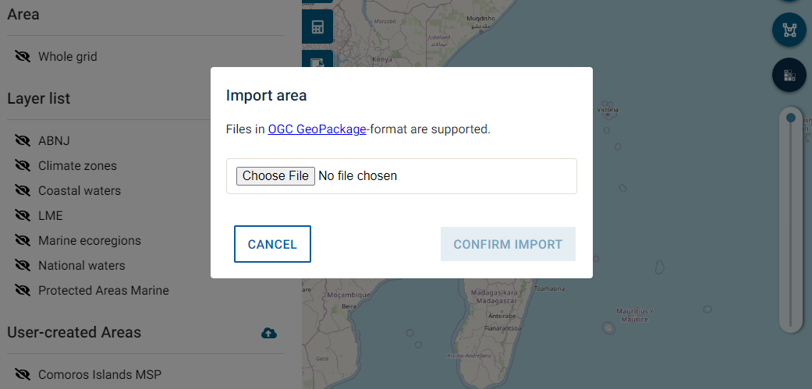
You click on a polygon to activate it for analysis. You start the analysis by clicking inside the polygon  move to the Scenarios tab  press the plus symbol. See chapter 5.5.
You can also merge areas to create new boundaries by clicking Alt+ Shift+ Click, this will
merge polygons.
You will see a new area under User-created Areas, you might consider to rename your new areas by clicking Edit area à Rename area. See chapter 5.10
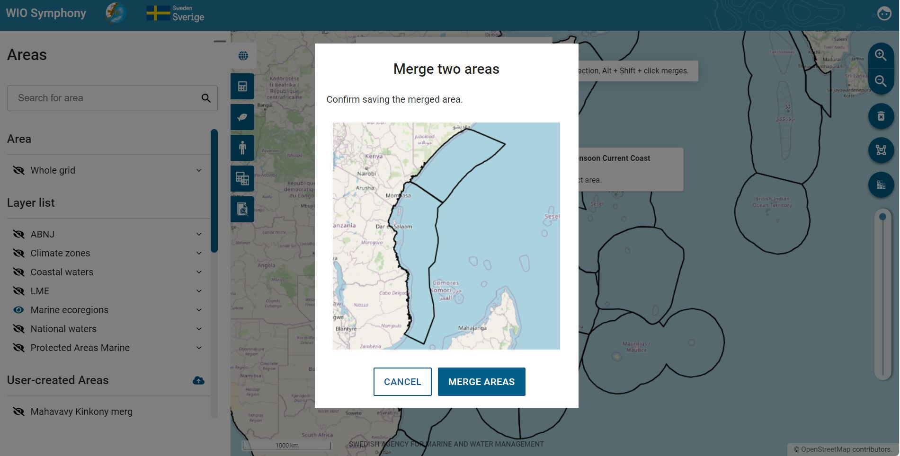
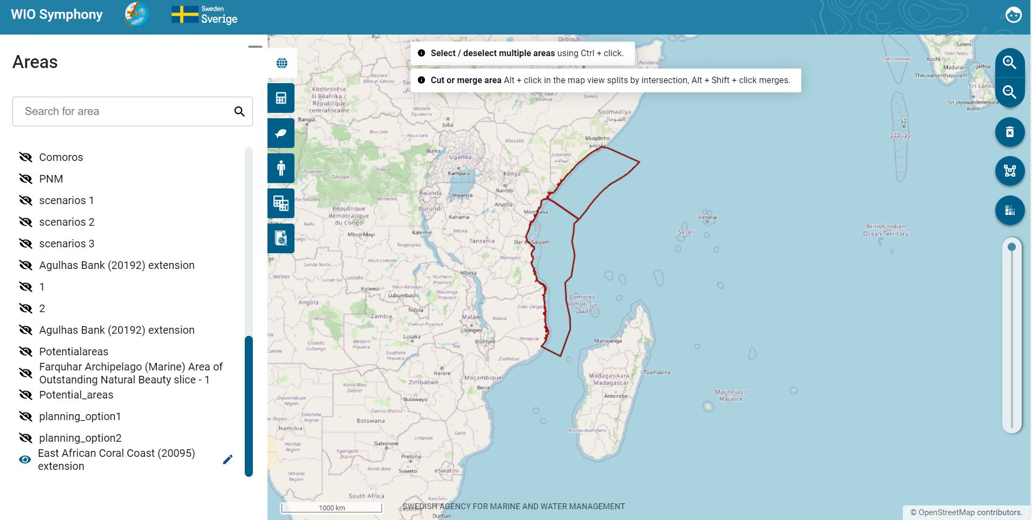
As user, you can also download the shapefile bundle for areas. Area polygons can be downloaded for use in external GIS software. Simply right-click the polygon you have selected and press Download shapefile bundle (.zip). This enables you to conduct further analyses in GIS with the same boundaries as in WIO Symphony.
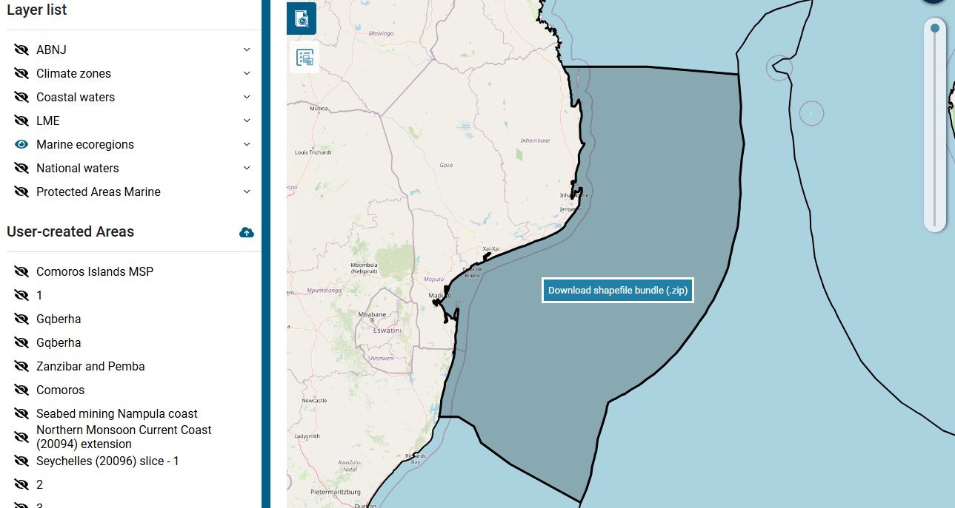

5.3 View data layers
A total of 52 ecosystem components and 48 pressures are listed in the WIO Symphony tool, whereof 88 have been modelled and are available as data layers (maps). Clicking on the ecosystem component tab lets you view the different habitats and taxa. Similar, the pressures tab lets you view the pressures categorised by sector. Untick the eye symbol to view
the data.
A brief summary of metadata and data sources is available. Press the info symbol by each ecosystem component or pressure. The dialog box provides a method summary of the layer, including a link to access that particular layer. In addition, known limitations are stated, as well as value range, processor, and data sources.
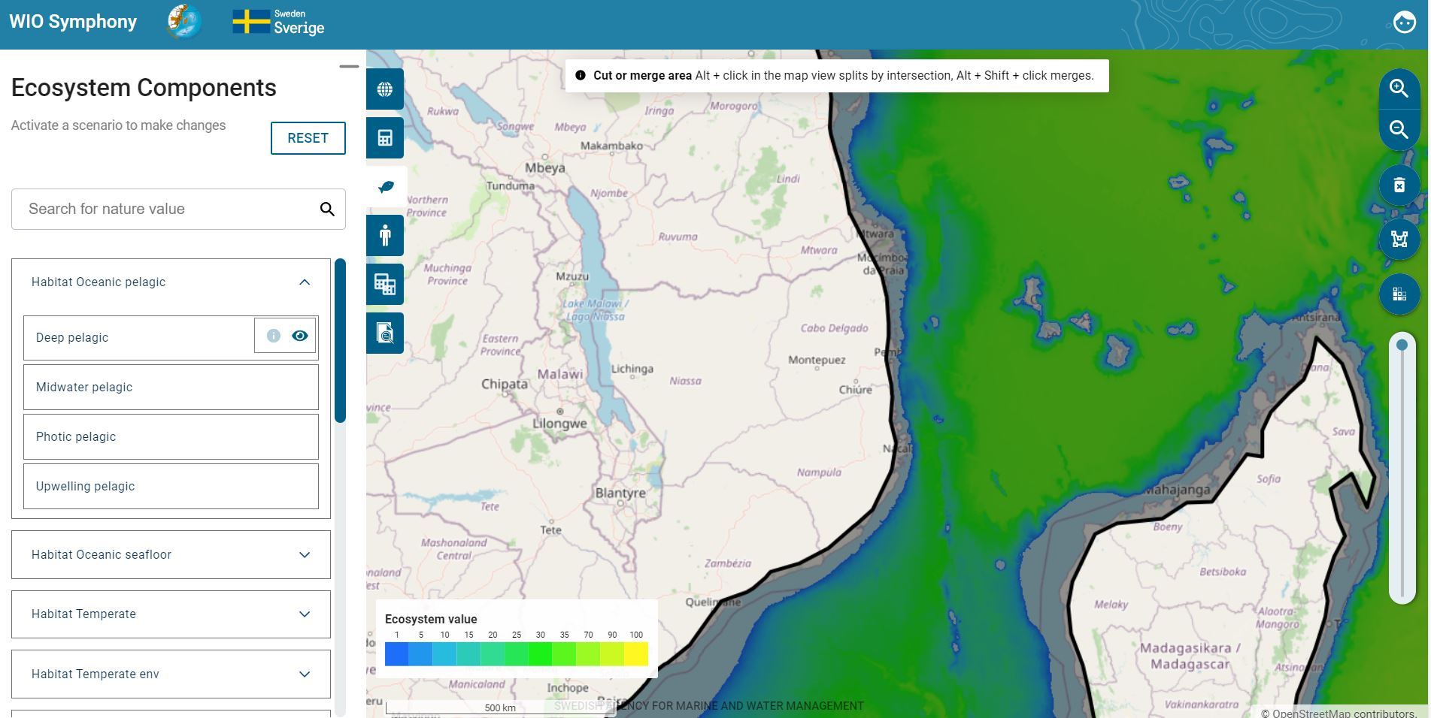

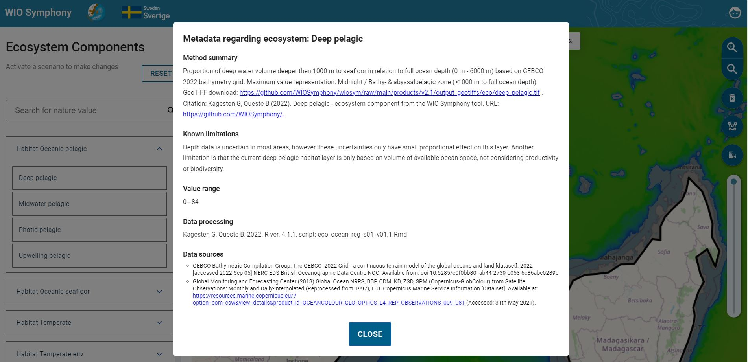
Some layers are still empty, but can be included in analyses, nonetheless. Empty layers are:
Ecosystem components | Pressures
Mesophotic coral | Invasive species
 | Pelagic gillnet
 | Pelagic trawl
 | Sport fishing
 | Seabed mining
 | Impulsive noise
 | Infrastructure
 | Renewable energy
 | Oilspill risk
 | Shark control
 | Research sampling

It is recommended to close the data display again (tick the eye symbol) before moving on, otherwise you might be swamped by many open data layers displayed at the same time. If this happens it is often easiest to simply refresh the browser and start over.
Some pressures and ecosystem components are listed but still not available (they are unticked). This is either because they are expected to be modelled and uploaded soon, or because they may be important for scenario-building (for example, Renewable energy installations or Oilspill risk). See chapter 5.8.
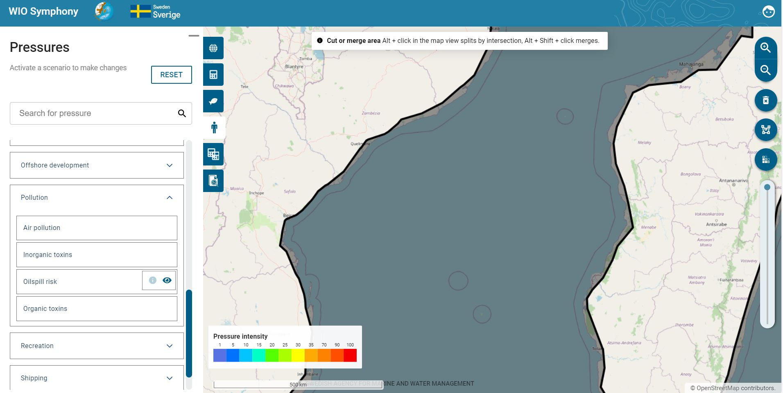

5.4 Notes on individual data layers
Some data layers deserve special attention:
- Seismic survey. This pressure has strong influence when included. However, the impact is temporary, where the existing data layer shows already conducted (past) surveys. Since surveys can provide lasting data, it is unlikely that a survey is repeated. The seismic surveys shown in the data layer hence refers to past, not ongoing, impact.
- Impulsive noise. Construction works such as pile driving can generate harmfully loud noise peaks. The pressure map is currently empty but can be populated by manually adding of constant (1-100). This pressure is temporary and should preferably by analysed alone (for example, MINISYM), typically not as part of the full model. A tip here would be to use an analysis of several areas, since you then can differentiate pressures within the same scenario. This could perhaps be combined with the “difference” function (“clip out” from a larger surrounding polygon) to get a realistic output.
- Oilspill risk. Larger oil spill is a very rare and unpredictable pressure. Like impulsive noise it is also rather temporary and should preferably not be mixed with other pressures. Oil spill analyses can however be suitable for MINISYM analyses.
- Infauna. This is a broad taxon that exists in all soft marine habitats. Because the habitat ecosystem components already include invertebrates per default, it may be considered double counting to run the analysis with infauna along with other. Studying impacts on infauna specifically can be done through MINISYM.
- Mobile epifauna. Same as Infauna above, but even more pronounced results if included with other ecosystem components.
- Dugongs. Some very rare species like dugongs have widely spread data layer. This is to mark important potential habitat rather than indicating extensive abundance of them.
- Rays and skates. These organisms are common and this data layer gives strong emphasis to them. Therefore, it is recommended not to include this ecosystem component in general analyses with many other ecosystem components.

5.5 Calculate cumulative impact
Cumulative impact is the straight-forward estimate of the impact of all selected pressures on all selected ecosystem components combined.
You calculate cumulative impact by selecting an area   go to Scenarios  and click on the plus sign select/unselect data layers in Ecosystem Components  and Pressures to be included  go to Scenario tab  rename your scenario if relevant by clicking on the pencil  press CALCULATE button (refer to the picture below).
In the ecosystem components tab and pressures tab, you are able to choose which data layers to include in an analysis. Ticked data layers are selected and will be included. This is true as long as there is a map available, which can be checked by unticking the eye symbol.
You may wish to double-check that all your intended pressure and/or ecosystem components are selected. As you have noted, individual data layers may be selected even if the category is not ticked. This is because some layers within the category might be available, while some are not.
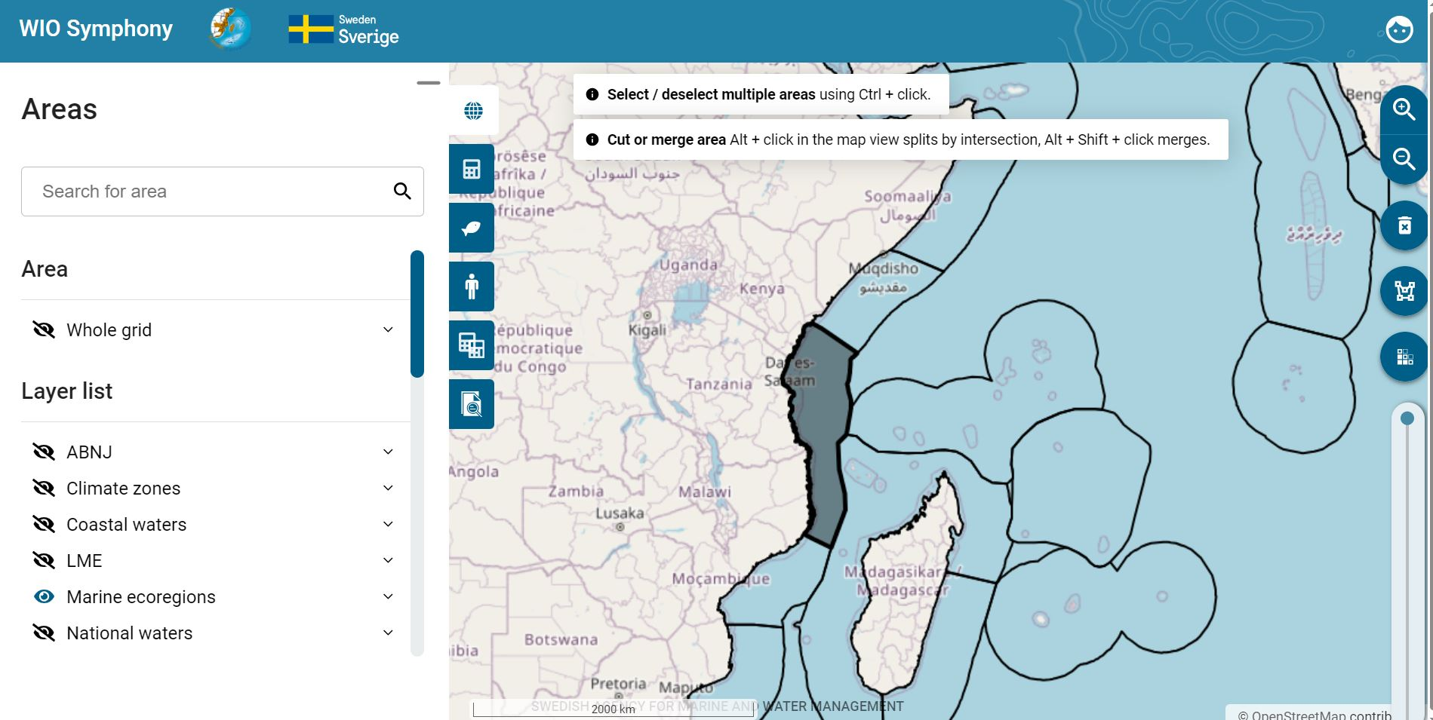
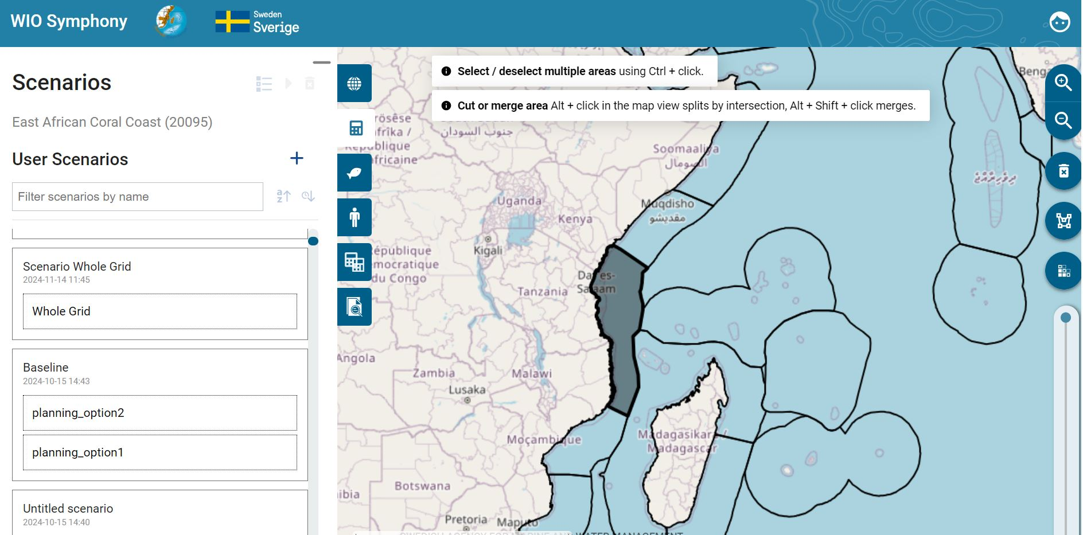
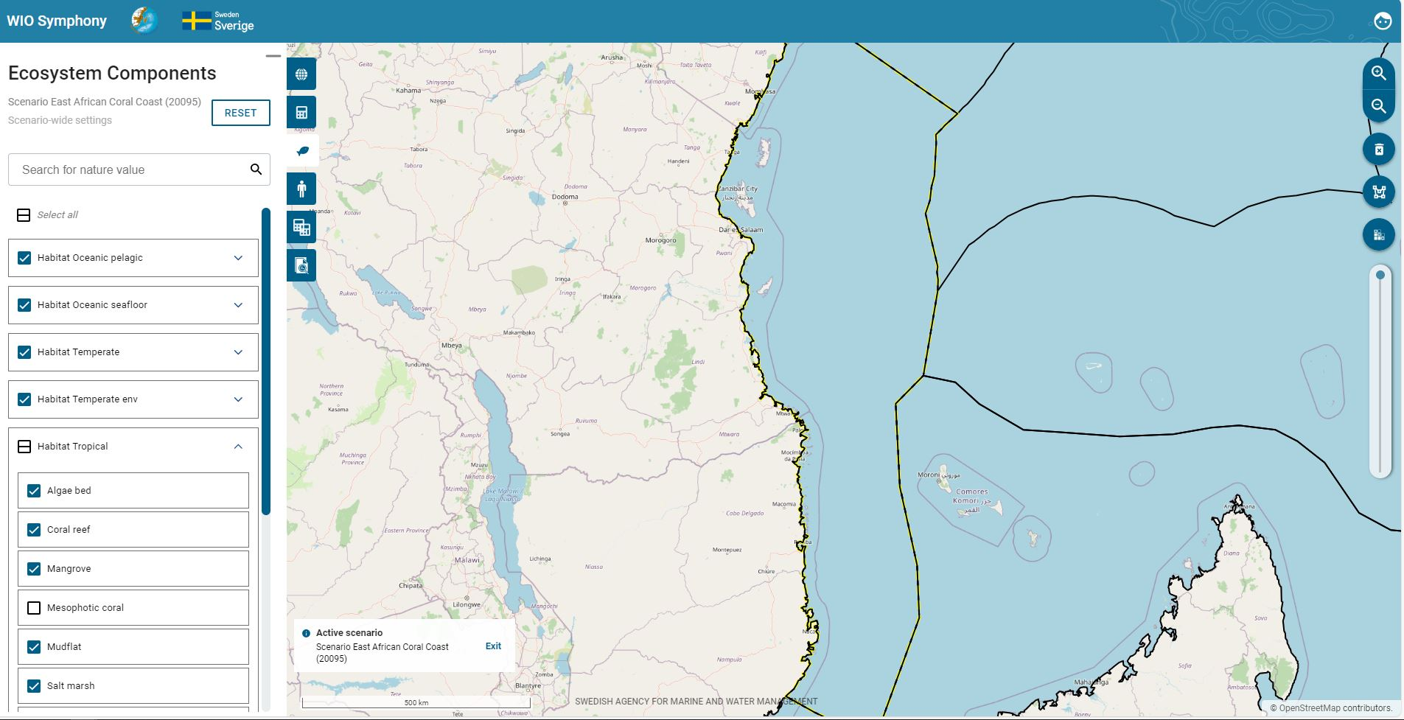
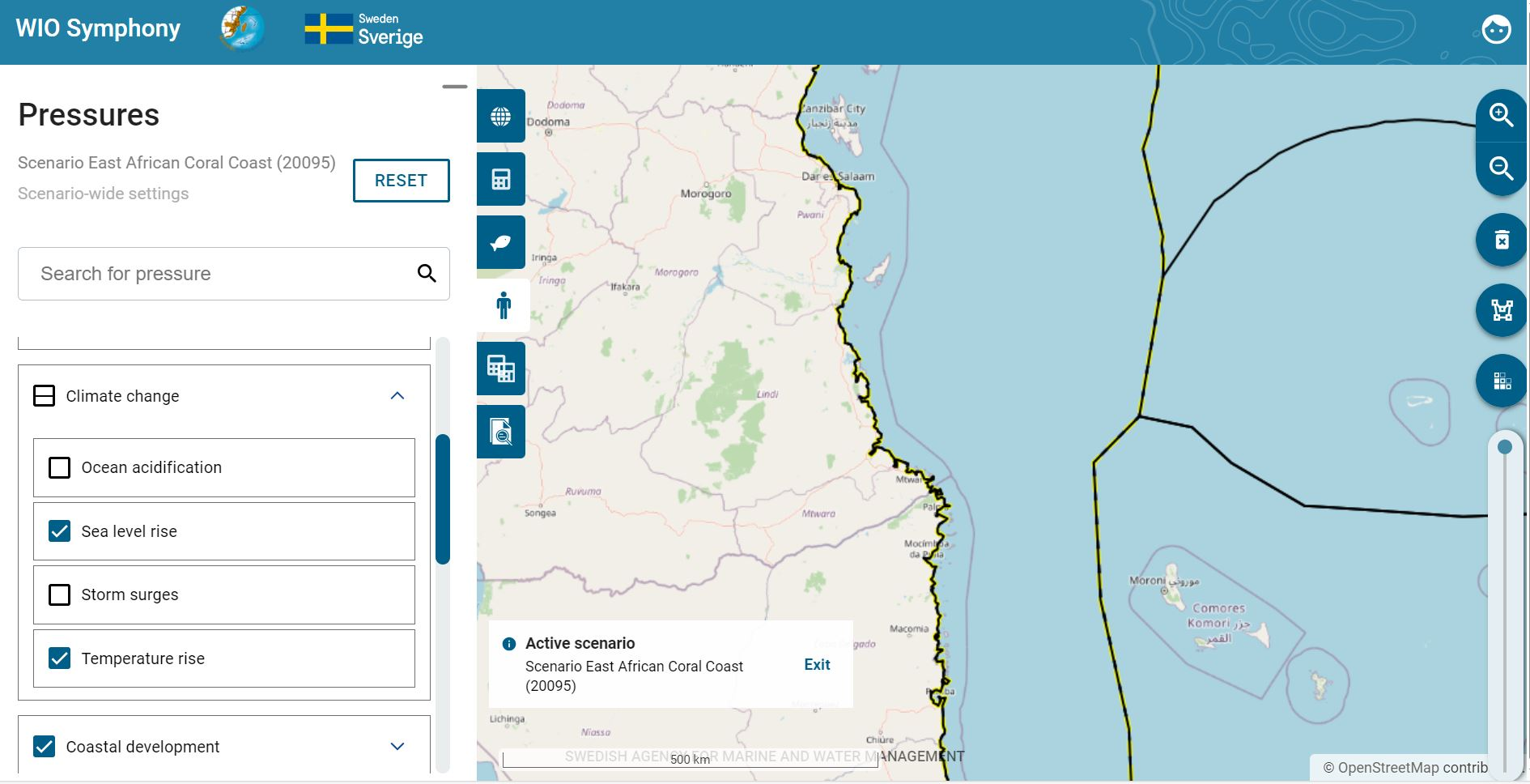
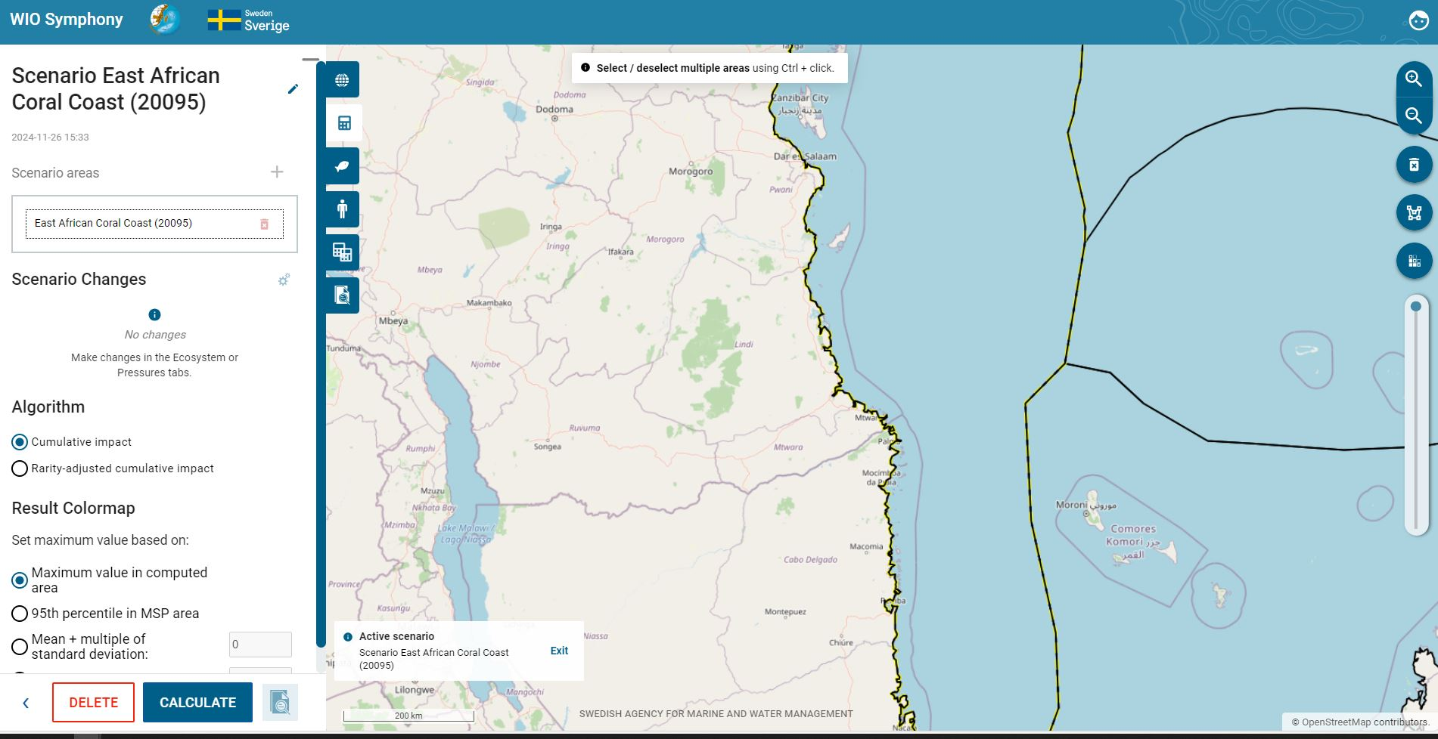
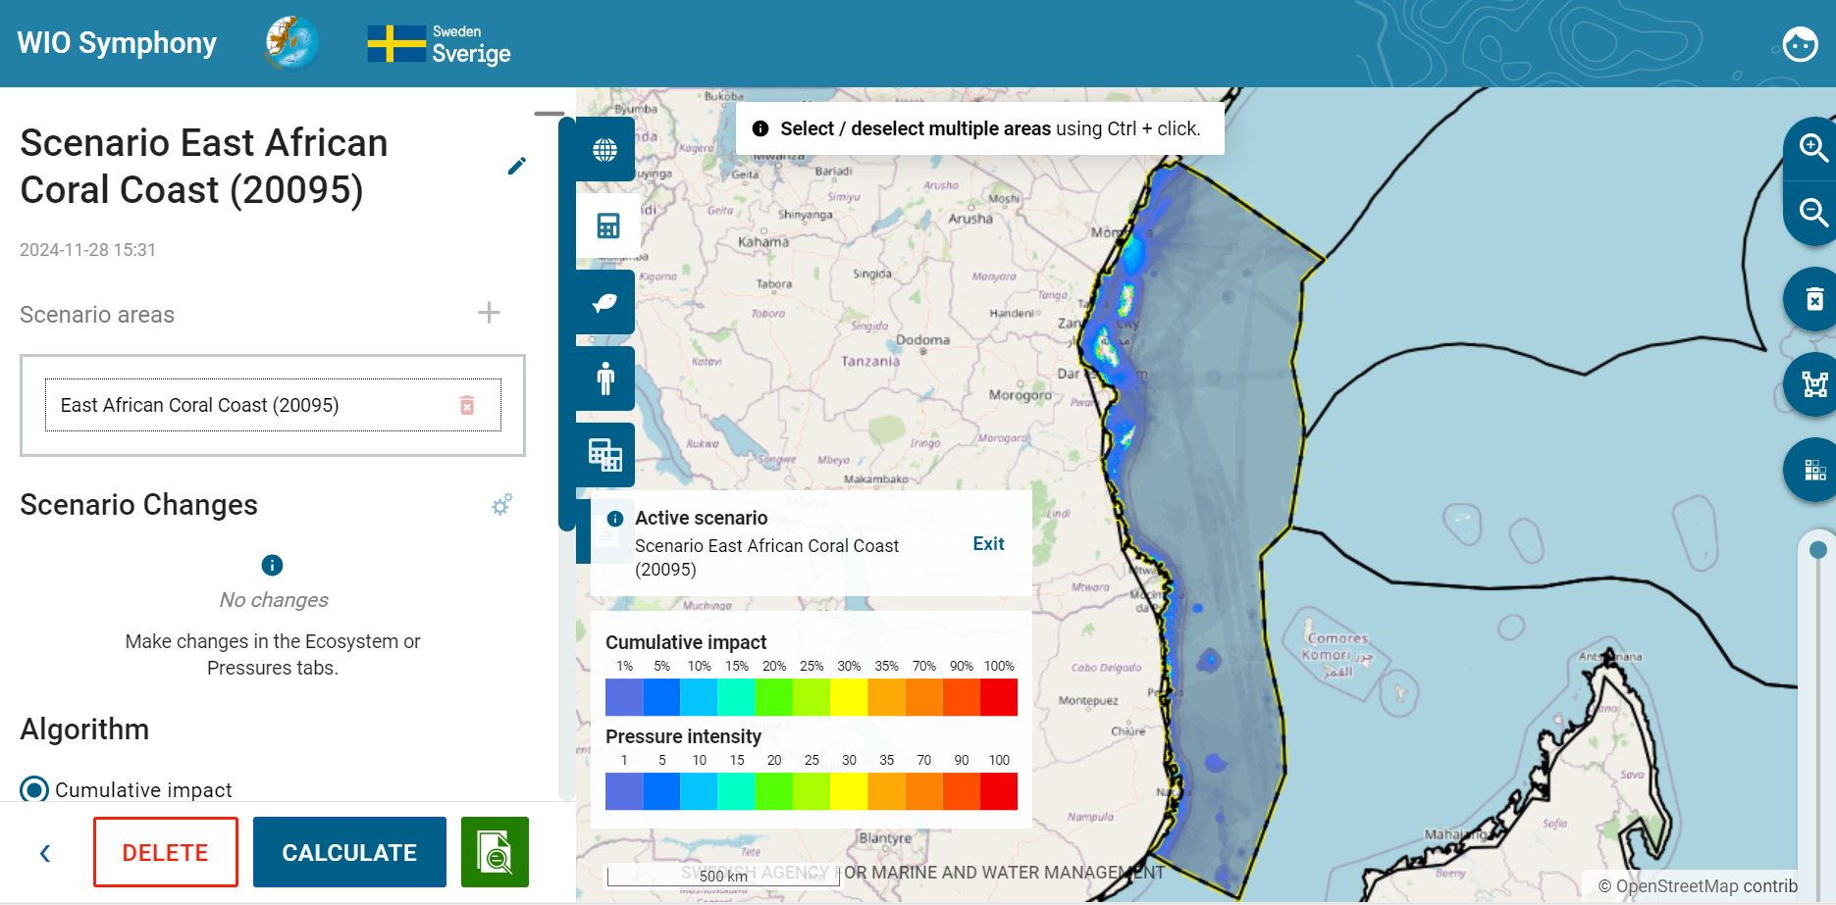

The resulting map highlights areas within your region where cumulative impact is relatively high (red) and relatively low (transparent). Keep in mind that offshore areas often include fewer number of ecosystem components, making direct colour-based comparisons between coastal and offshore areas difficult. It can be reasonable to look for hotspots, both coastal and offshore, even if offshore hotspots display only moderate colour intensity options for cumulative impact calculations.
This above-described procedure runs a default analysis, but several options beyond default settings exist.
What to include? In default mode, habitats are selected, but not individual taxa. Analysing only habitats is the most balanced model and is similar to the original method by Halpern et al. Nevertheless, this can be changed by ticking the empty boxes for taxa of your choice, such as Tuna and billfish. Or Mammals, Birds, Turtles etc.
Algorithm. Cumulative impact is the default algorithm. See chapter 6.3 for the alternative rarity-adjusted cumulative impact, which may be suitable from a conservation viewpoint.
Sensitivity Matrix. The default sensitivity matrix is the final revised product of the WIO expert panel. The panel includes a number of regional experts following a protocol including large group discussion (50 experts), anonymous scoring (19 experts), and review (workshop and open review).
By selecting User-defined matrix and Edit Matrix it is possible to manually change the sensitivity to any specific combination of pressure and ecosystem component, motivated by new knowledge or simulation of management measures. See chapter 6.5.
Result Colourmap. Result of a cumulative impact calculation is a unit less, relative, index which can be called an impact score. The resulting heat map simply display this index from transparent and blue to orange and red. The tool’s default colour scale setting is per automatic the 95e percentile in MSP area. However, it is recommended to use Maximum value in computed area (your selected boundary polygon) as default for your calculation.
If selecting the 95 percentiles in MSP area, the colour scale will scale towards the 95 percentiles of the fully loaded Whole grid scenario instead of your maximum. Since the Whole grid contain a lot of offshore water, the 95 percentile is a rather low value. This typically generates more colourful, but less detailed result maps.
If selecting Mean +multiple of standard deviation, the result colour map sets its max value to the dataset means +some user-defined multiple of the standard deviation.
If selecting User-defined value, you will assign a customised value for the colour scale maximum. This can be recommended when demonstrating results for others or for increasing the optical resolution in either too-red areas (impact hotspots) or transparent areas (low-impacted offshore areas). You may want to run a primary analysis and then read the report to find reasonable numbers for the customised colour scale, such as using the average value or a certain percentage of the maximum value. You may also set the colour scale in relation to environmental impact benchmarks.
Changes to the result colour map do not affect the impact index or numbers. It only changes the scale of colours. Changing colour scales can be done sequentially in your GIS program after downloading the resulting map from WIO Symphony. See chapter 5.6.
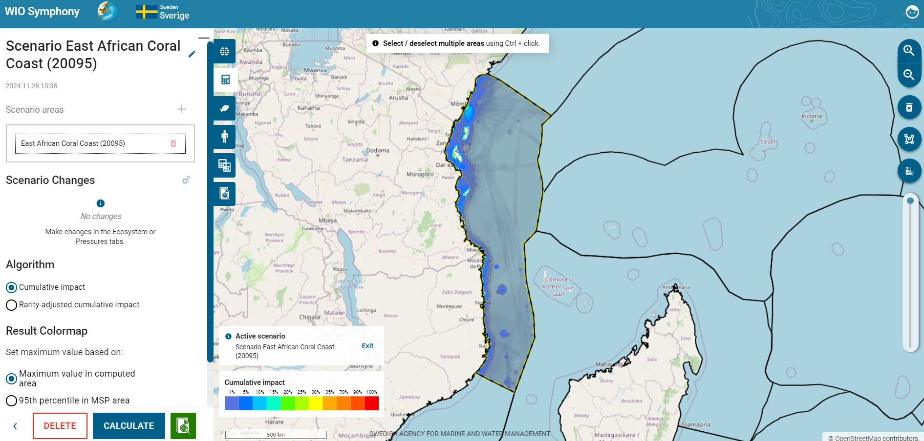
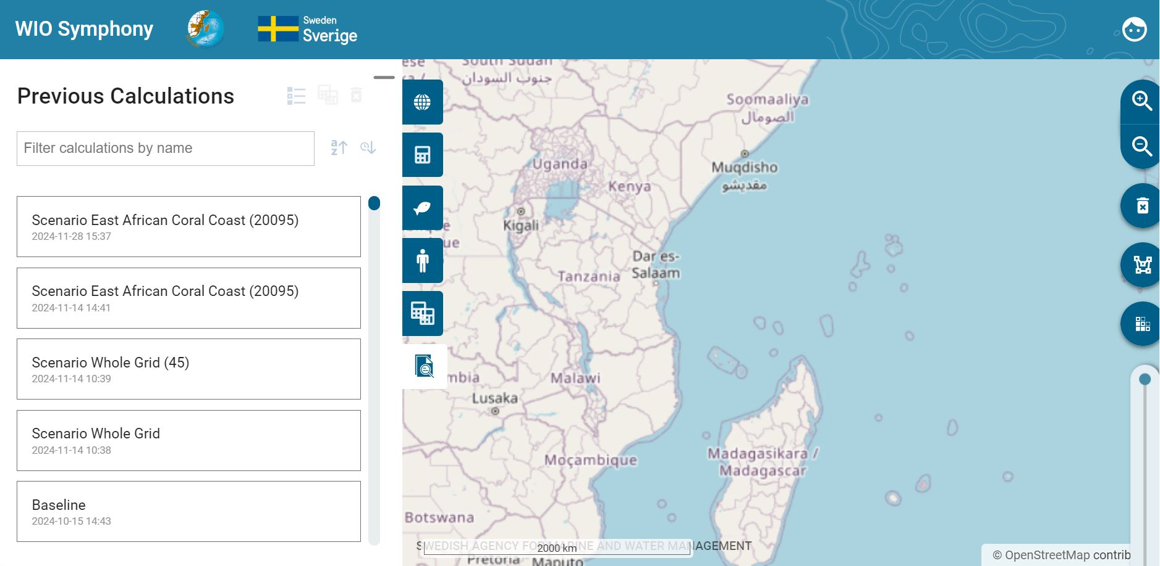
Above the list of scenarios under the Scenario and Previous calculations tabs, you can filter your scenarios by name and sort by name or date, making it easier to find the scenarios you are looking for.

5.6 Cumulative impact Calculation Report
All analyses create a Calculation report. The report provides both an overview and a detailed result.

Impact map and basic statistics
The scenario name and impact colour map are shown in the upper left corner. The same resulting map can be exported (downloaded) as a raster file by pressing EXPORT AS GEOTIFF.
In the upper right corner, you find applied baseline versions, settings, and summary statistics for the report. Calculated area is crossed because the WIO Symphony projection in the data raster does not allow to calculate the surface measurement programmatically.

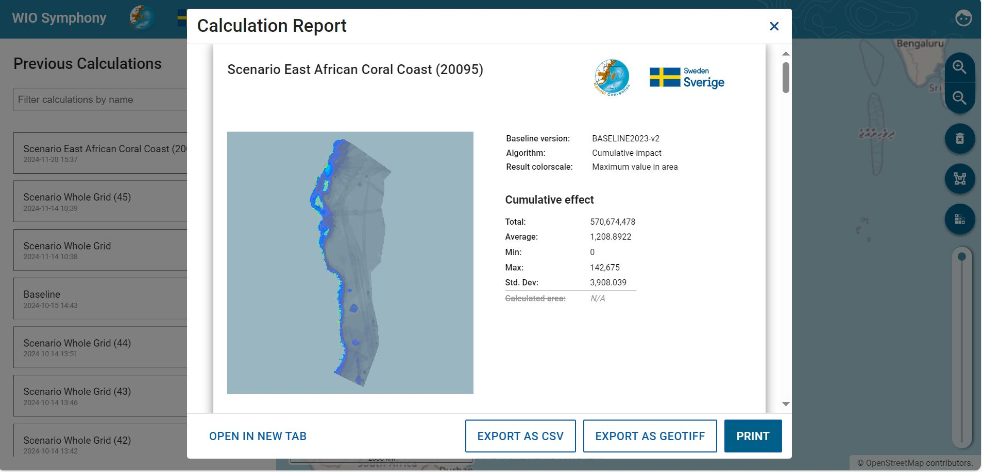

Top-5 summary table
A summary of the top-5 contributing pressures and the top-5 ecosystem components affected are provided as numbers and bars. Note that the colour legend is also related to the Colourmap (the colours match).
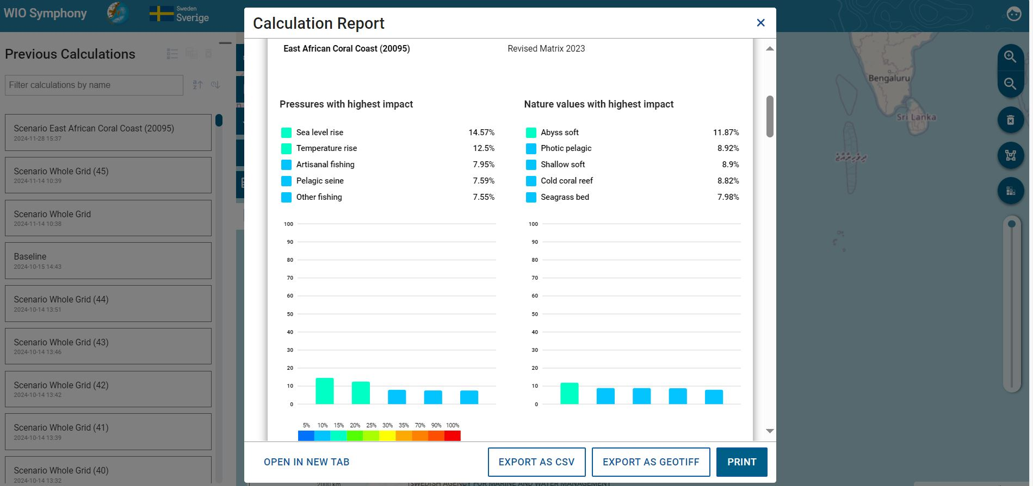

Sankey diagrams show contribution flows
The report also provides a Sankey diagram, which gives an informative illustration of the main (largest) impact flows. This means that you can see how relatively much each major pressure (left axis) contributes with environmental impact to each of the main impact-receiving ecosystem components (right axis). Wide flows indicate that the impact is proportionally large.
The Sankey diagram allows you to get a good understanding of the details. You can see which of the pressures that dominate the impact on each ecosystem component. Precise numbers are given when you hover with your mouse across the impact flows. Keep in mind that uncertainties are large and numbers should be interpreted as orders of magnitude, rather than to decimals.
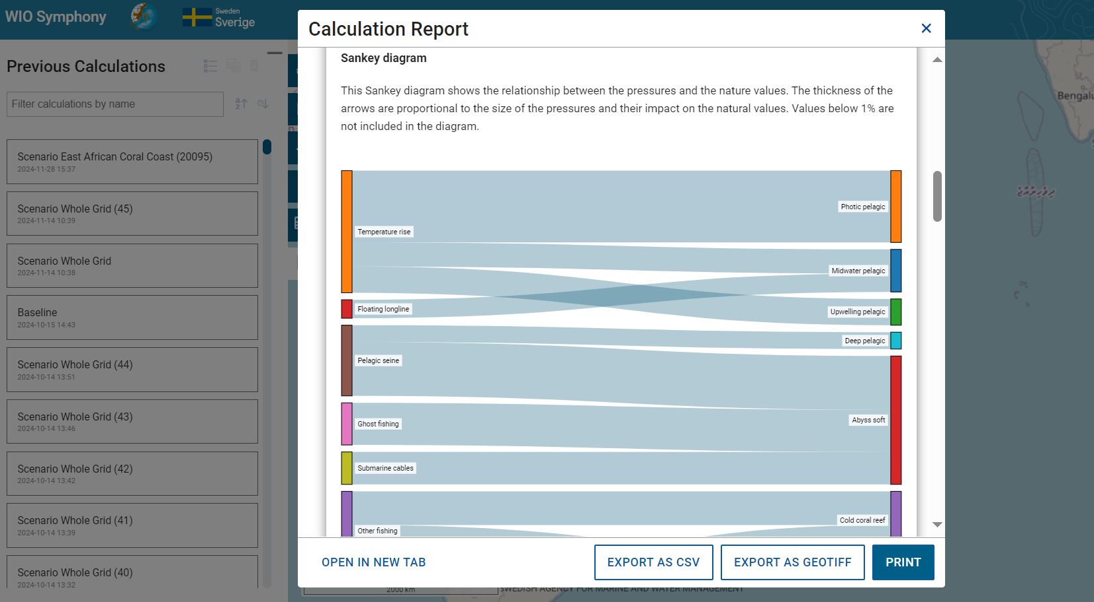

Scenario parameters and statistics
The report provides Scenario Parameters (only relevant after scenario simulations) and a table showing the details of contributions and receiving numbers behind the above diagrams. In a later scenario where you have made pressure changes, they will be shown under Scenario Parameters. Note in the red box that if you have made general or area specific changes, they will be shown here, as well. These numbers, in even more detail, can be downloaded and analysed separately by pressing the EXPORT AS CSV button.
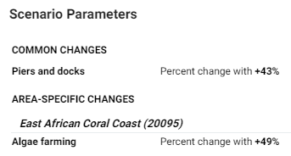
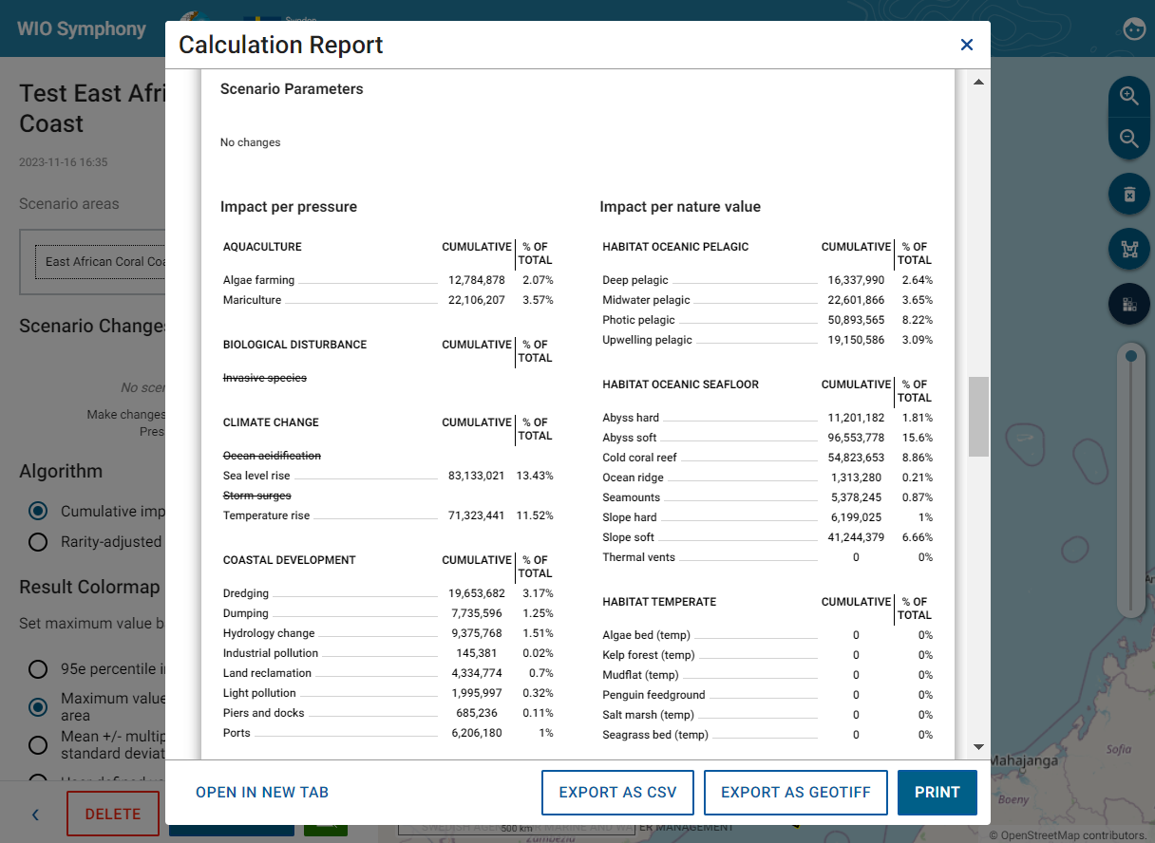

Histogram of impact scores
The report histogram shows a number of pixels (y-axis) across different levels of impact score (x-axis). Move your mouse along the bars to inventory check numbers. This can be useful information when customizing the colour scale or correlating impact scores to environmental impact benchmarks. In areas with both coastal areas and vast offshore areas, the histogram will show a strong L-shape.
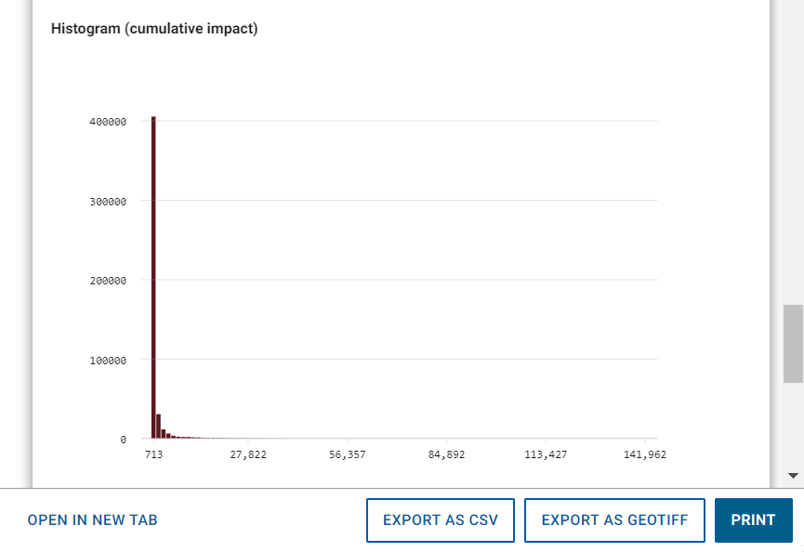

End of report
Lastly, at the end of the report, further information is provided of when the report was created, how WIO Symphony was created, how to cite and the license, as well as the people behind the tool and its contributors.
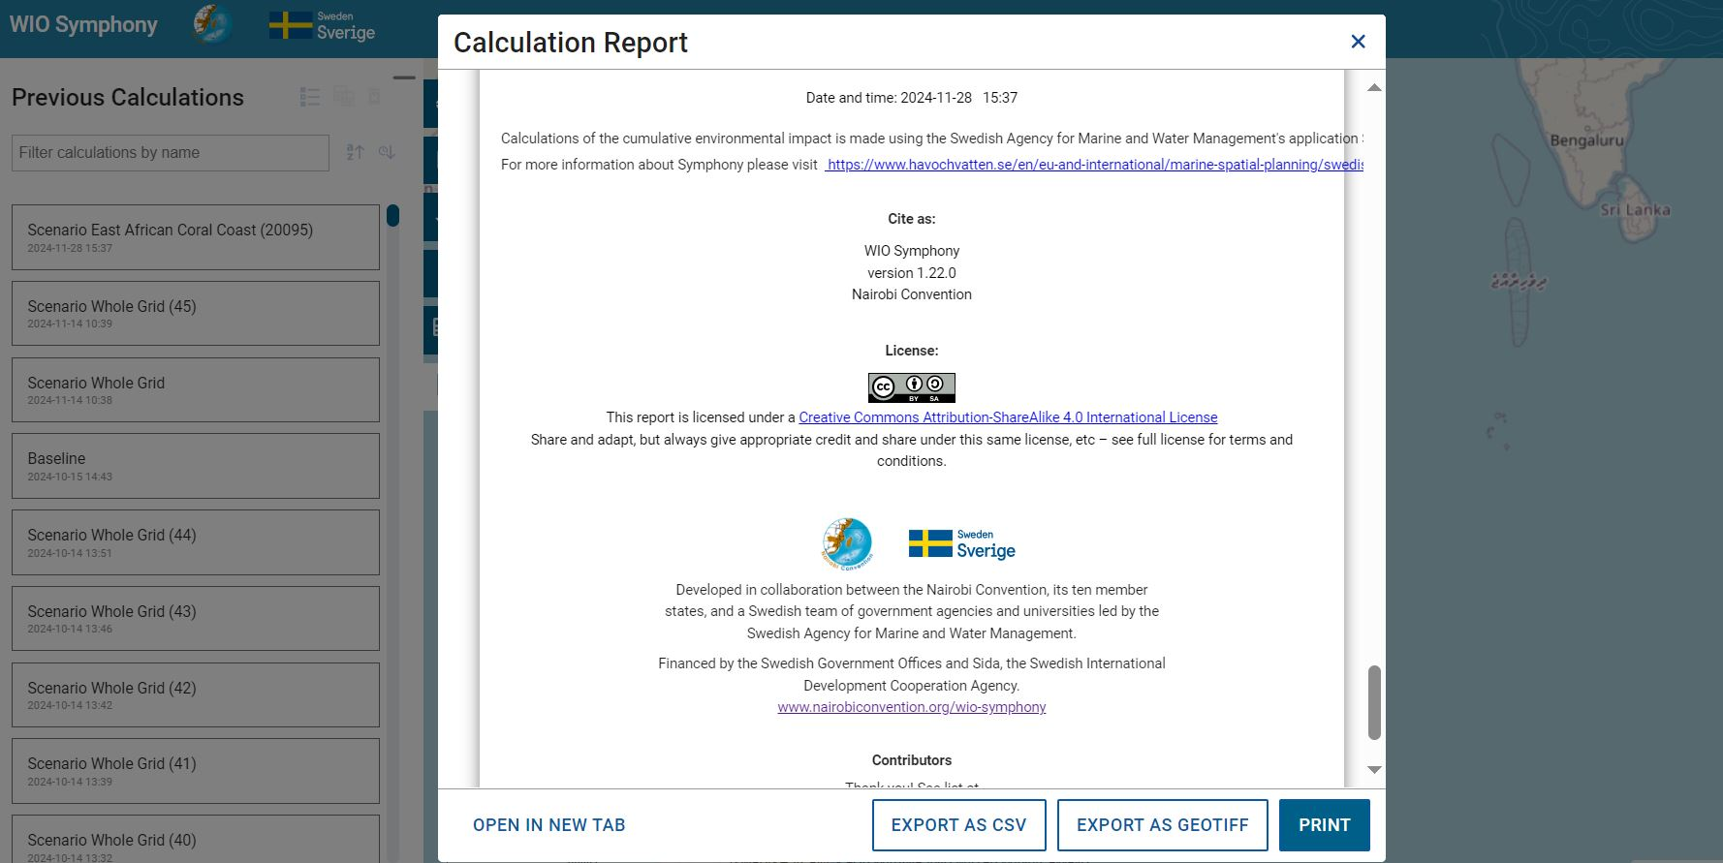
A final function in the reports is the PRINT button. This gives you the option to print or save the report as a PDF, for example.
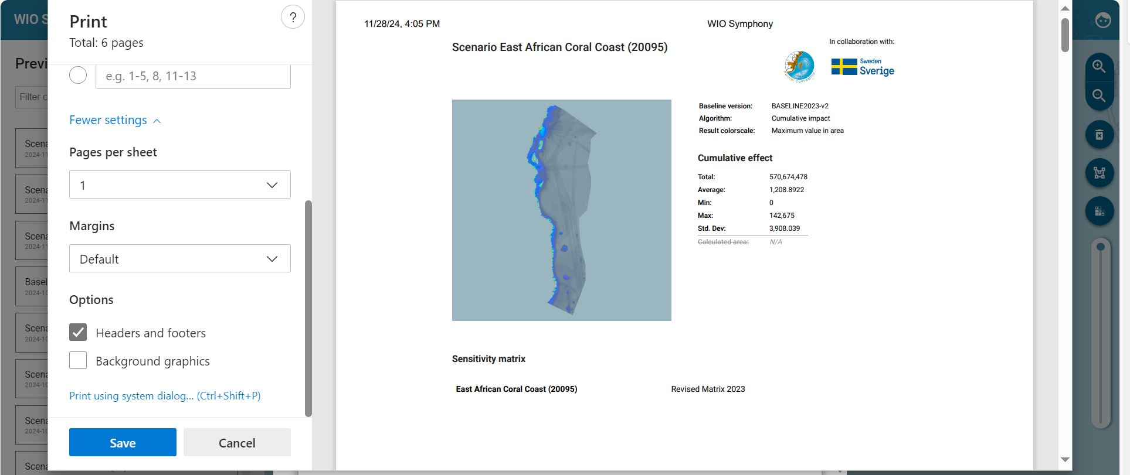

5.7 Erase and reset
Colour maps are removed by pressing the bin symbol. You can retrieve the colour map again by clicking on your scenario under the Previous Calculations tab. If you wish to delete a scenario, press the small red bin symbol. This is possible for your previous scenarios as well, under the Scenarios tab. To view the report again, press the report icon, and to rename scenarios press the rename icon next to it. To view it in the map frame, press the eye icon.
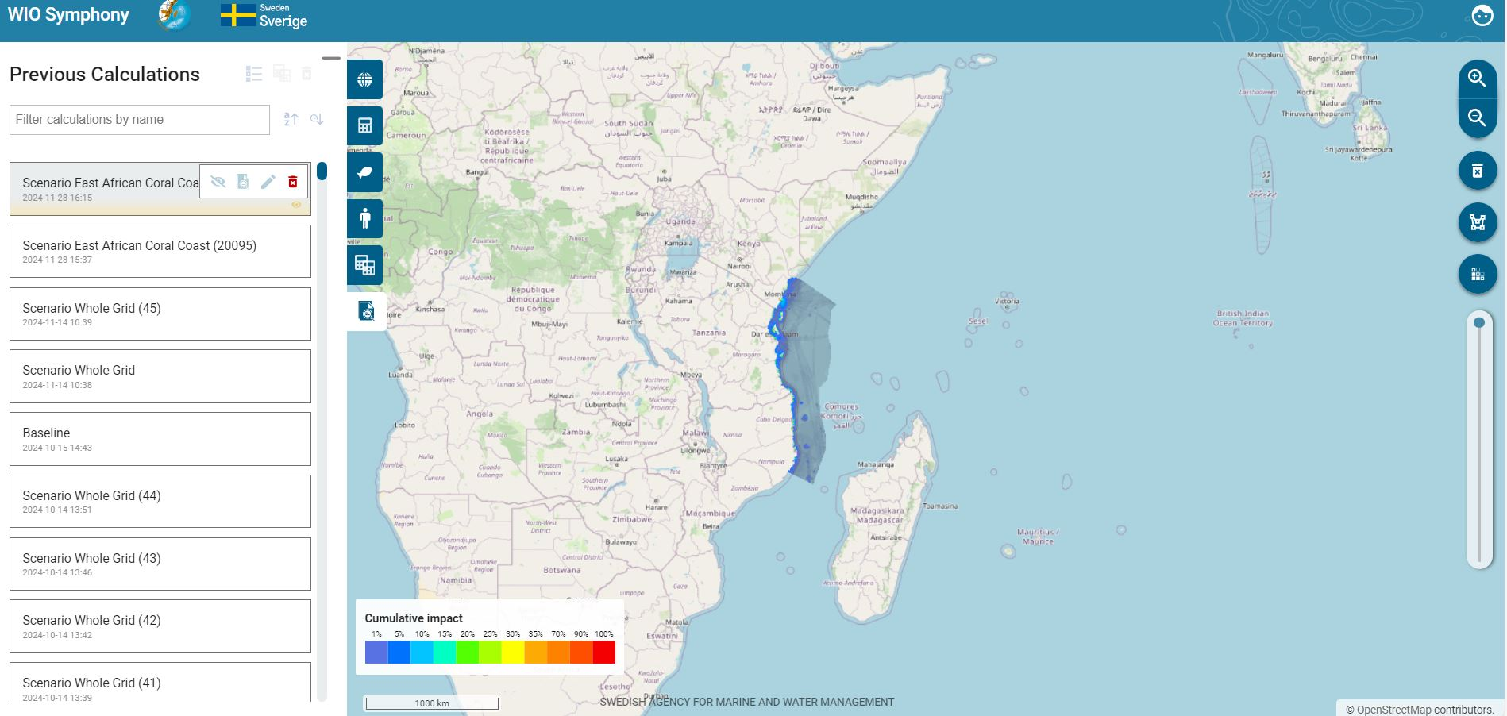
If you wish to delete previous calculations, press the enter multi-selection mode and select the previous calculations in the list that you want to remove. Thereafter, click DELETE to delete them.
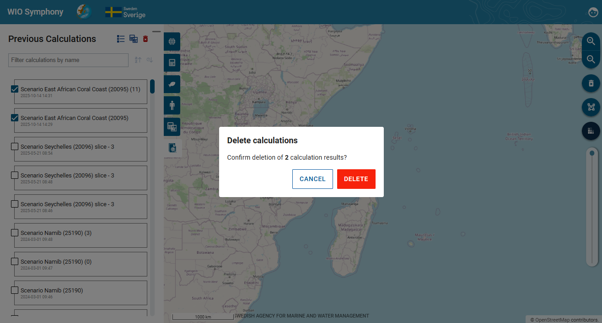
Your selection of included data layers can be reset by returning to the pressure tab and ecosystem component tab and press the RESET button. Now, the default selection is restored. This reset will also remove changes you have done to scenario simulations (changed/added values for individual pressures).
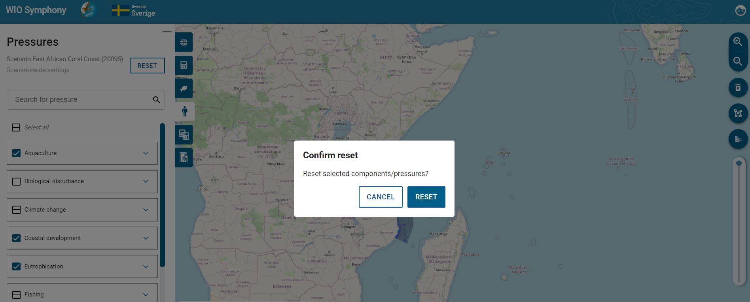

5.8 Create and analyse scenarios
A main functionality in WIO Symphony is to make changes to an area and compare the results with a baseline (no-change) scenario of the same area. Otherwise, it is possible to make two different changes to an area and compare the two.
This way, you can simulate the environmental impact if a marine spatial plan (MSP) is implemented or if a management plan of a marine protected area (MPA) is followed.
First, select an area and create a baseline scenario by selecting or drawing a boundary polygon  go to Scenario tab, and click a plus sign  go to Ecosystem components/ pressures  select which data layers to include (ticking)  go to Scenarios tab  rename your scenario with (for example) prefix “Baseline” on the pen symbol  press CALCULATE.
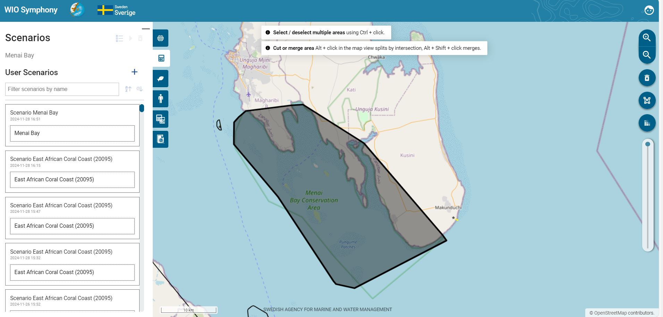
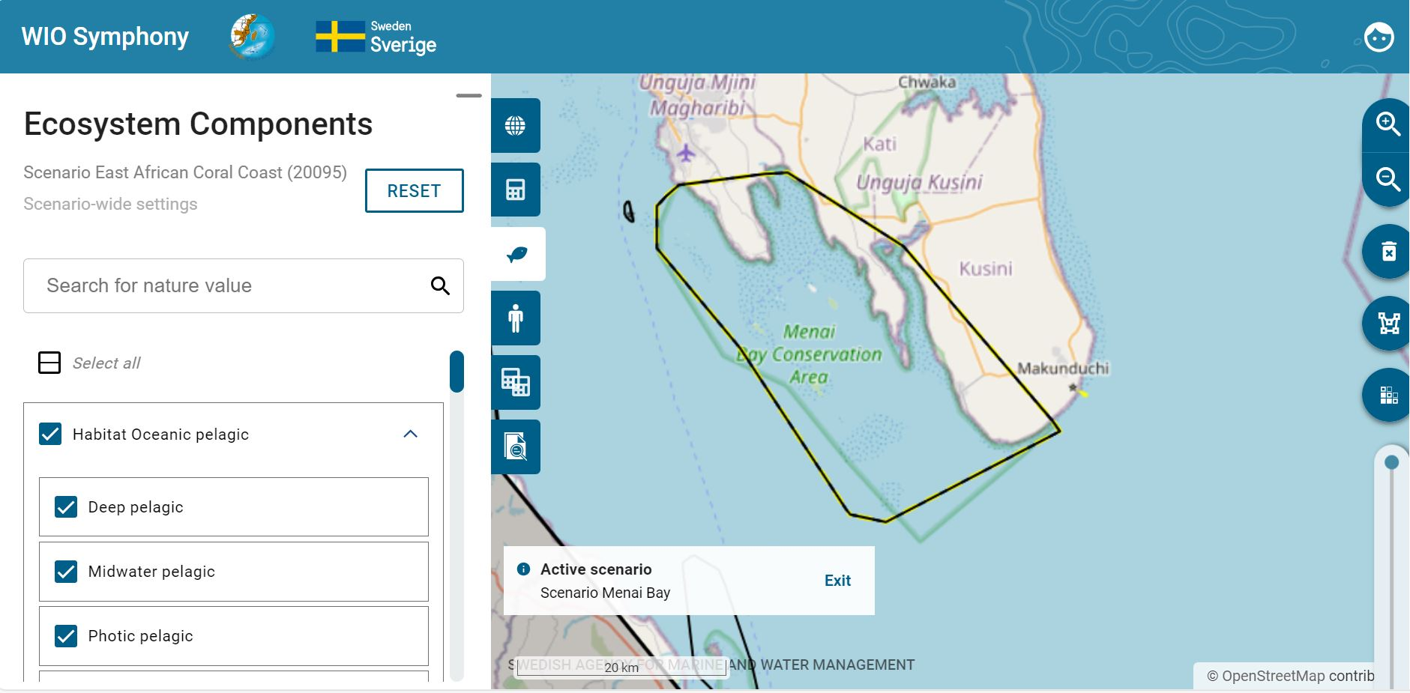
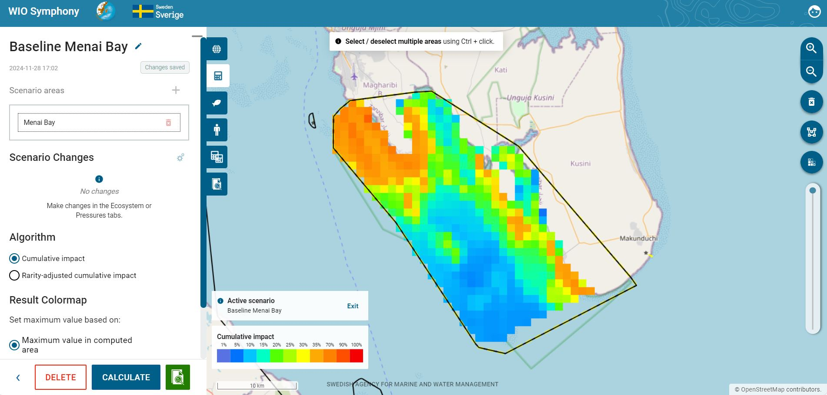
Then study the Calculation Report or other information (such as your draft MSP plan) and develop an understanding of appropriate changes that you wish to simulate. When testing the tool, you have no restrictions. In real life, you will probably consult marine spatial planners and stakeholders, or MPA documents and stakeholders if you are working with conservation.
Press the Return symbol to go back and out of the current baseline scenario you just created and analysed. You may also want to erase the baseline colour map by pressing the bin symbol.
Next step is to simulate the changes of pressures inside your boundary polygon, based on new ways of using the area. Such simulations can be done in four ways, first pressing the adjustment symbol:
- Reducing a pressure by percentage, meaning that the current levels of that pressure from a human activity is reduced with a specified percentage across the whole area of analysis: drag intensity percentage to the left, click the downward arrow within the percentage square or type in the percentage change you want.
- Adding a pressure by percentage, meaning that the current levels of that pressure is intensified in the same places as it is currently existing, within the area of analysis: drag intensity percentage to the right, upward arrow within the percentage square or type in the percentage change you want.
- Completely removing a pressure, meaning the pressure is no longer occurring at all in the area: set the percentage to -100%. Note that if you untick a pressure in your scenario, but it is still in the baseline, the comparison later on will not generate a report, since it cannot compare the changes anymore.
Add new pressure scores across the area, regardless of whether the pressure already exists in the area. This action adjusts a constant value: type in a number in the Constant field, to represent the pressure intensity applied to each pixel in the area. For example, a value of 100 indicates full coverage of the pressures on every pixel across the entire selected area.
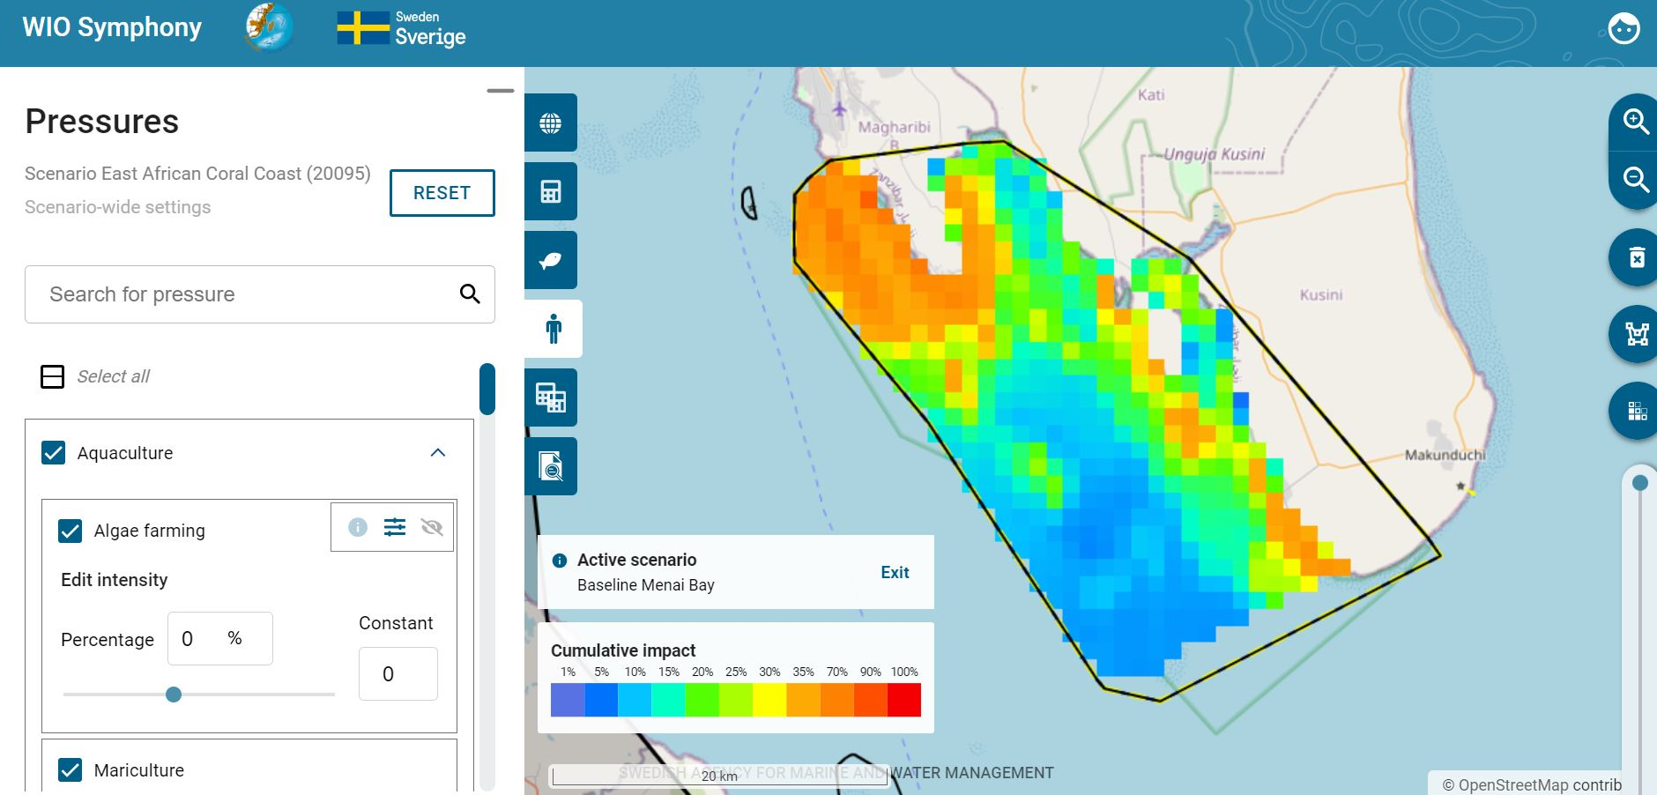
Changes made in this example (see figures below):
- Increased existing Algae farming with +50%
- Completely banned (removed) Dredging and Dumping with -100%
- Increased Coastal tourism and Boating with +30%
- Moved out Shipping from the area, thus removing shipping related pressures with -100%

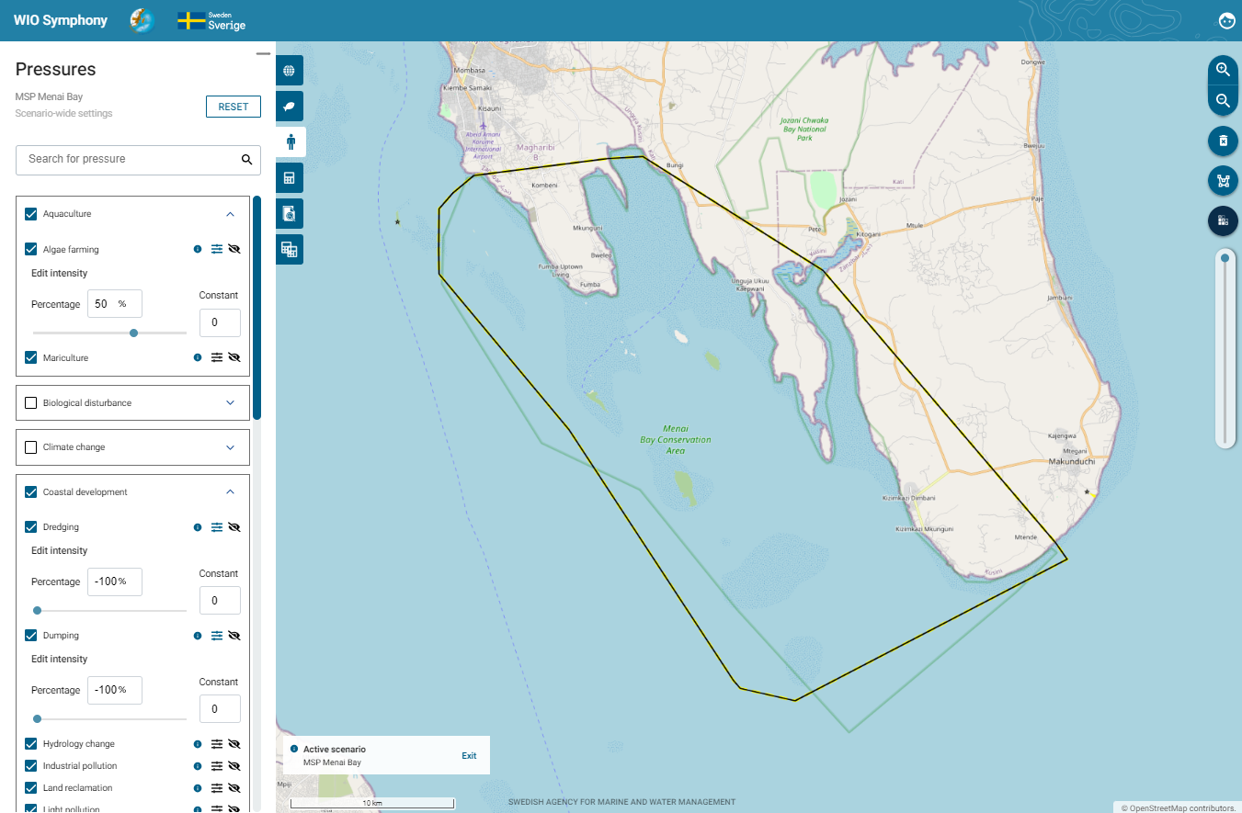
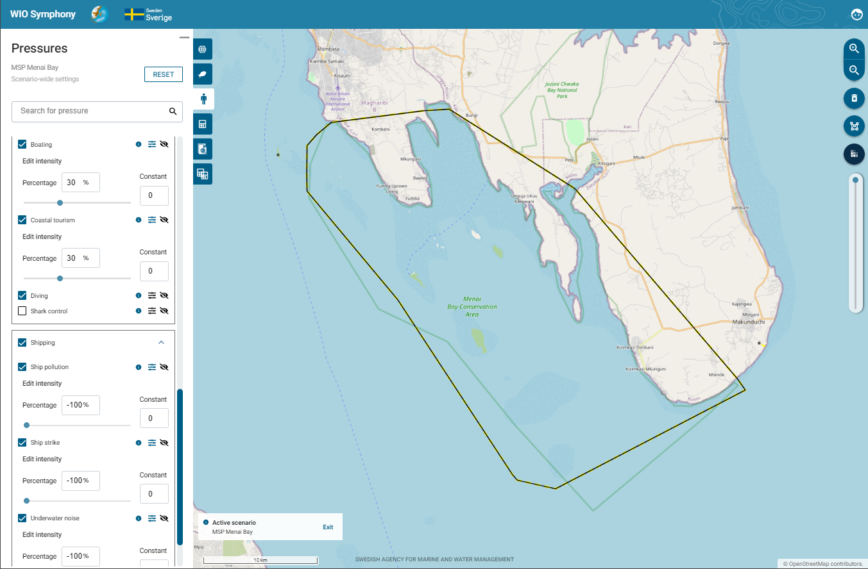
Go to Scenarios tab  rename your scenario with, for example, prefix “MSP”  move to the Pressures tab  make changes to relevant pressures, corresponding to your simulated plan  return to the Scenarios tab  press CALCULATE  have a look at the report  press the Return symbol to get back.
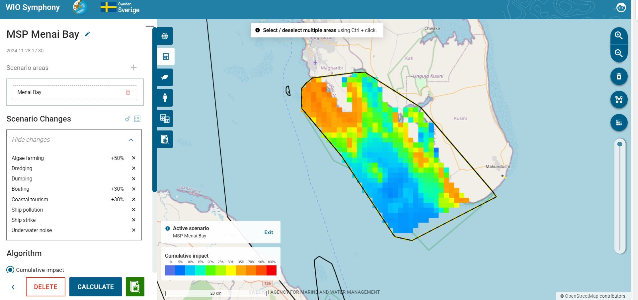
Under the Scenario Changes, you can show the changes you have made by pressing the arrow button, making sure you have not missed any before calculating. This box only shows the pressures you have actually changed, and does not show the ones that are removed, since that might be many with all the pressures removed by default. For pressures with values of -100%, only activities names will be shown.
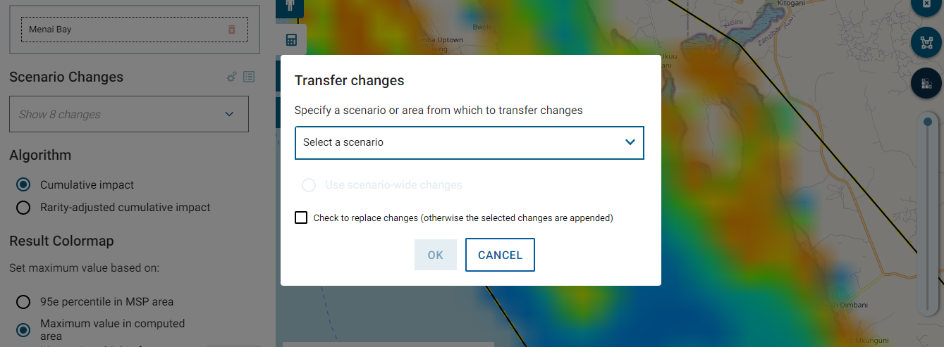
At the cog wheel icon, you have the option to transfer changes from an existing scenario or scenario area if you wish to apply the same ones. This is useful if you wish to do the pressure changes to different areas. Press the arrow button to view previous scenarios with changes. The round button refers to the scenario’s general changes. If a scenario is chosen within several areas, the user is provided with an opportunity to choose changes from one of those areas. If the square tick box is ticked, then it will replace all changes. So, if there are changes in the output scenario, these will be removed first. If this box is unticked, the user can add changes. Changes in the output scenario will remain, although overwritten if a change to the same pressure or ecosystem component occurs in the scenario where it is originally from.
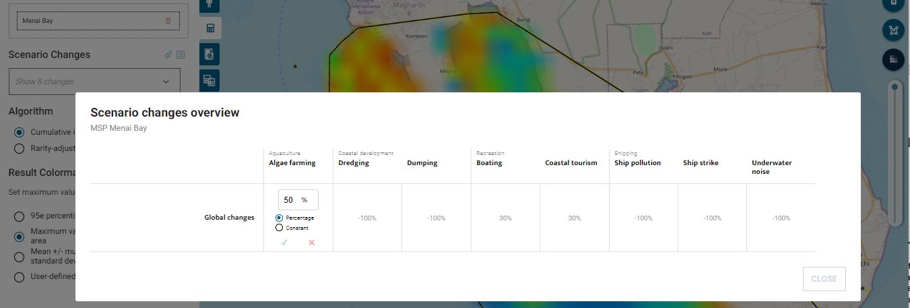
On the table icon next to the cog wheel, there is a tabulated overview of all the changes made in the scenario. This intuitive table lets you adjust all the changes you have made, similarly like previously back at the pressures tab, however, without going back there. By clicking the pen button, you may adjust both the percentage increase/decrease and constant of the changes you made before, which is especially helpful for complex scenarios.
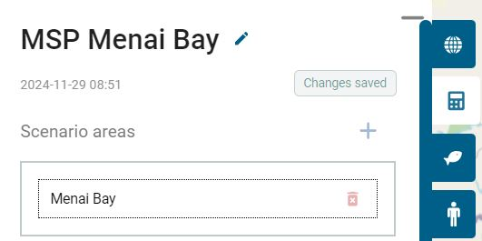
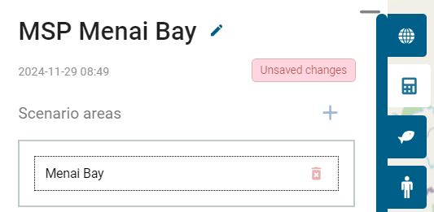
In previous versions of WIO Symphony, when a scenario was being edited, the tool itself saves all changes made (to the scenario) by the user at a regular interval, and following certain actions such as starting a calculation or leaving the edit mode. The new, and current, feature makes the saved state of the active scenario explicit to the user. A notification/button alerts the user if the user interface displays unsaved changes (left figure above). Clicking the notification Unsaved changes persists the scenario setting to the database (right figure above). This interactive save scenario function is to give the users the certainty that the made changes have been saved.
Now when the “MSP” scenario has been simulated, you might have noticed some differences in the reports between the “Baseline” and the “MSP” scenarios. However, the full comparison will be computed to have quantitative results, which are easier to interpret. See next chapter 5.9.

5.9 Compare two scenarios
Two scenarios from the same boundary polygon(s), such as the “Baseline” and “MSP” scenarios, can be compared using the Compare Calculations tab. By default, the compare calculations will be set to Implied baseline, which lets you automatically compare your scenario (with changes) to that scenario’s implied baseline.
Move to the Compare Calculations tab  select your “Baseline” scenario as Calculation A and your “MSP” scenario as Calculation B  press COMPARE CALCULATIONS. There are two ways under Customise colour scale to showcase the differences. This enables you to compare two scenarios that both have changes that are different.
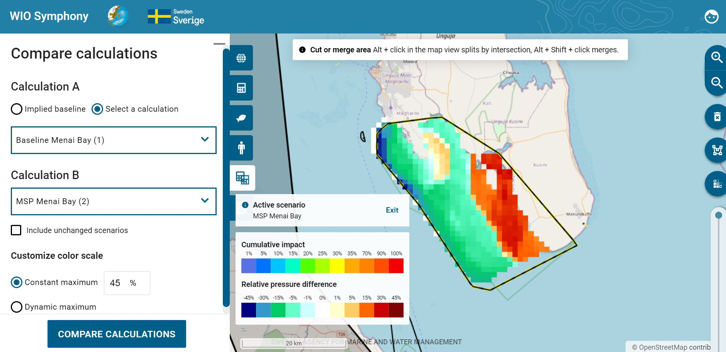
The first adaptive colouring range for the comparison report is the default Constant maximum (45%).
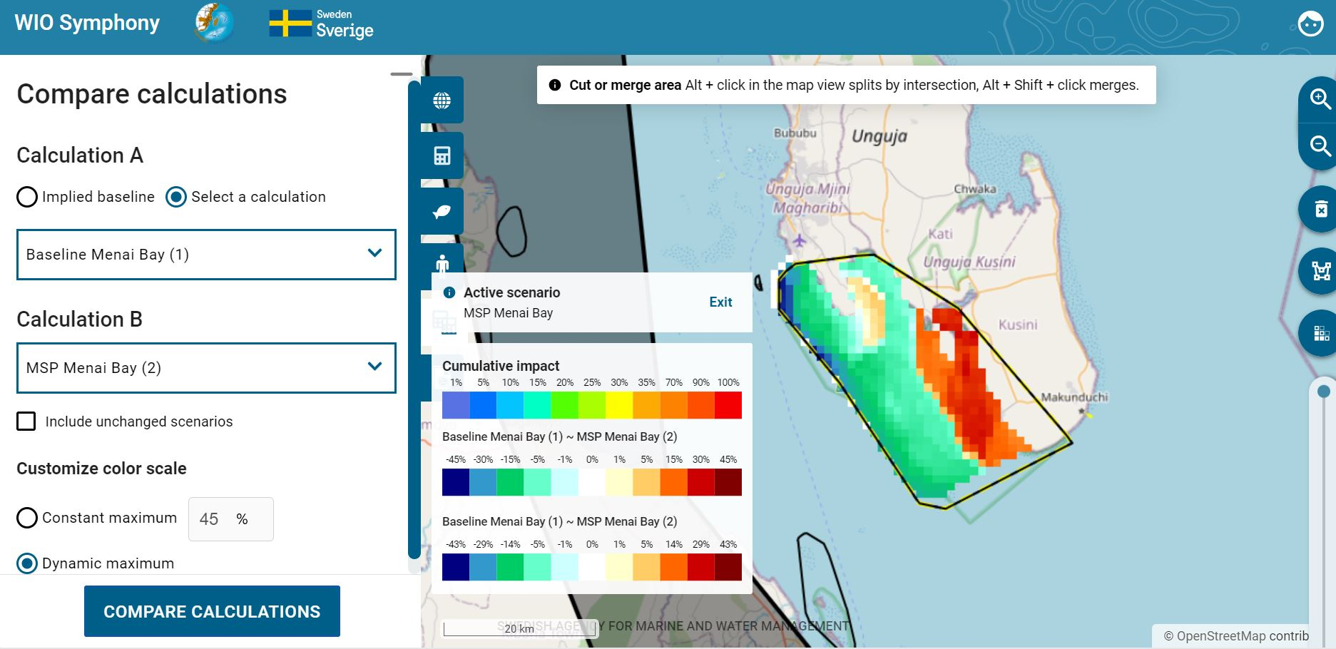
The second is the Dynamic maximum, adapting the colour scale maximum to the actual max value of the specific comparison, instead of a set min and max of 45.
The Calculation Comparison Report that pops up once you click Compare Calculations generates a graphic illustration of differences in cumulative environmental impact. More orange-red colours equal an increase in cumulative impact, while more green-blue colours equal decreased environmental impact.

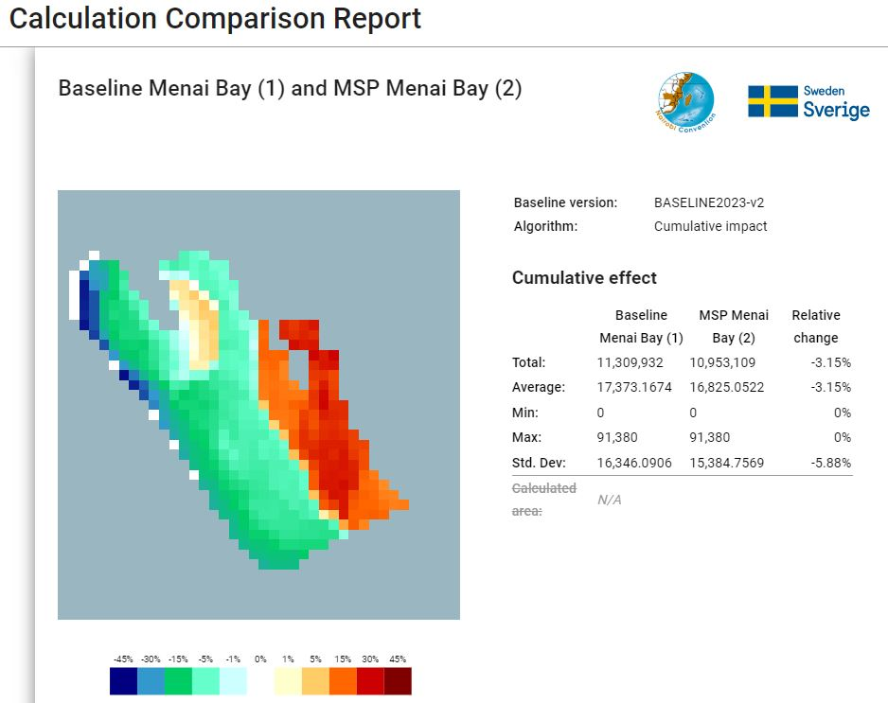
In the associated summarizing table of Cumulative impact, the Relative change gives an indication of total outcome, across the whole area. For this example, where you have increased algae farming and tourism, while reduced dredging, dumping and nearby shipping, the net result of the cumulative is -3.15%, which is positive for the environment.

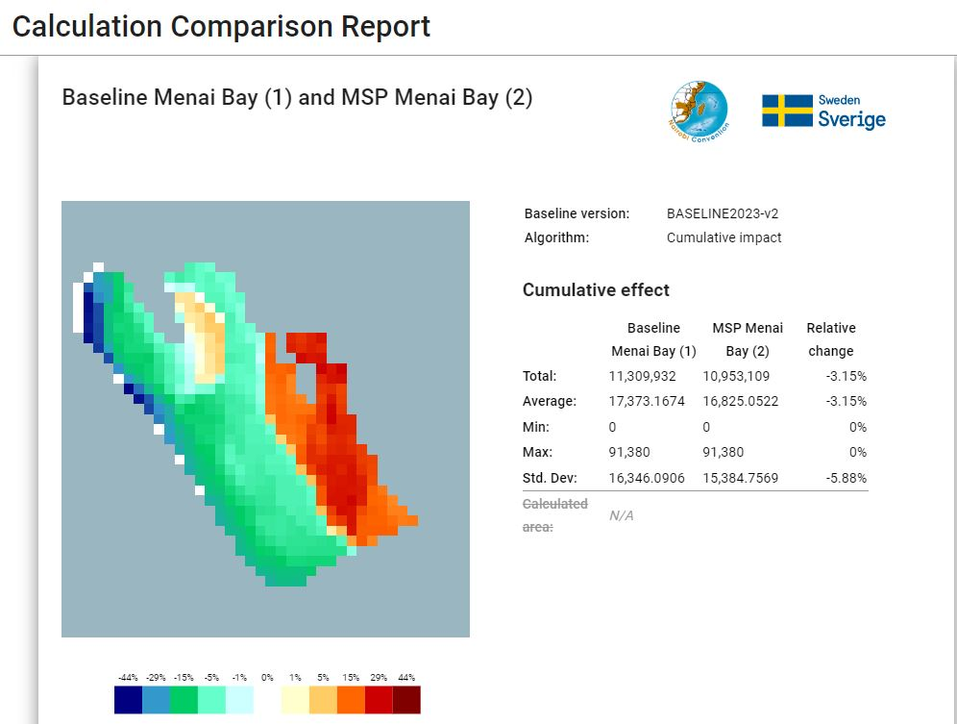
Being basically the same, the Dynamic maximum report provides identical information as the default Constant maximum (45%). However, as previously said, the difference lies in the map illustration. Note that the differences on the map will be more visible in a larger area compared to this quite small one.

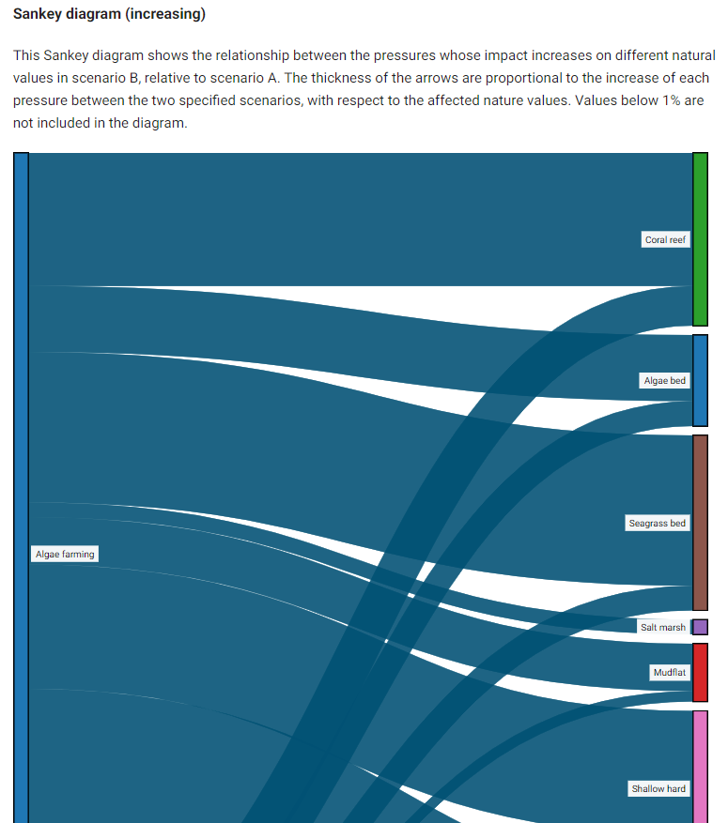
Similar to a regular scenario report, the comparison report provides a Sankey diagram. However, this is split up in two different diagrams, one with increasing pressure (above) and one with decreasing pressure (below).
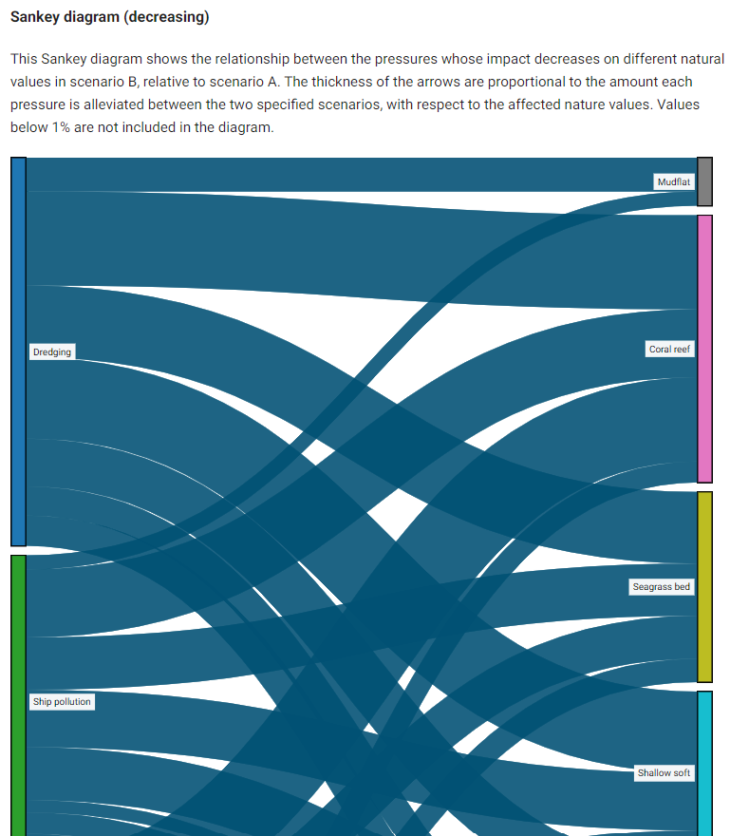

Similar to a scenario report where you have done changes, the comparison report lists the changes under Scenario Parameters. Below, the section to the right lists all the changes we have made for the MSP scenario, while to the left, the baseline is left as a default analysis. Additionally, we can, in detail, see the specific relative change for all the included ecosystem components and pressures, which was summarised in the beginning of the comparison report.
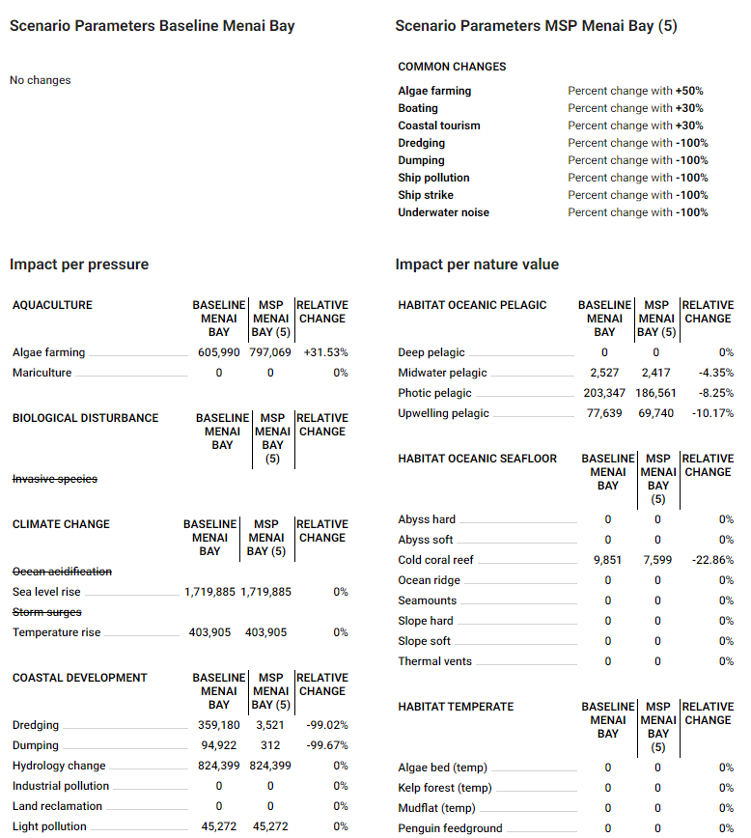
Comparisons can be exported as CSV and GEOTIFF files, as well as printed and saved, just like the regular scenario reports.
By comparing different MSP options with a baseline, or with each other, the planner can analyse one or several MSP zones and evaluate solutions in an iterative process, easy to communicate to sector representatives and other stakeholders.

5.10 Compound comparison
The compound comparison feature lets you select multiple calculations containing projected changes and compiles a dataset consisting of the comparative changes with respect to an “implicit” baseline calculation for the same geography. The results may then be downloaded as either JSON data or an ODS spreadsheet document (Excel).
After selecting two or more previous calculations through the multi-selection mode, click the generate comparison data icon . This enables you to set at title for the compound comparison, and calculate the result via the CALCULATE button.
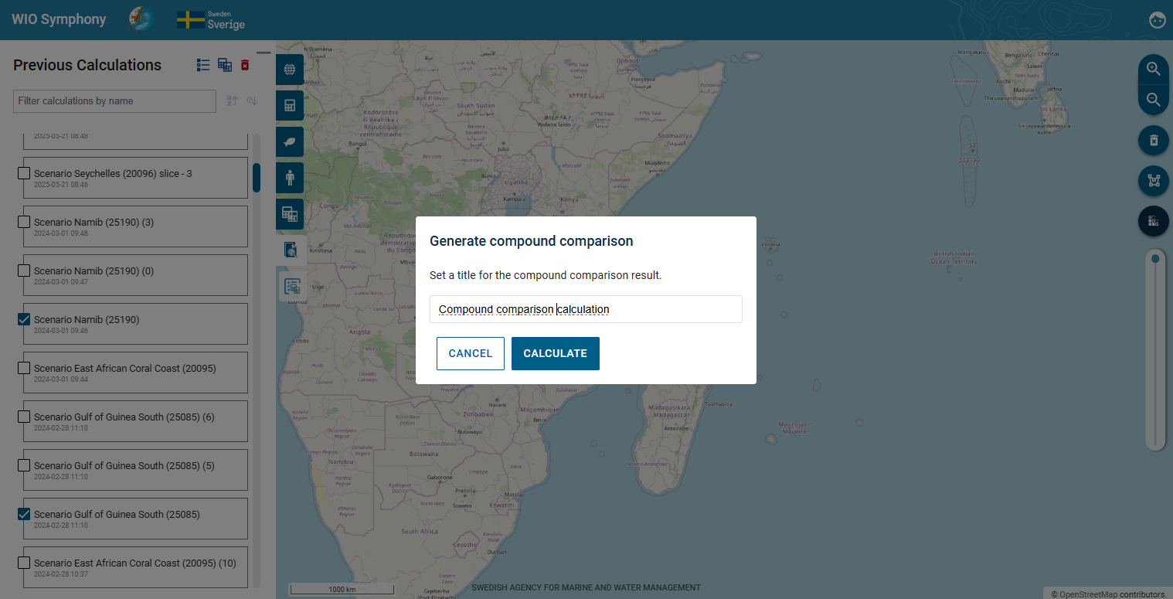
After the calculation is done, you will get a summary of your compound comparisons. Once you have generated your first compound comparison, a new tab icon will appear called Compound comparisons, that show you previous calculations. Click the Download compound comparison icon to get the comparison results.
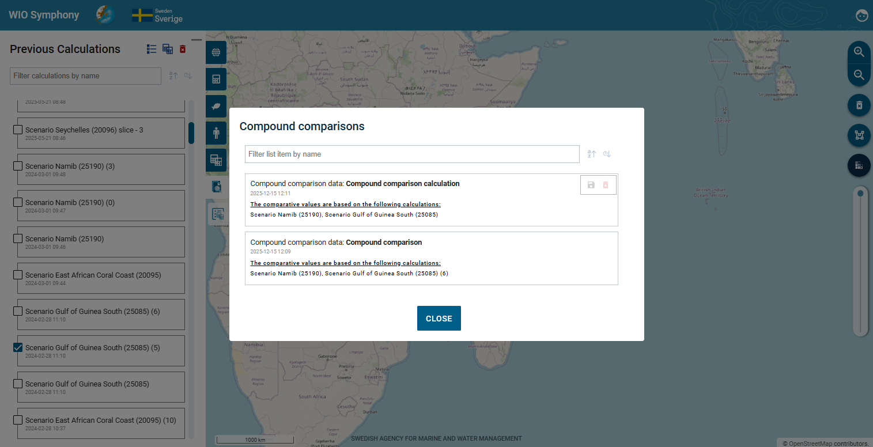
The final step provides a few choices. As previously mentioned, select the format to download, either as data or as spreadsheet (JSON or ODS). You can decide to include or exclude unchanged results for JSON, and for ODS you also have to option to include combined dataset or not.
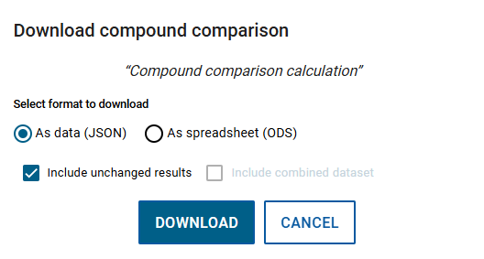
With this feature, you are able to compare completely different scenarios for different geographies. The exported data result could then be used for further analyses.

5.11 Select, Merge or Split several polygons
Another functionality of the updated WIO Symphony that did not exist in earlier versions is to select, merge or split polygons.
Select multiple areas by first selecting a single area. Then, hold down the Ctrl key and left-click to select additional polygons. Selected polygons will be treated as a single entity for calculations.
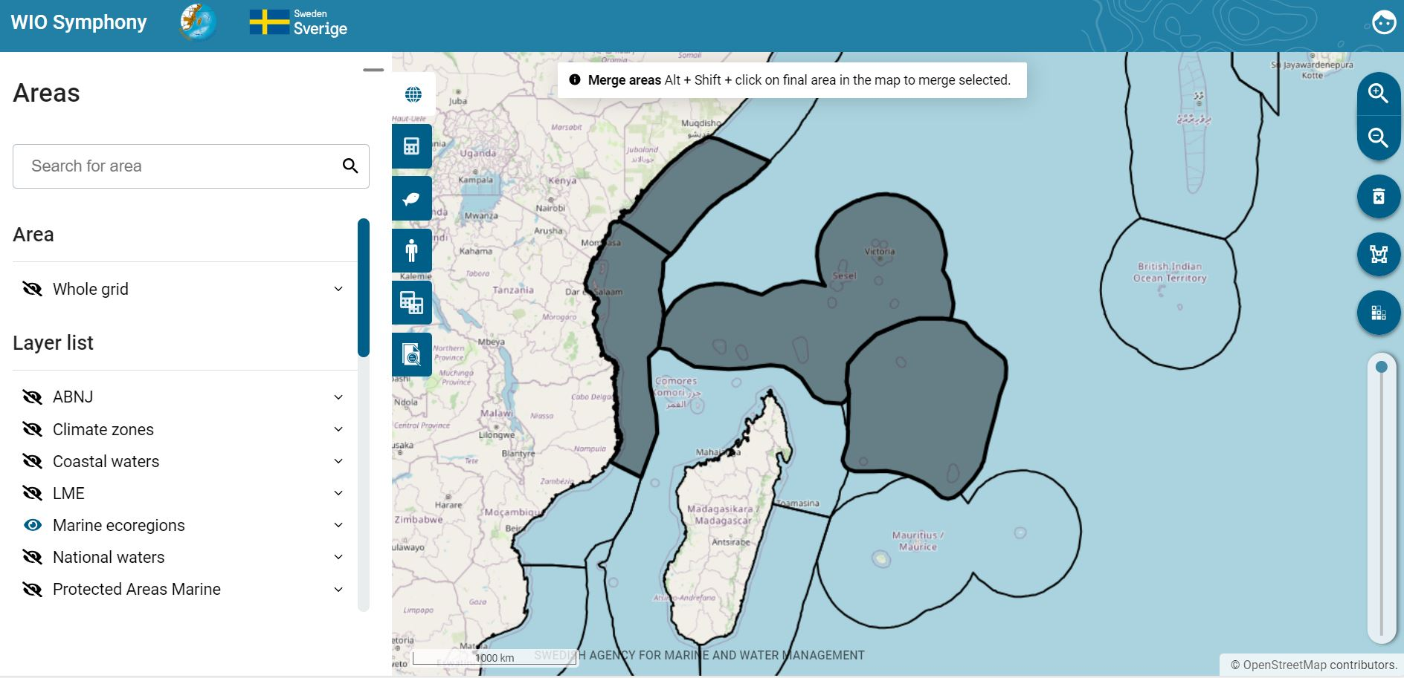
You can also select two or more polygons and merge them into one by first selecting one or more, and on the final one hold Alt + Shift + left click. This triggers a dialog box (see figure below) that enables saving the result of merging both areas together as a new user-defined area, or overwriting either of the merged areas (option available if the one to overwrite is already a user-defined area). This will be saved under User-created Areas where you can rename it.
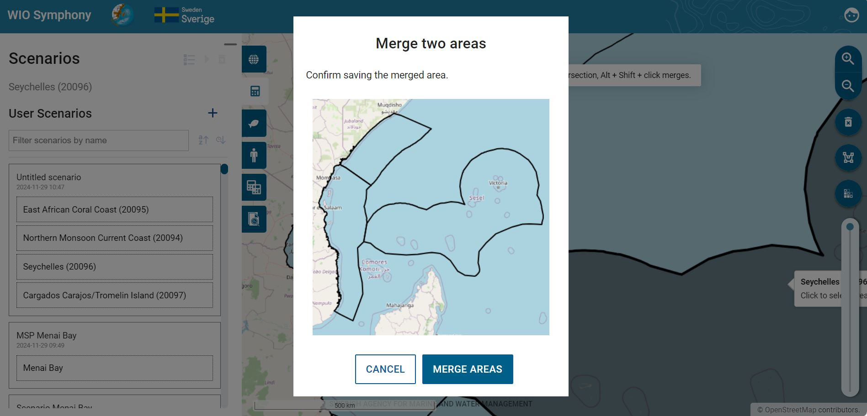
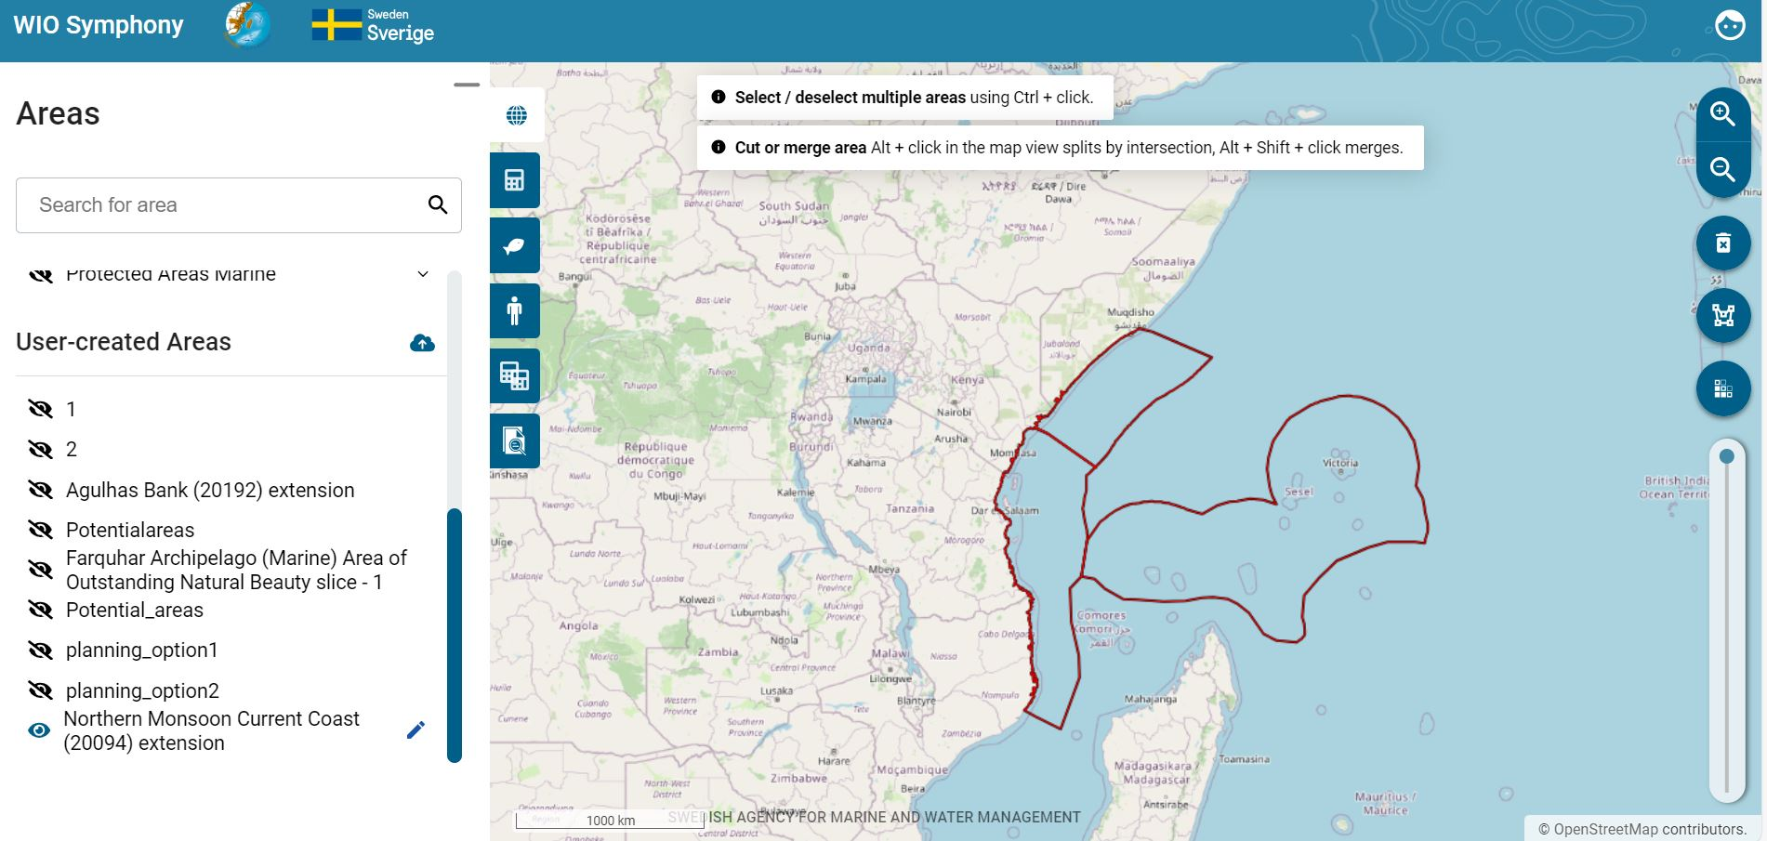
A final function is to cut or split an area by intersection. To cut, first select a polygon and then hold Alt + left click to select the polygon that you want to cut out. This is a function for the so-called Differential zoning, using two distinct, overlapping areas. This triggers a dialog box allowing the user to create new areas based on the intersection and relative complements of the active selection. By clicking Save to “User-created areas”, the intersected polygon will be saved there.
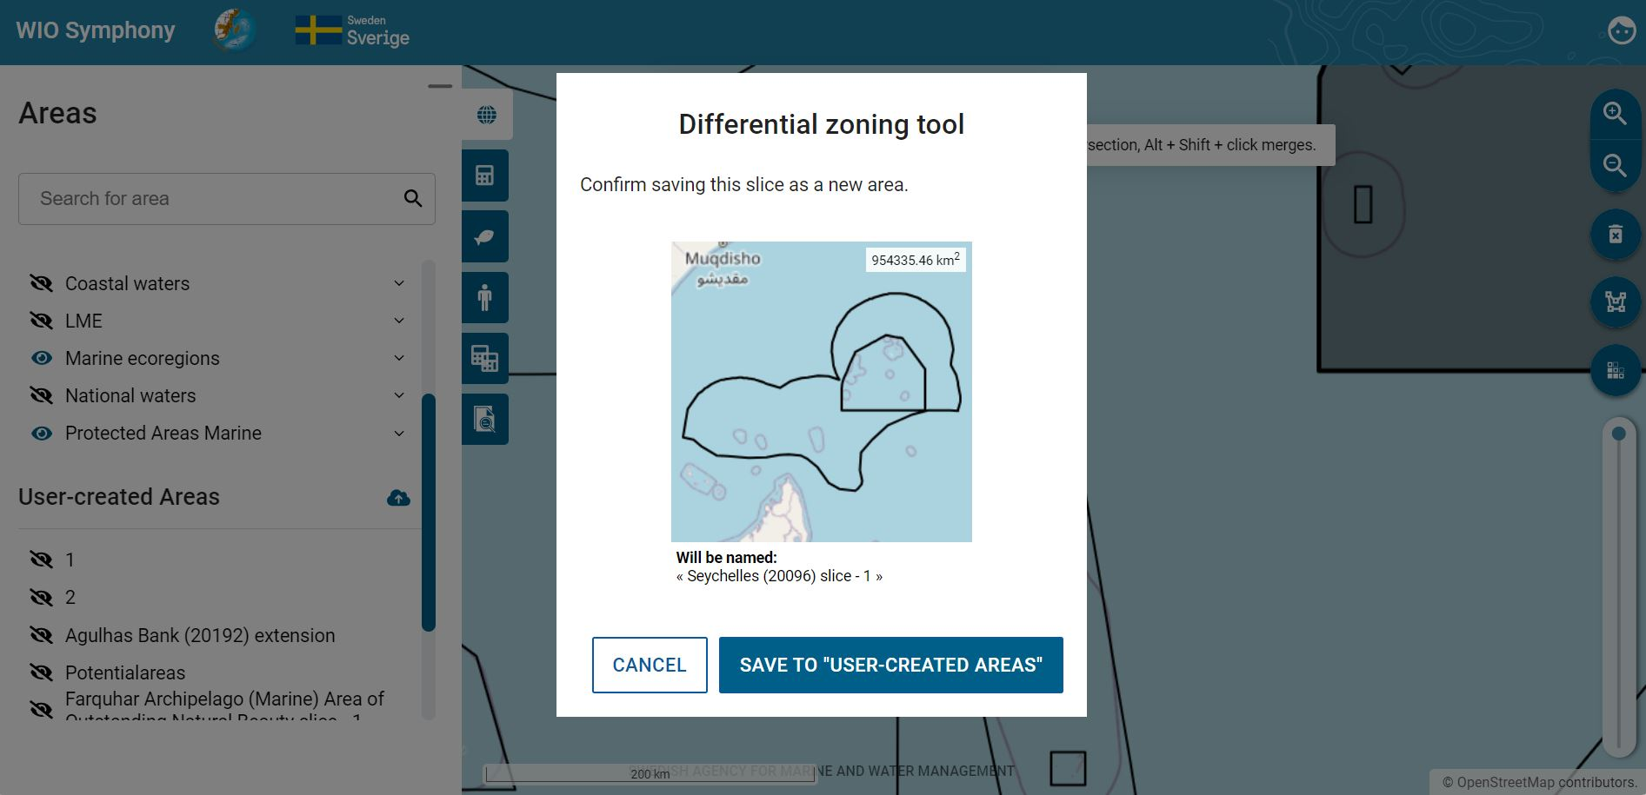
You will see the new polygon with the inner area cut out. You can also rename it by using the 'Edit area' option.
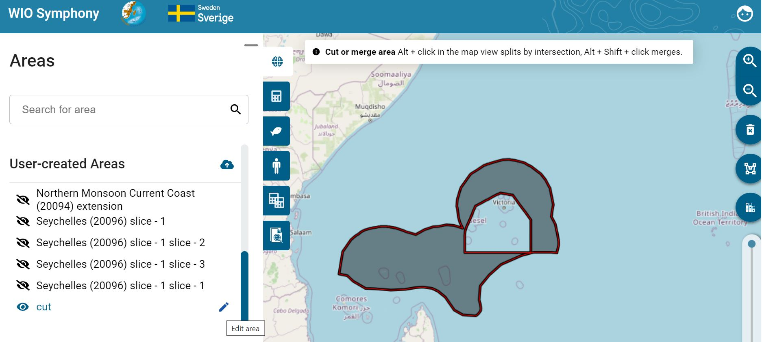
To split a larger polygon into smaller areas, select the larger polygon, then hold Alt and click on the smaller polygons that intersect or overlap with it to activate the Differential Zoning tool. Ensure that the areas you want to split have sections that intersect, overlap, or fall within the larger polygon.
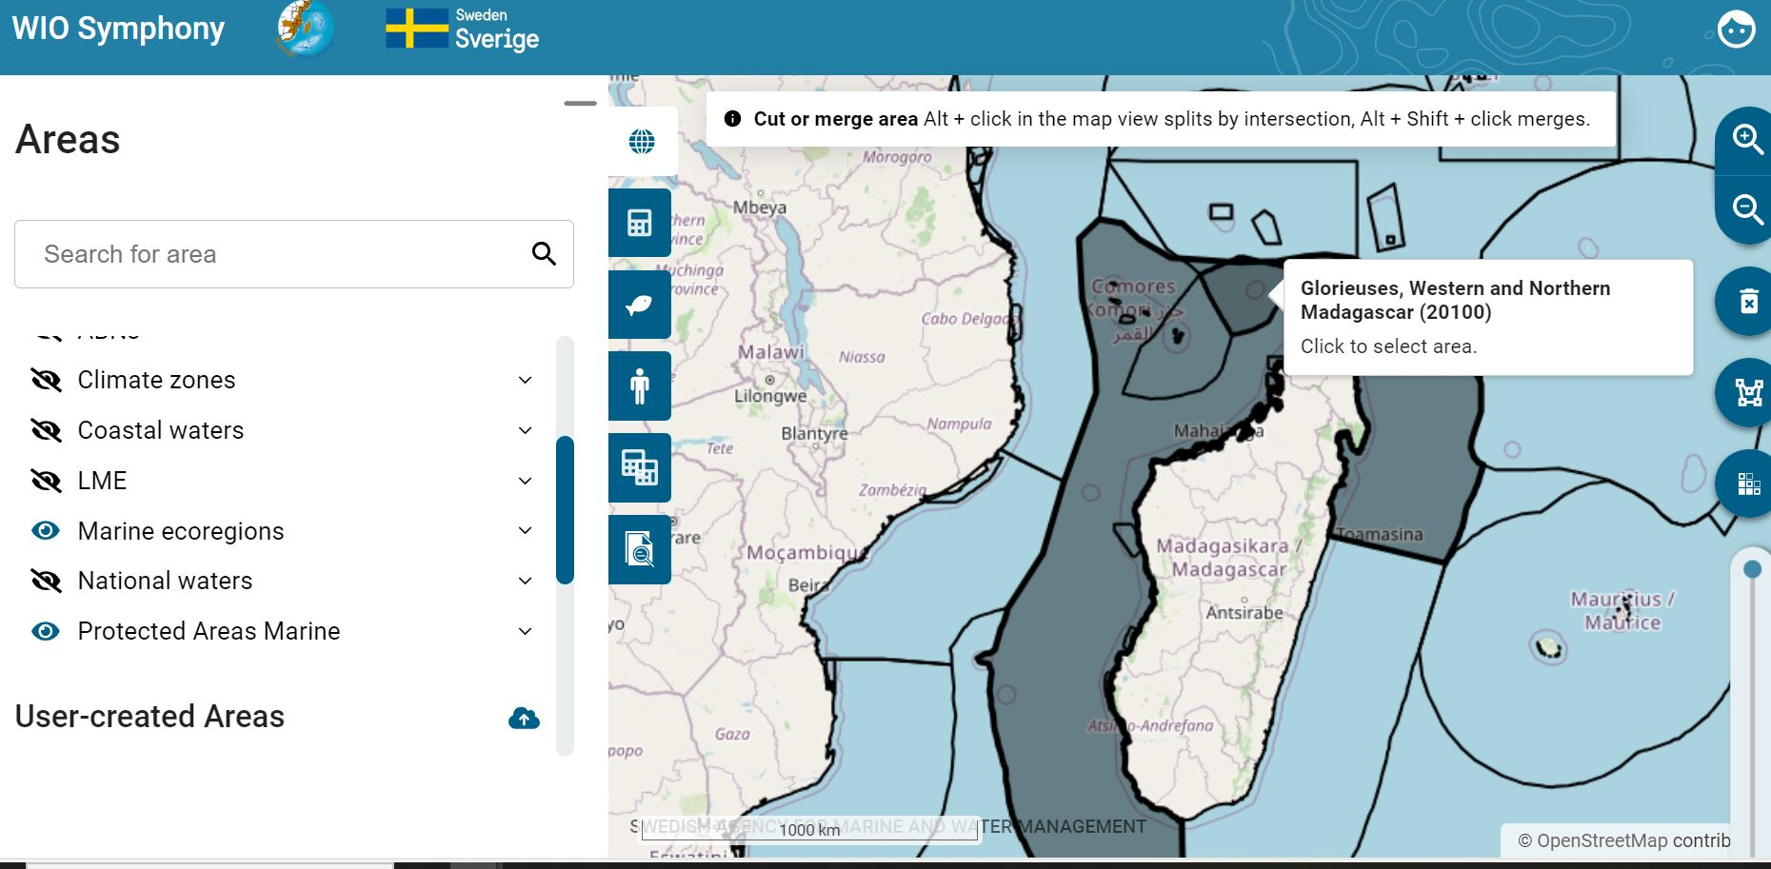
Additionally, in the dialog box within the Differential Zoning tool, an intersecting area may provide more than one slice to save as new areas, depending on how it overlaps with other areas. You can enable specific polygons to be saved as new areas by ticking the checkboxes in the top left corner. Refer to the figure below for the available options.
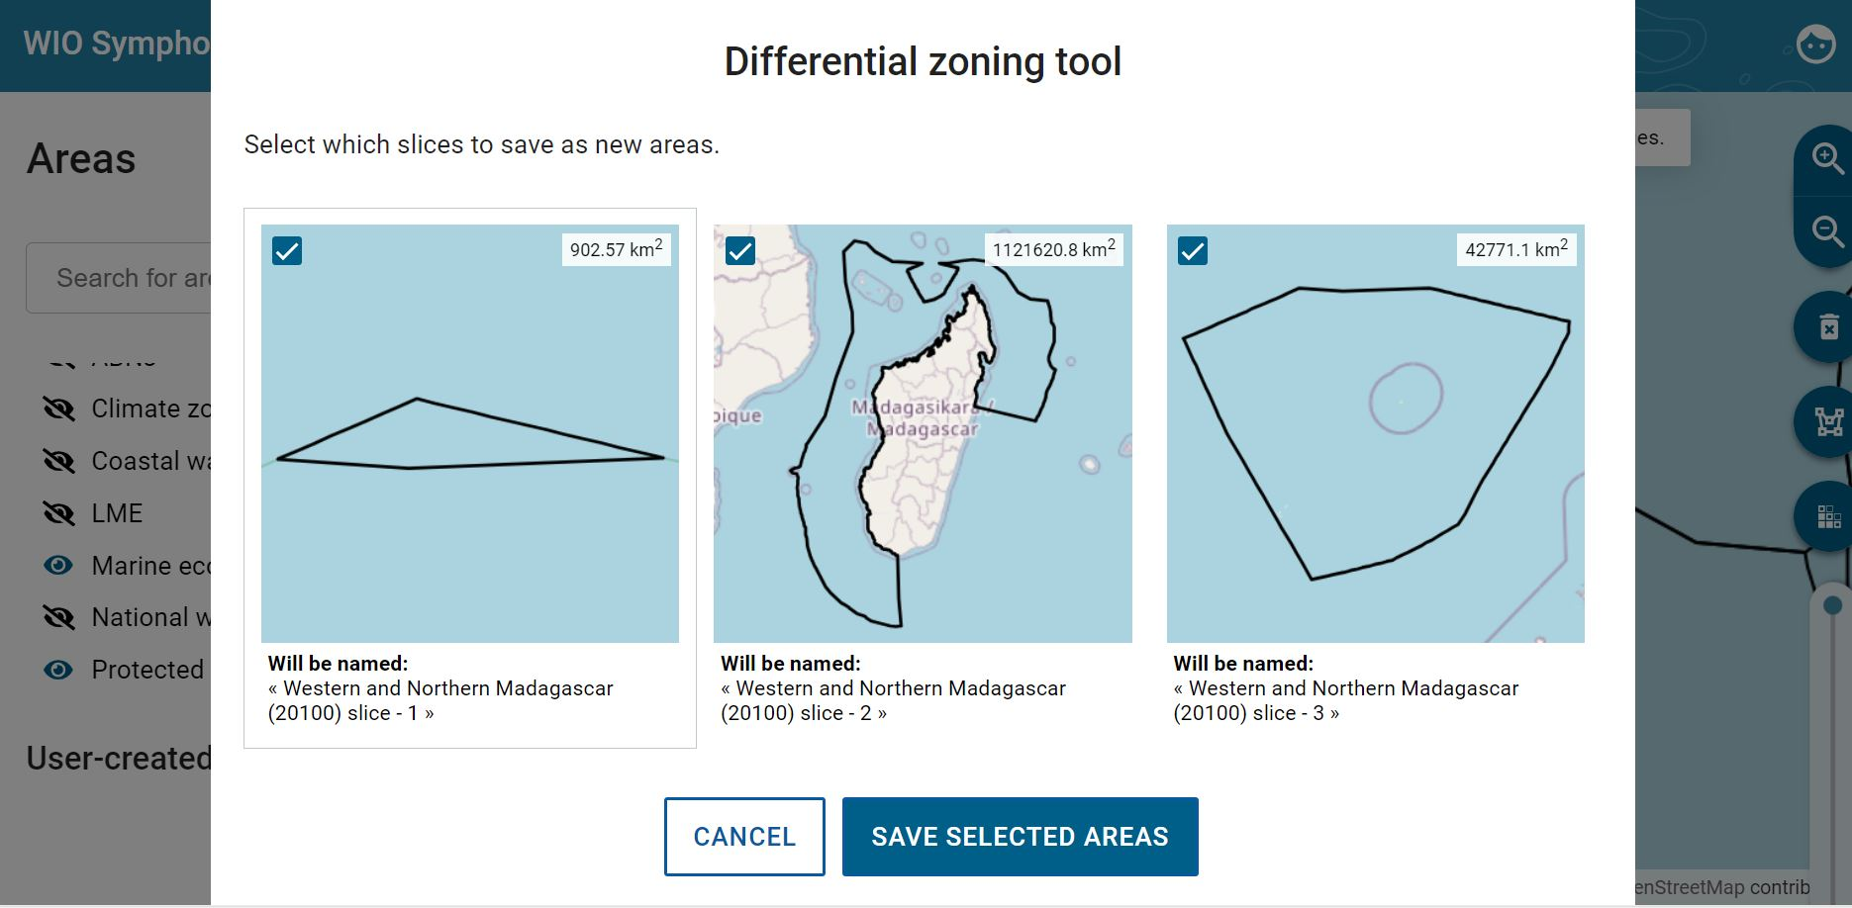

5.12 Analyse several polygon areas
With the merge and split polygons functionalities described in chapter 5.10, the tool allows scenario analyses of spatial extents spanning multiple calculation areas, and for different areas within the same scenario to have separate sensitivity matrices. This enables the option to create a proper MSP, by including all areas that the plan encompasses, and use this function to apply area specific changes according to the MSP. Hence, the user can compare this MSP with another if the same areas are used, but with different changes.
After selecting two or more polygons, go to the Scenario tab  press button. This leads you to the user interface seen below. Here we can go back to the Pressures tab and do changes to our scenario, such as adding Diving with a 10 constant, increasing the diving tourism in all
three areas.
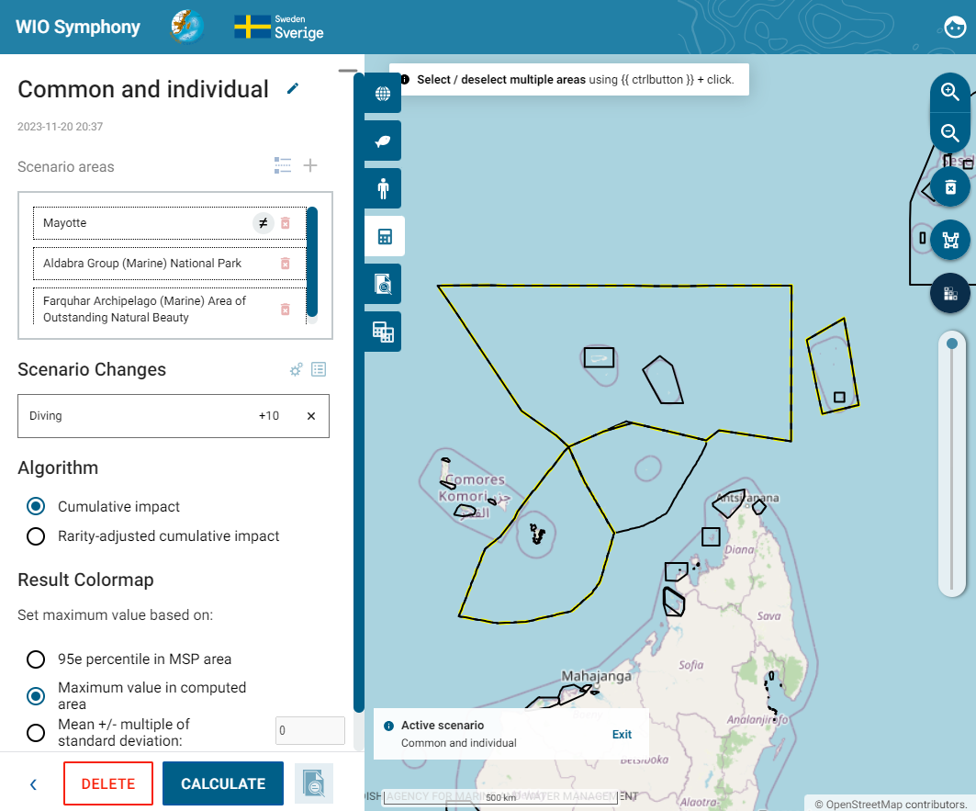
Going back to the Scenarios tab, you can click either of the three areas in the “Scenario areas” list, and you will enter that specific area, where you can afterwards go to the Pressures tab and make other changes, but just to that area and not for all three. Each scenario may apply the same general changes that were set for the original scenario, as well as specific changes, if any. Let us say that in Mayotte, we want to increase Algae farming by 10%. Remember to tick the Override group setting to make sure this change is only for Mayotte. There is also an option here to RESET and remove the changes made in this specific area of the whole scenario.
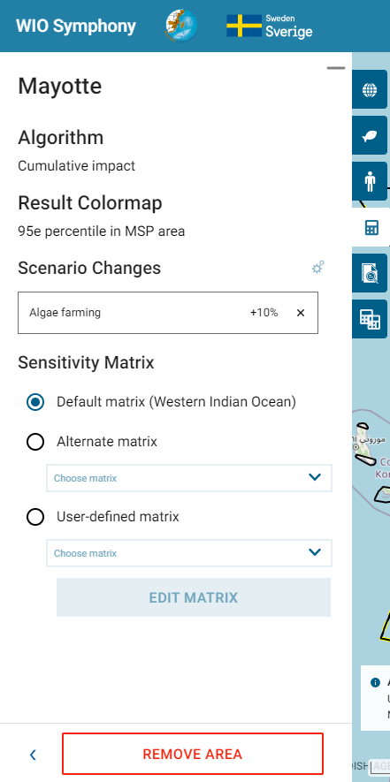
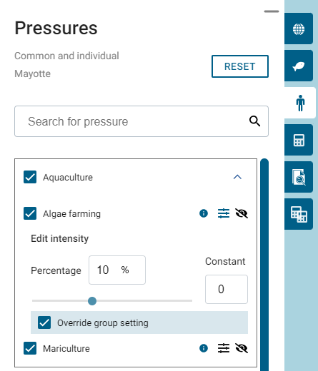
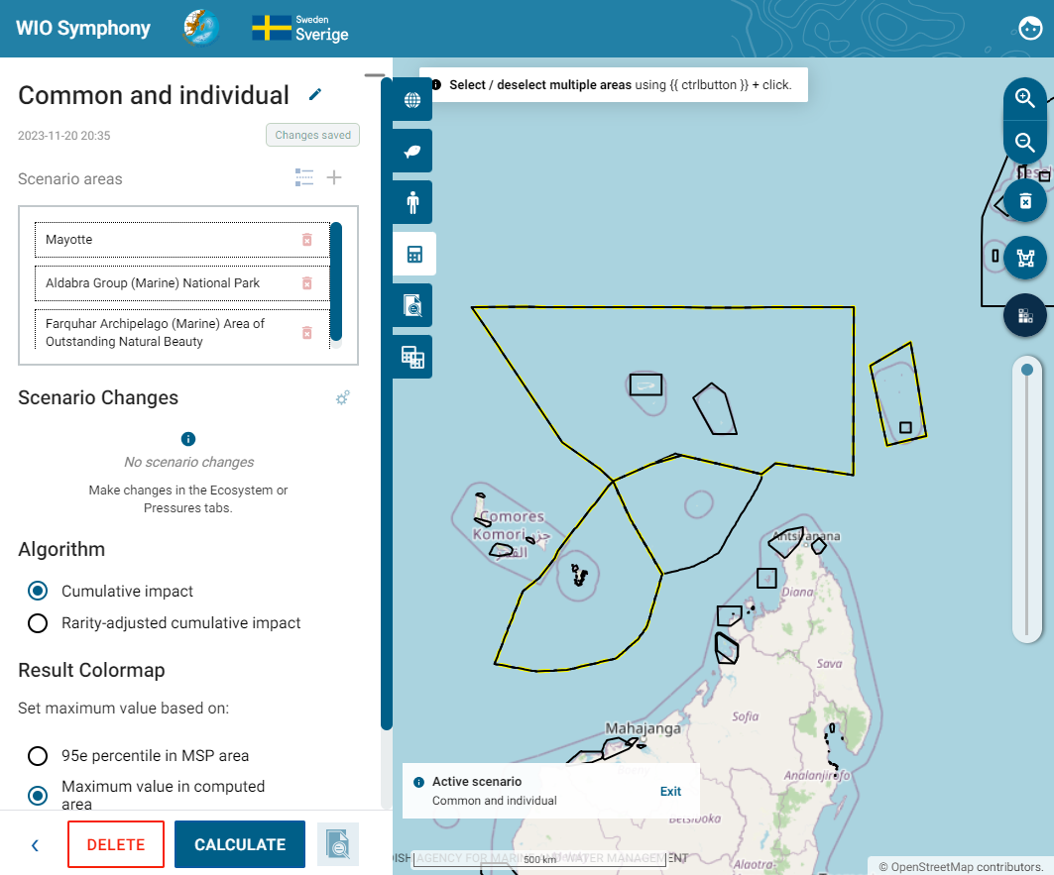
As stated in the beginning of this chapter, you may set separate sensitivity matrices to different areas within the same scenario, seen in the figure to the right.
Returning to the Scenario tab, a table overview of your changes can be seen by clicking the Show an overview of all changes button. This table view the general, so-called Global changes for all areas, and the individual ones. See figure below.
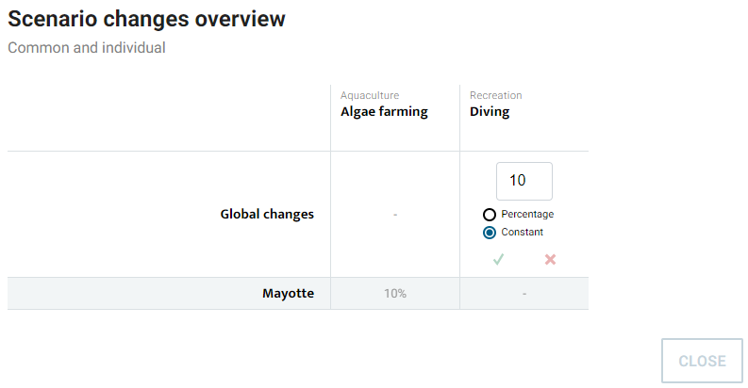
When all settings you wish to apply are done, you can run the analysis for the whole scenario, which includes all areas and you will get a report of the scenario.
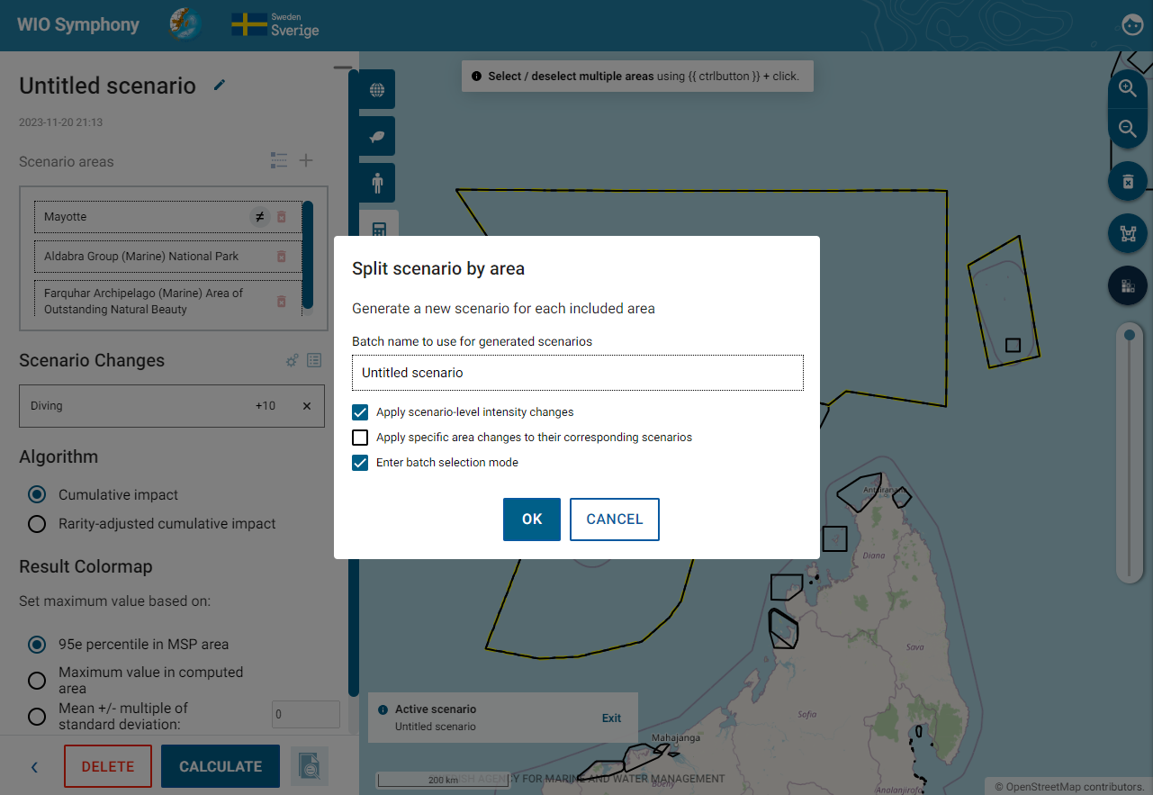

5.13 Batch analysis
This function enables multiple analyses to be conducted at the same time and also for using Split calculation in different areas.
Start by selecting a few polygons that you want to include in your analysis using Ctrl + click. Then go to Scenarios Tab and click + sign. You can activate the batch analysis by clicking on Multiple area action.
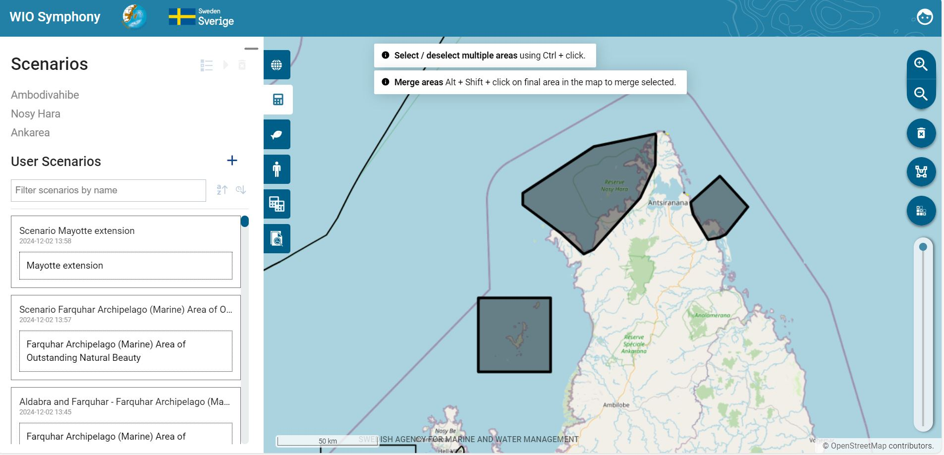
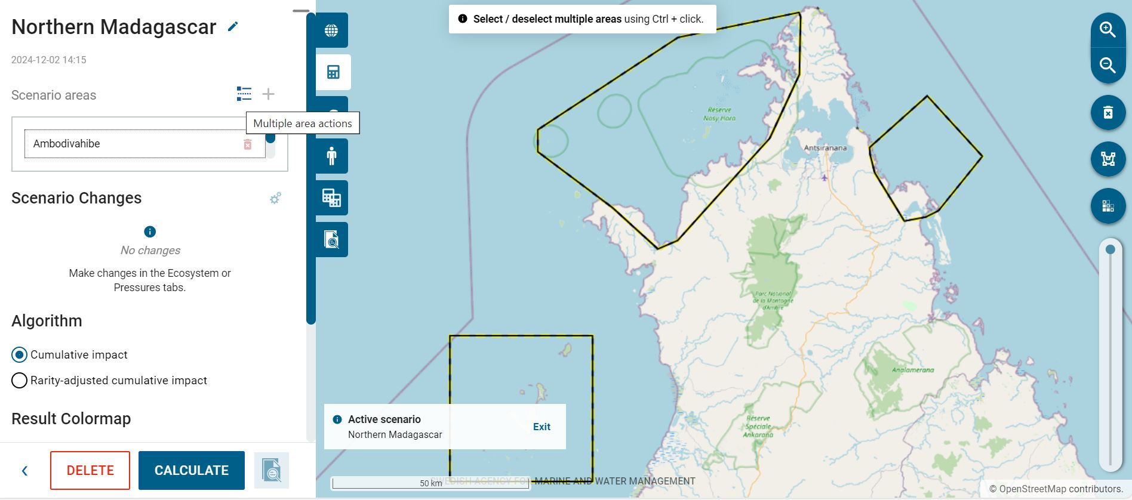
Then there will be a dialog box coming up, make sure to tick all the boxes and press CALCULATE. After that you will see the Completed batch calculation in the bottom right corner. Each report will show each cumulative impact analysis result for each of the selected areas; Ambodivahibe, Nosy Hara and Ankarea.
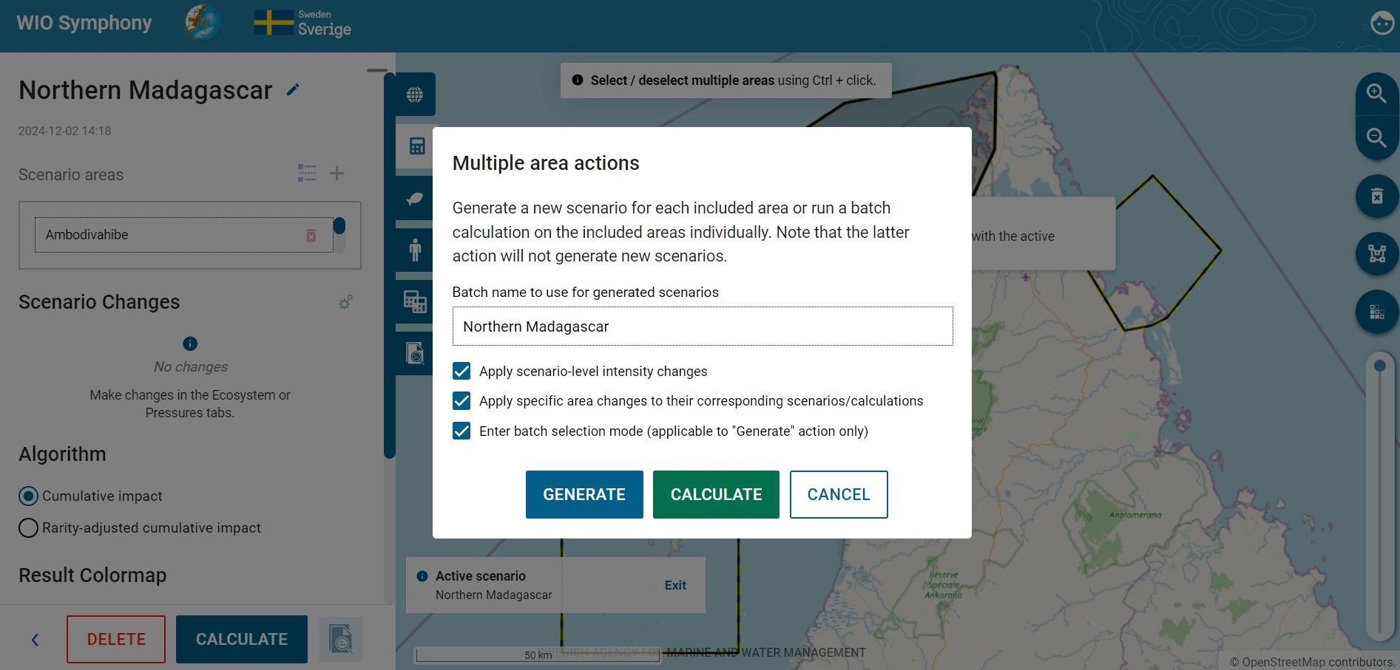
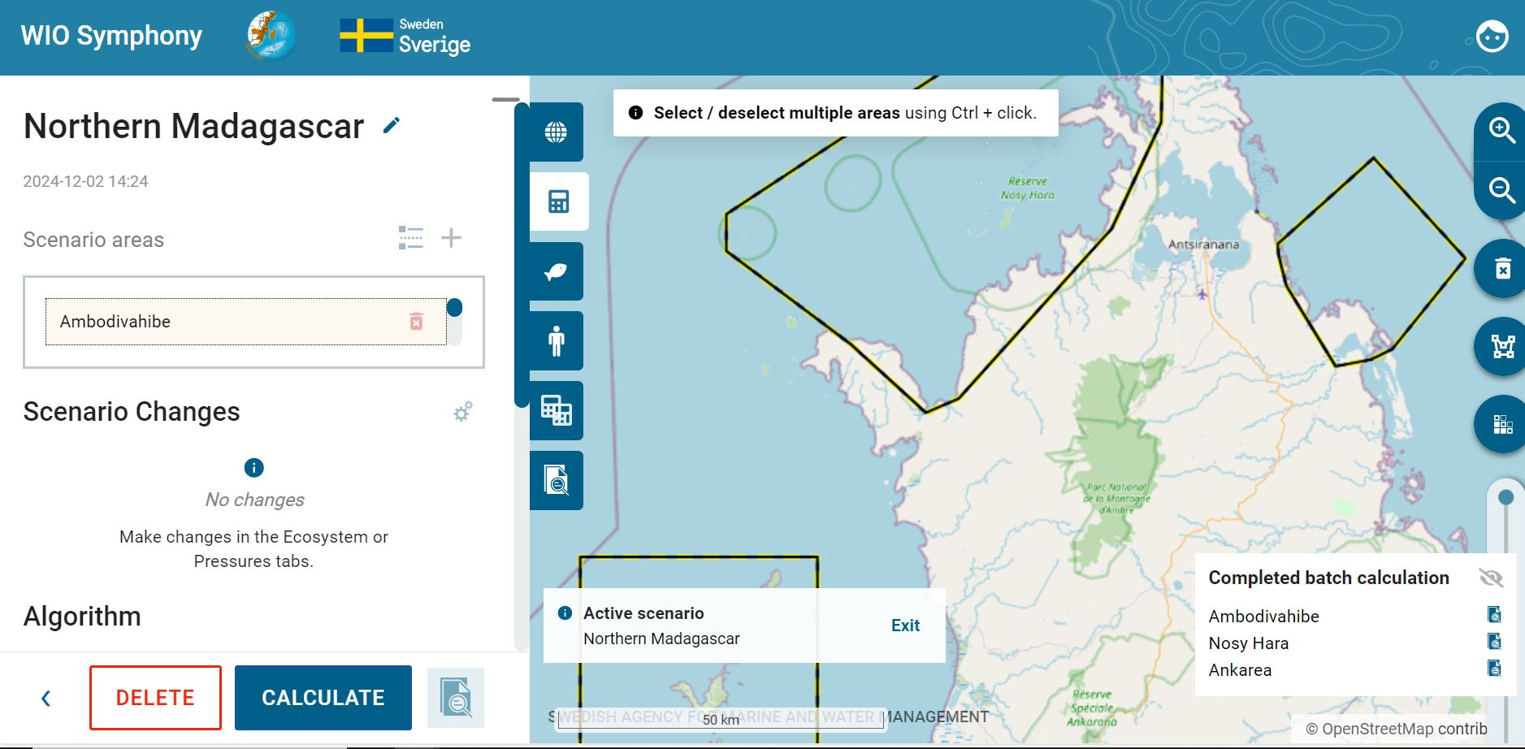
If you do not want to run your analysis for the whole scenario, you can click the Split scenario by area button. A dialog box will pop up. Name your batch to use for the generated scenarios and tick the boxes you wish to apply. The first one applies changes made for all areas within the scenario. The second applies the specific area changes made to their corresponding scenarios. The third lets you enter the batch mode, which will be described in chapter 5.12. Click OK. If the third box is left unchecked, you will come back to the Scenario tab and may Calculate your scenario. However, if checked, you will enter the batch mode, as described.

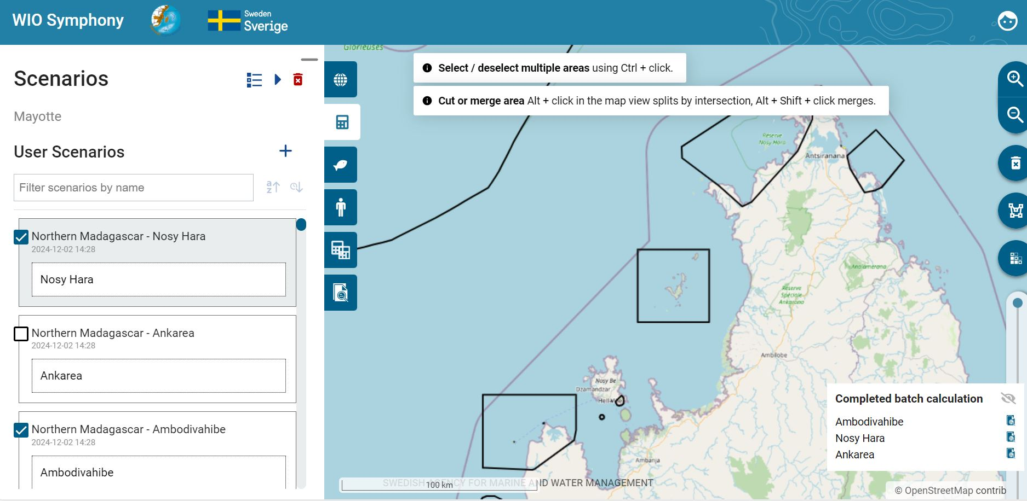
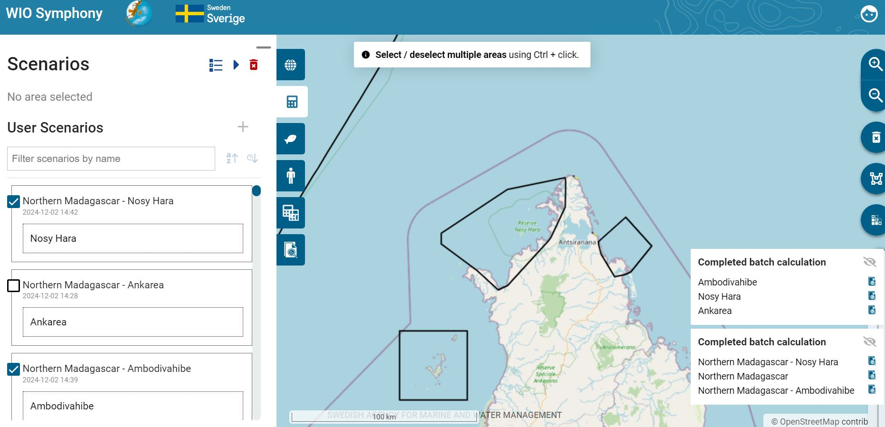
The scenario list view offers a batch mode, allowing multiple scenarios to be queued for sequential calculation. The idea behind it is that you can generate multiple scenarios with common and/or individual settings in one batch. By entering the batch mode by clicking enter batch mode, you will get one report for each area within the same scenario, seen in the figure below down to the right. Press the play button to run the batch analysis. The batch mode is also available directly when moving into the Scenarios tab. From here, you can make a batch analysis of previous scenarios that are in your scenario list. Press the enter batch mode button again to exit it.

6. Further analyses

6.1 MINISYM – analysing individual pressures
Using the same principles as when analysing cumulative impact (chapter 5.5), it can sometimes be useful to focus on a single sector or pressure. These “one-over-many” analyses gives an understanding of the combined impact of that specific human activity alone.
Such focused analysis on only one sector or pressure is labelled as MINISYM.
Select one or several boundary polygons  go to the Scenarios tab  press  go back to the Pressures tab  Deselect all  select only one or a few associated pressures  Go to Ecosystem Components and select all relevant ecosystem components  Go to Scenarios tab and click CALCULATE, which will generate an analysis as described in chapter 5.5 and 5.6.
Mind that you may have to open the pressure categories (sectors) to untick the underlying pressures, even if the category appears already unticked.
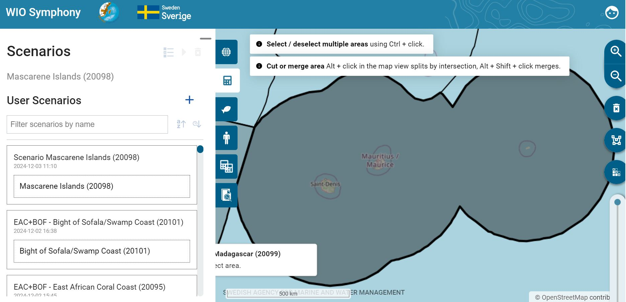
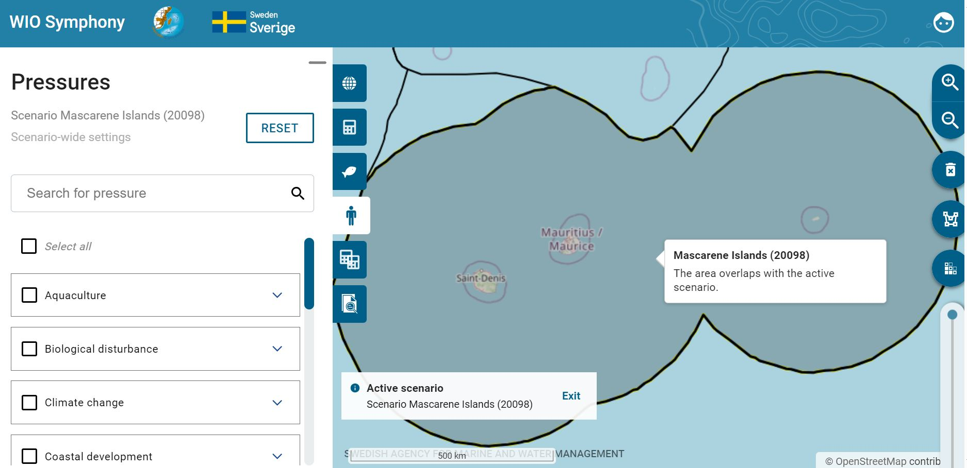
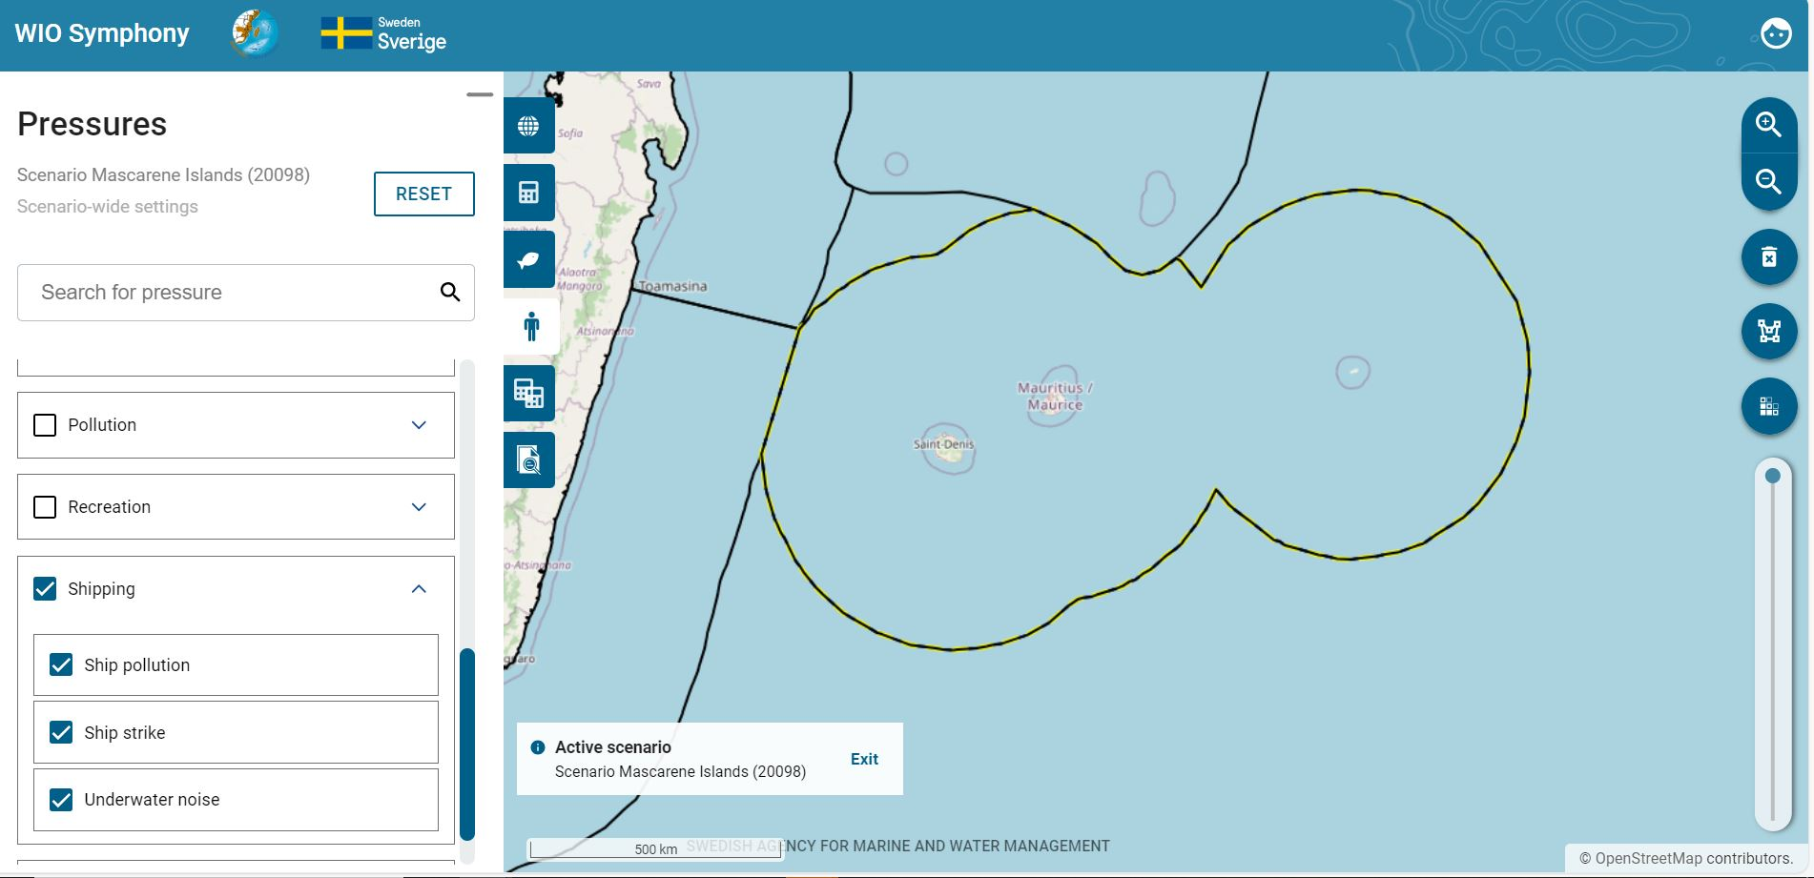
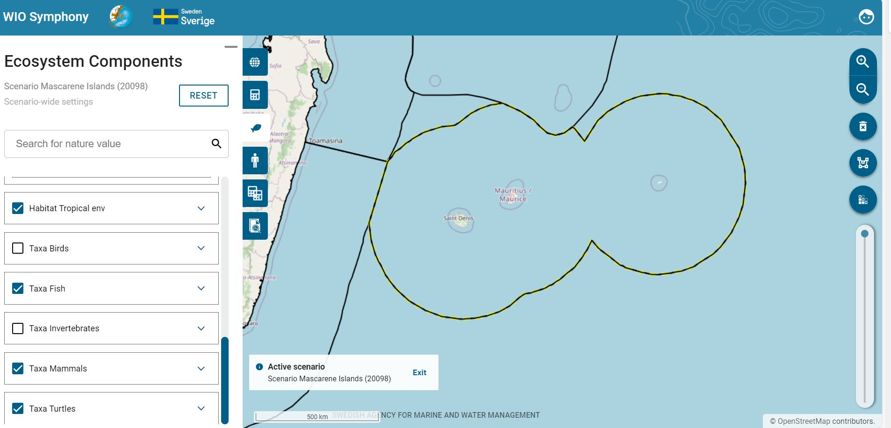
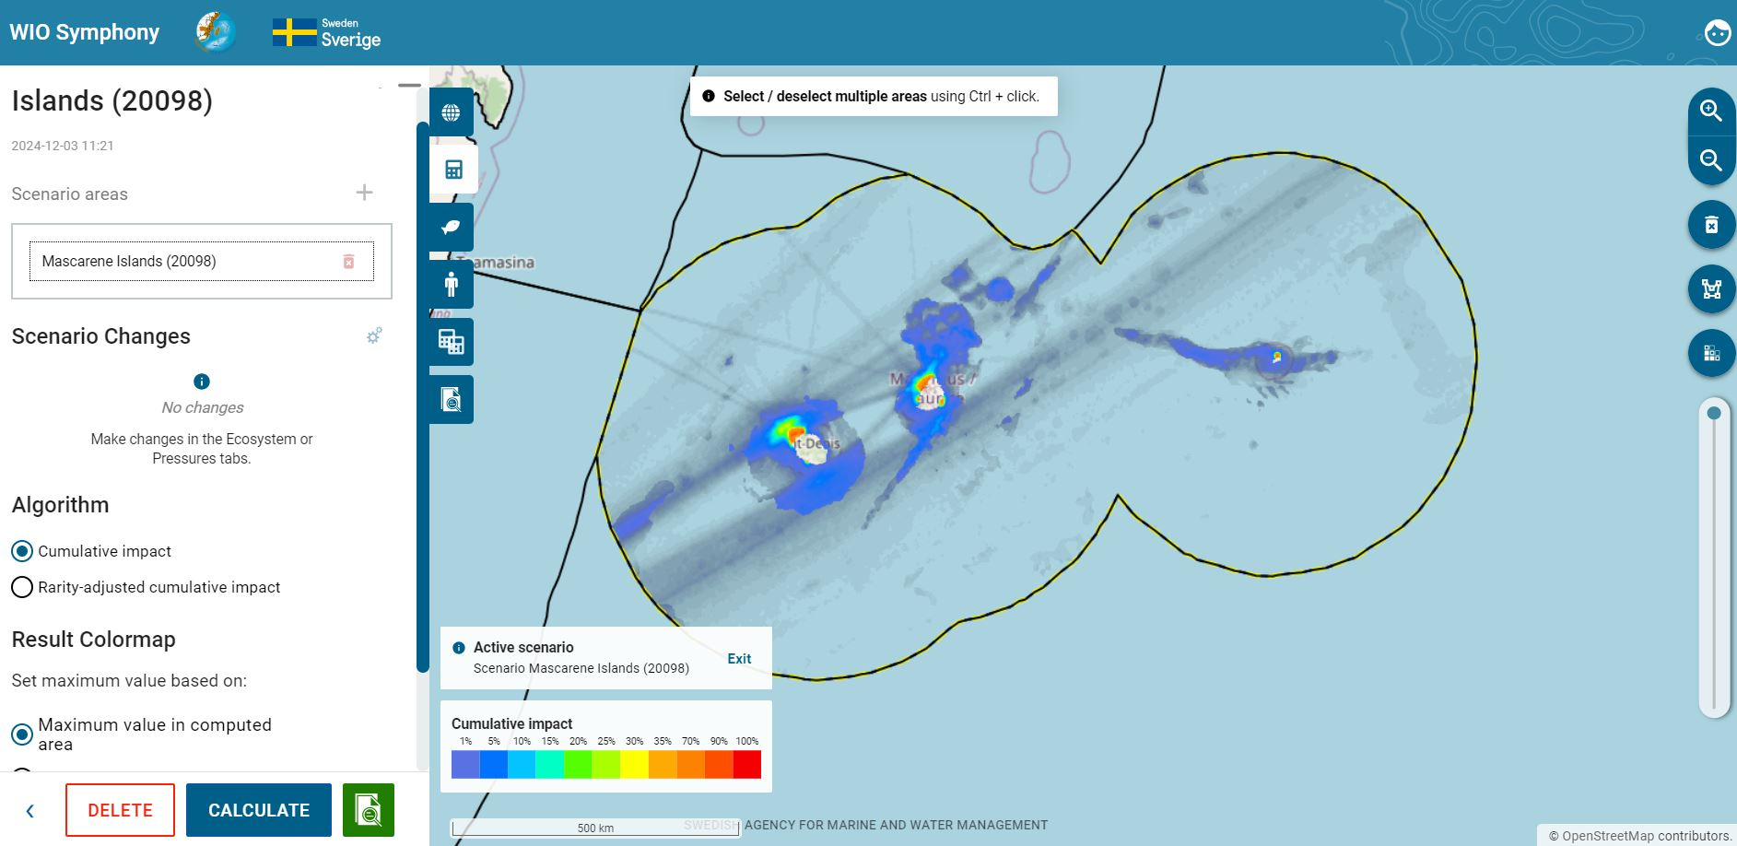
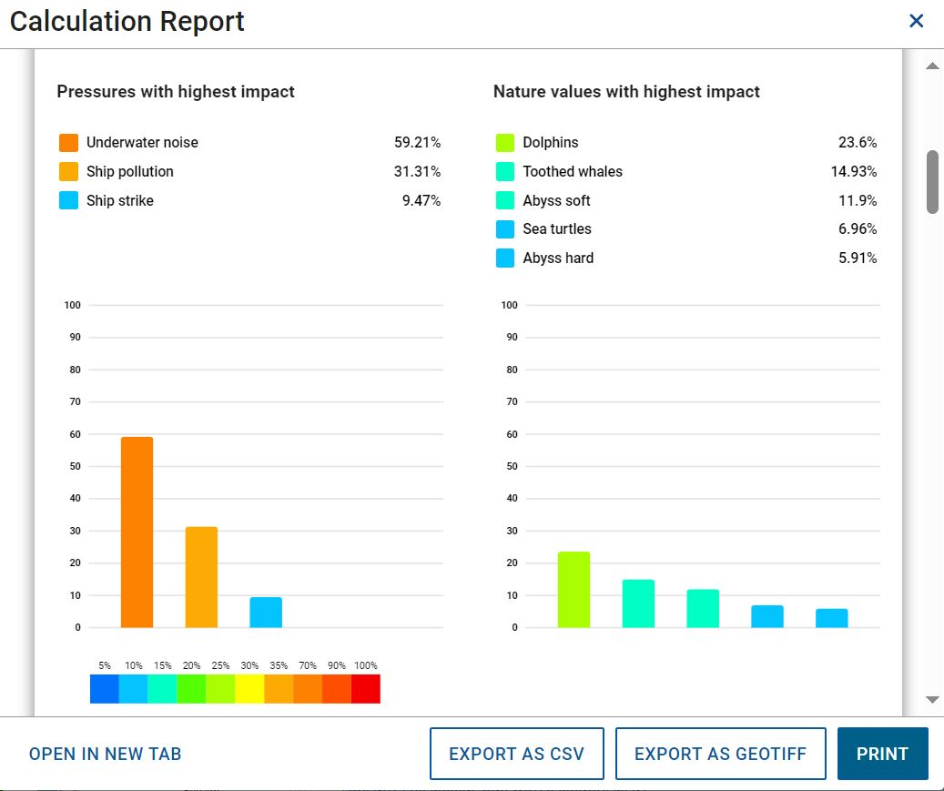
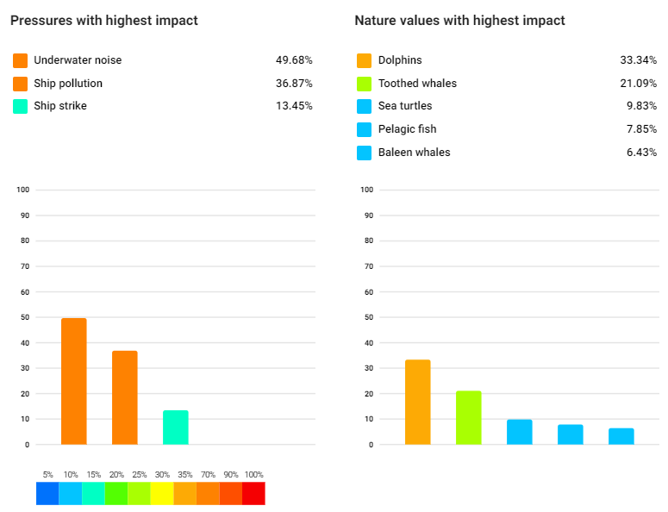
This example of a MINISYM analysis for shipping pressures around the Mascarene Islands, including Mauritius, Réunion and Rodrigues, included only taxa and no habitats. The result indicates that the shipping industry predominantly affects Dolphins and Toothed whales, but also Sea turtles, Pelagic fish and Baleen whales to some extent. Whether the impact is strong enough for action to be taken, it cannot be concluded by this analysis alone, since the impact score is a relative index. Deeper analysis into pressure levels and sensitivity scores can help: 6.1 MINISYM – analysing individual ecosystem components.
In a similar way as above (chapter 6.1) it can be relevant to analyse how all pressures combined affect a single ecosystem component. With this “one-over-many” analyses, you get a screening of the major threats to a specific habitat or taxa of interest in your area.
Select your boundary polygon  go to the Scenario tab  press  go back to the Ecosystem components tab  Deselect all  select only one or a few associated ecosystem components  Go to Pressures and select all relevant pressures  Go back to Scenarios and click CALCULATE which will generate an analysis as described in chapter 5.5 and 5.6.
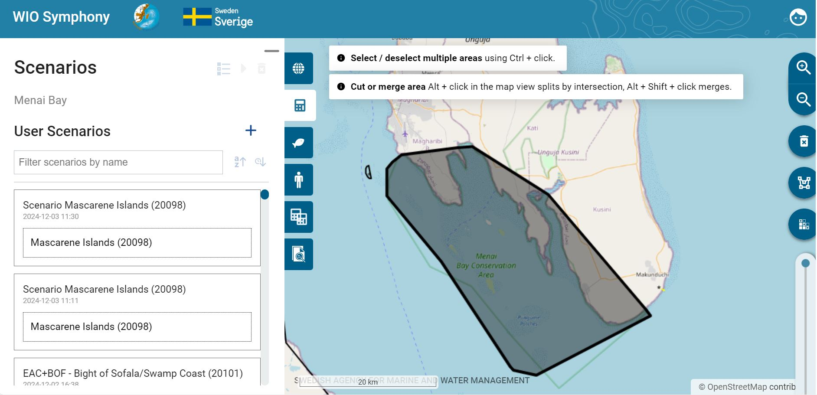
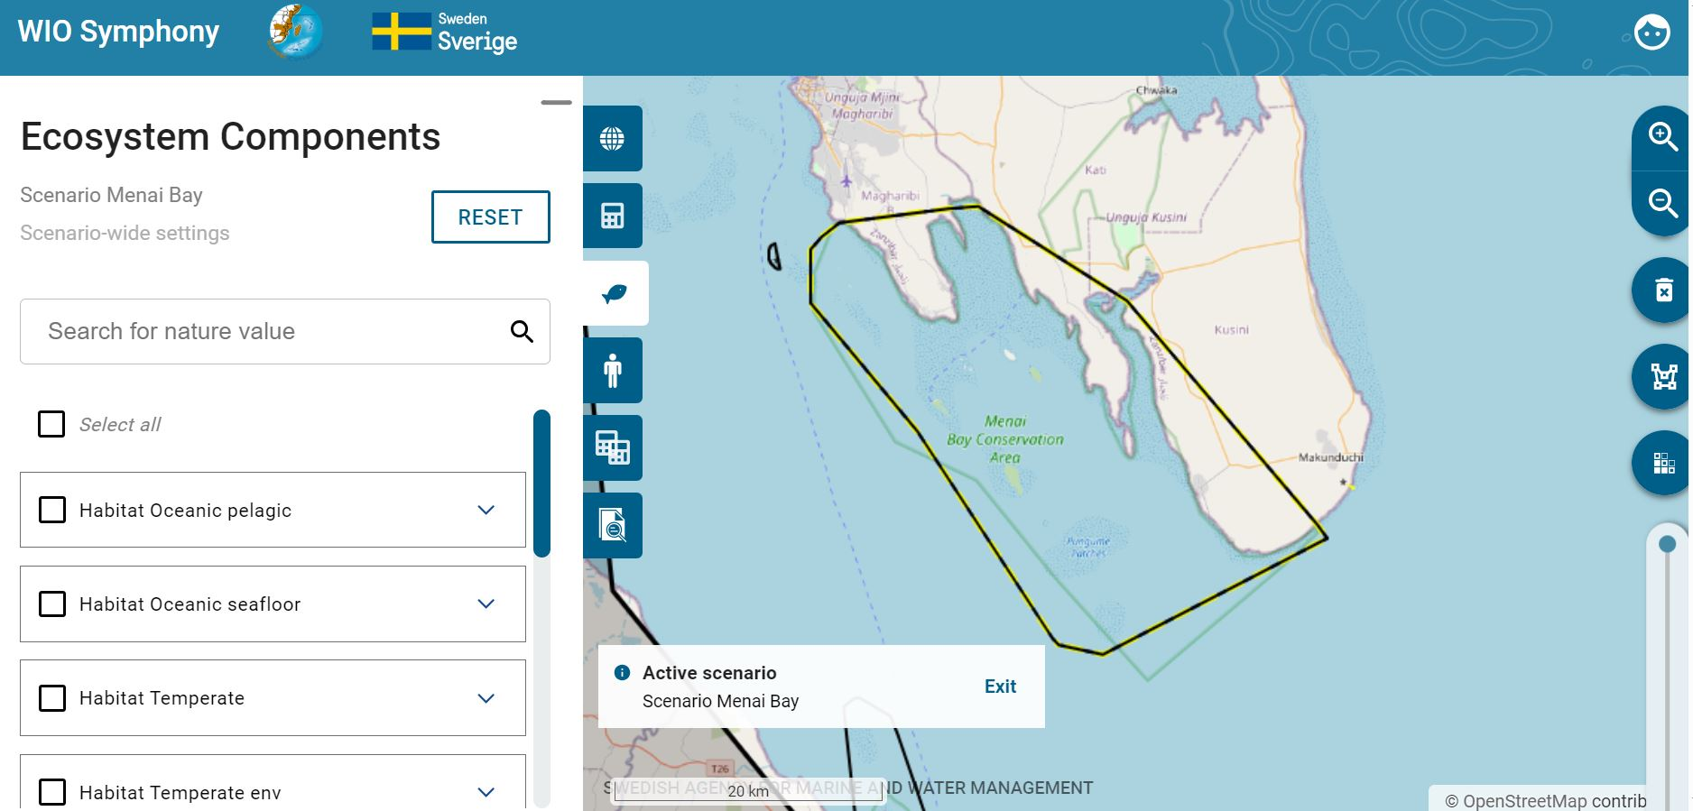
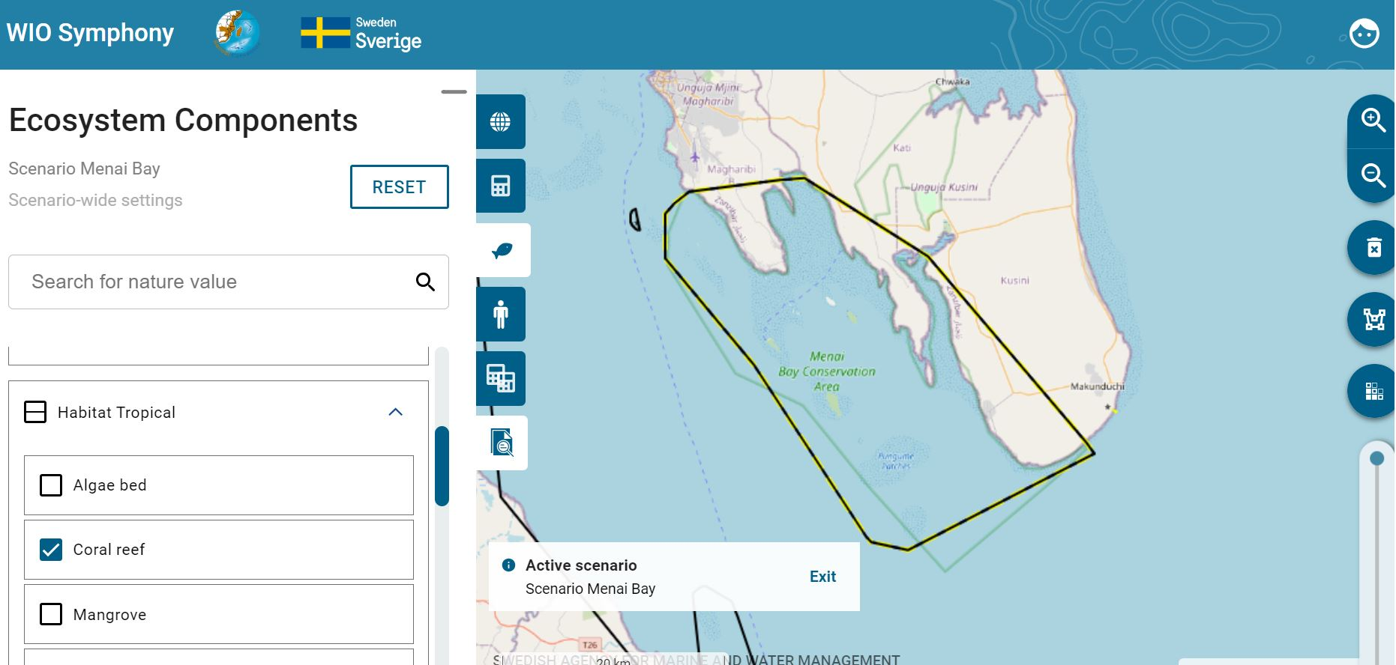
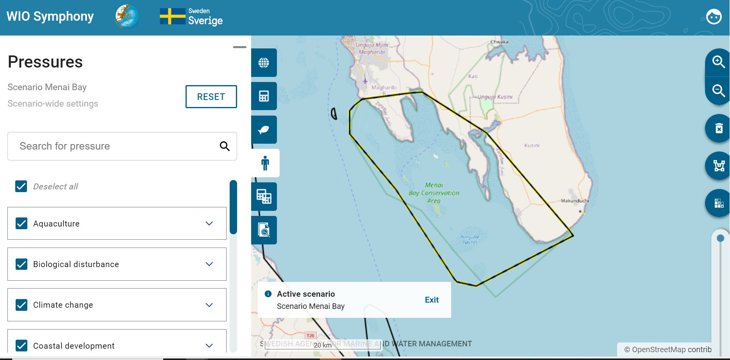
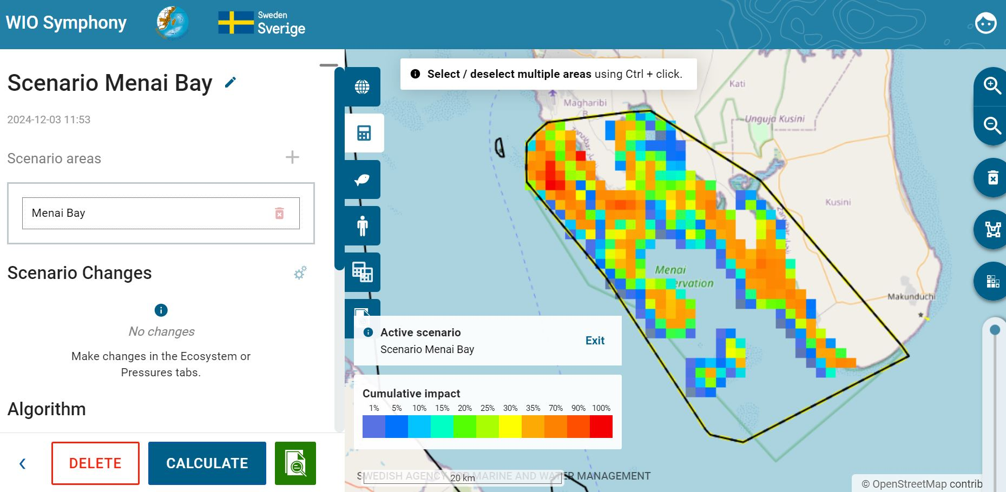
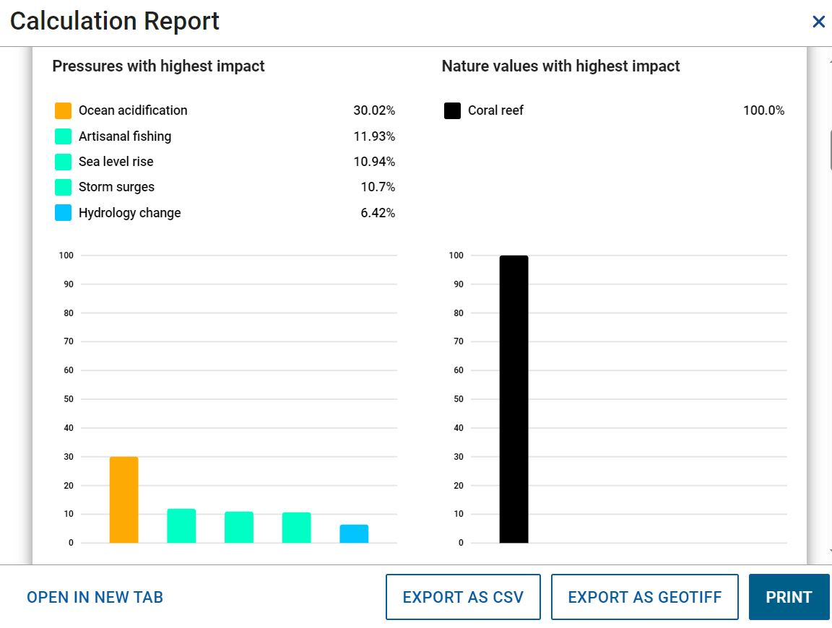
This example of MINISYM shows results for Coral reef of Menai Bay on Zanzibar and indicates that this important habitat is most affected by Ocean acidification, Sea level rise
and Artisanal fishing.

6.2 Rarity-adjusted cumulative impact
Rarity-adjusted cumulative impact considers how rare or common the ecosystem components are. In contrast, ordinary cumulative impact often highlights results dominated by common ecosystem components, which make sense because these involve more organisms being affected. However, from an ecological perspective, it can be more meaningful to assess how much is lost in relation to how much remains. This approach focuses on the impact per remaining habitat or population.
In WIO Symphony, the Rarity-adjusted cumulative impact algorithm calculates the impact for each ecosystem component then divides the total impact by the ecosystem component’s total coverage. This results in much lower impact scores compared to ordinary cumulative impact scores, which often reach into the thousands. Therefore, the two type of ordinary- and rarity-adjusted impact scores, cannot be directly compared by numbers. However, their relative differences are comparable, and both methods provide valuable information for management
and planning.
To begin the comparison, start with calculating an ordinary cumulative impact assessment. Select your boundary polygon  go to Scenarios tab  press the plus button  rename your scenario with prefix “Ordinary”, select Cumulative impact algorithm  press CALCULATE.
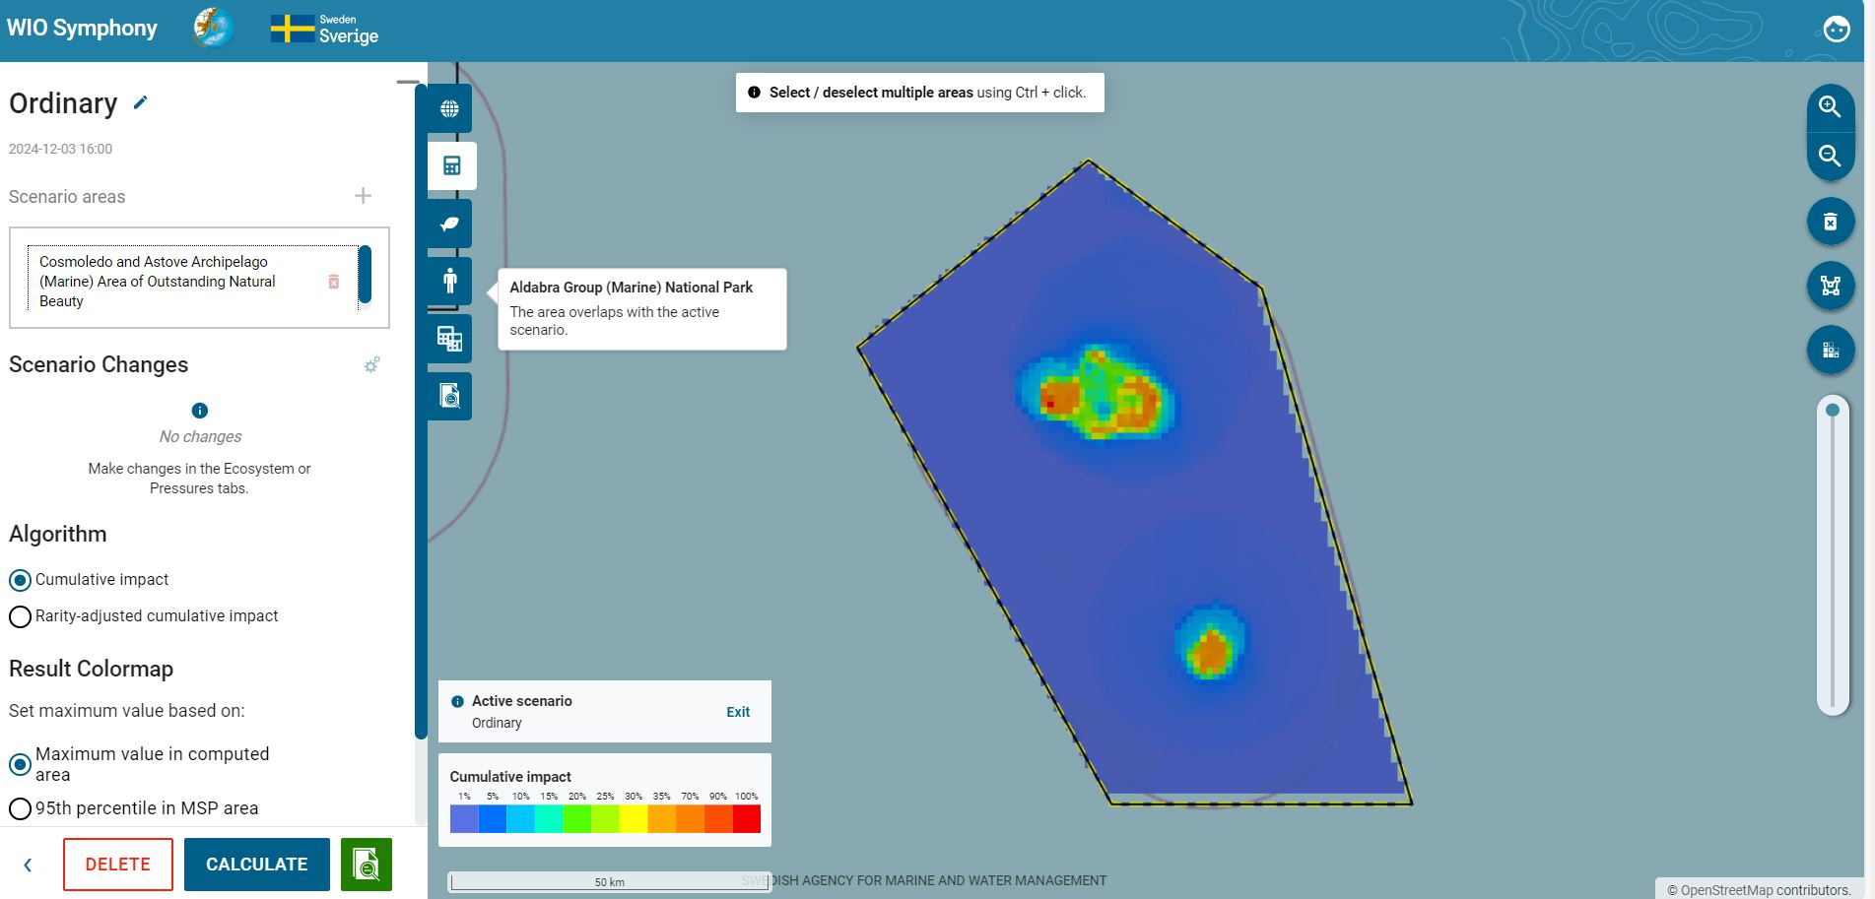
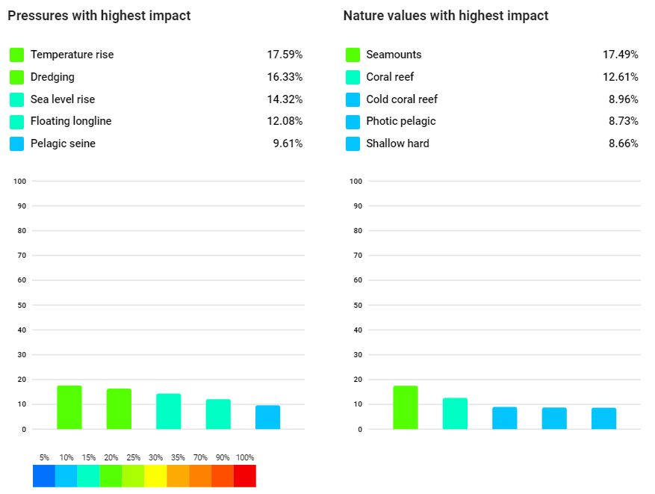

Select the same boundary polygon  go to Scenarios tab  press the plus button  rename your scenario with prefix “Rarity”  choose the algorithm Rarity-adjusted cumulative impact  press CALCULATE. When enabling the Rarity-adjusted cumulative impact, you get an option to choose between two alternatives under Calculate rarity indices based on. Data grid extent calculates rarity based on the Whole grid, and Calculated area extent is based on the
scenario area.

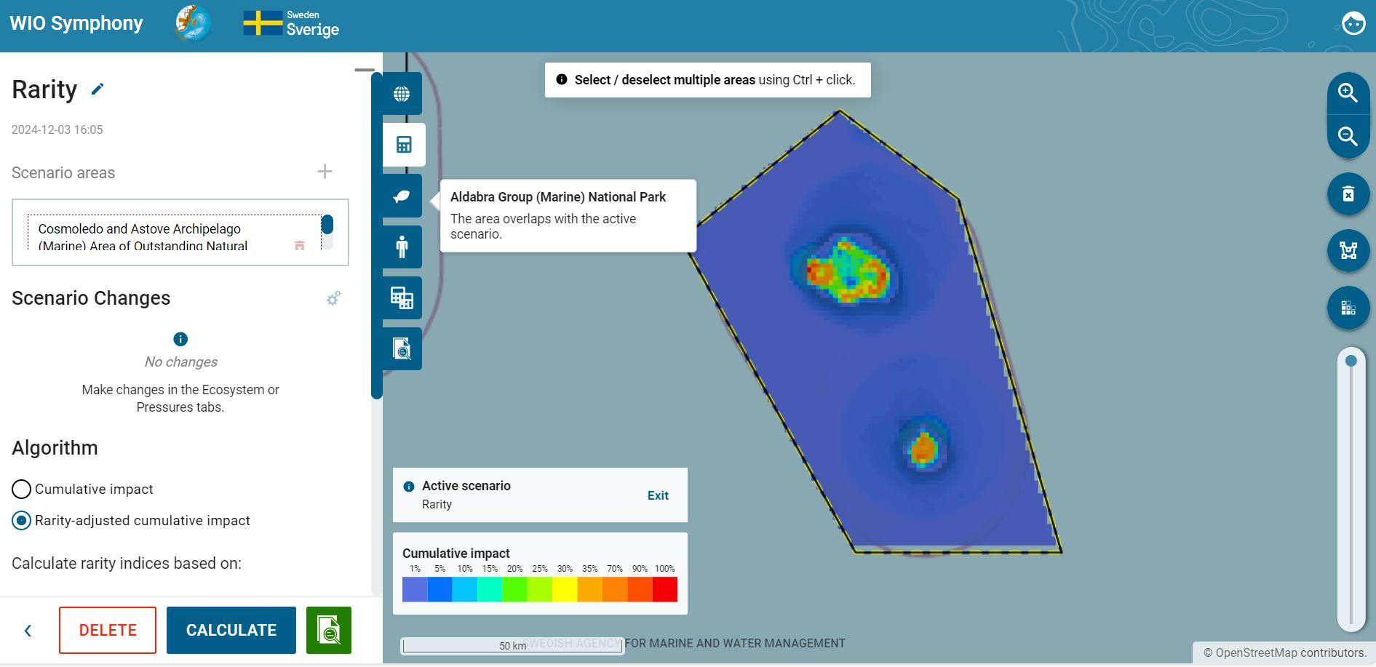
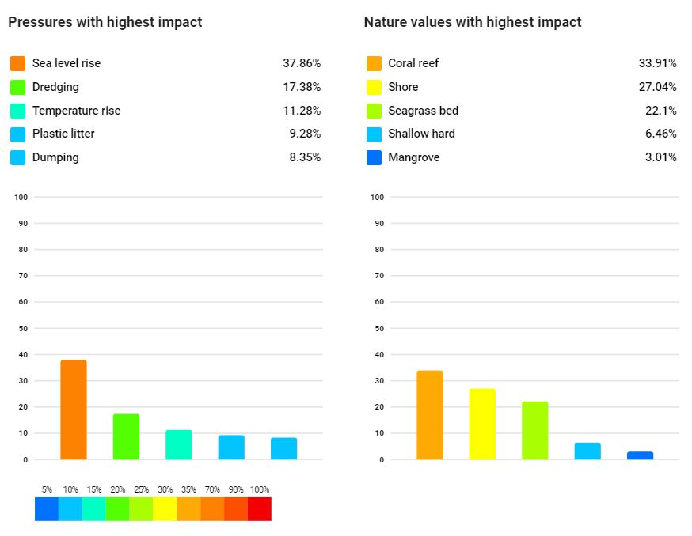
Comparing the two analyses, you can see several differences. For instance, the colour map is more confined with high impact in coastal stretches and all of the top-five impacted ecosystem components are coastal (including the new Shore, Seagrass bed, and Mangroves) when Rarity-adjusted cumulative impact is applied. Interestingly, coral reef and shallow hard remains in the top-five impacted ecosystems, regardless of which algorithm that was used.

6.3 Screen for Suitable Locations for new activities
WIO Symphony can be used for overview assessment (screening) of suitable locations for new activities. Such analyses can be quite informative for early stages of MSP or other development plans.
The principle is to add pressure scores to each pixel in the area of investigation, by using the Constant field (see chapter 5.8, bullet point 4). When analysing this added pressure in isolation (removing all other pressures), the resulting colour map will give indications of areas with high and low cumulative impact, where areas of low impact would be more suitable locations for the activity. For example, search for the most suitable locations for coastal seabed mining in an area of your choice.
Select or draw a boundary polygon representing the area in which the new activity could be located  go to Scenarios tab  press the plus button  move to the Pressures tab  deselect all pressures except Seabed mining  click on the adjustment symbol for this pressure layer and type value 50 in the Constant field  go back to Scenarios tab  rename your scenario with prefix “Seabed mining”  press CALCULATE.
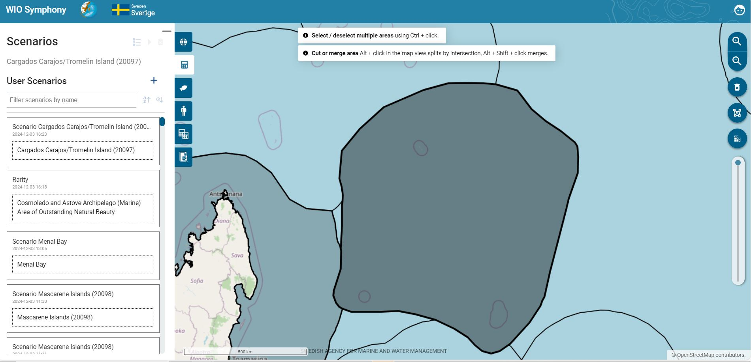
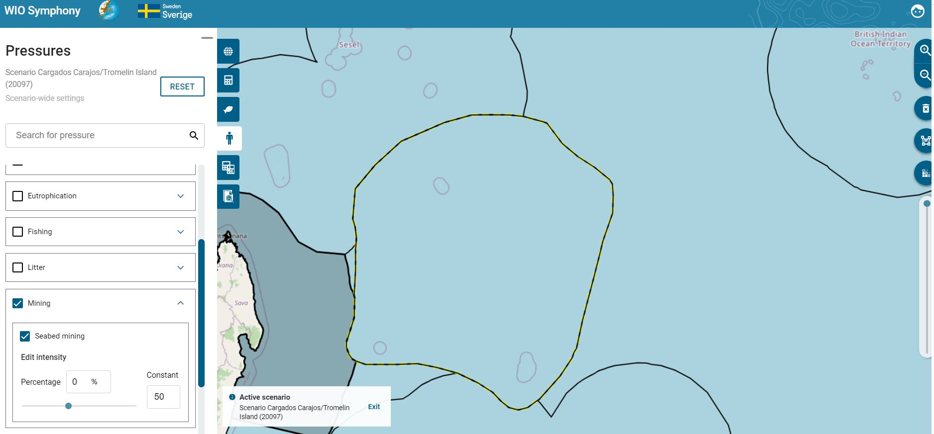
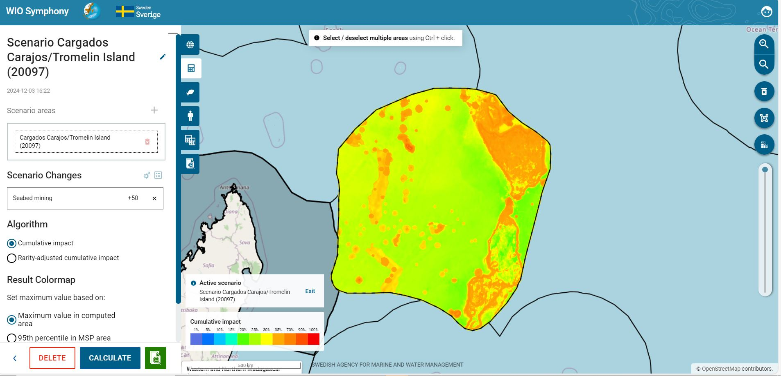
It does not matter how much pressure you add in the Constant field as long as you have no other pressures involved and you use the colour scale with default settings. However, for reference, a value of 50 means that mining with an intensity half of maximum takes place in every pixel (that is, 50% of the area in every 1 km² pixel is subjected to direct harvest of sand or other minerals).

The resulting colour map indicate that greener areas are more suitable for seabed mining, from an environmental viewpoint. Yellow toward green areas would mean substantially lower combined impact compared to dark orange to red areas. According to the colour legend, yellow is 30% of maximum, while dark orange is three times worse with around 90% of maximum.
These results obviously need to be confirmed with other studies before decision making, and it must be stressed that physical, economical, and social aspects are not involved here. Still, this screening can be highly efficient and save lots of resources in directing the search for locations into certain, more promising areas, with regards to the environment.
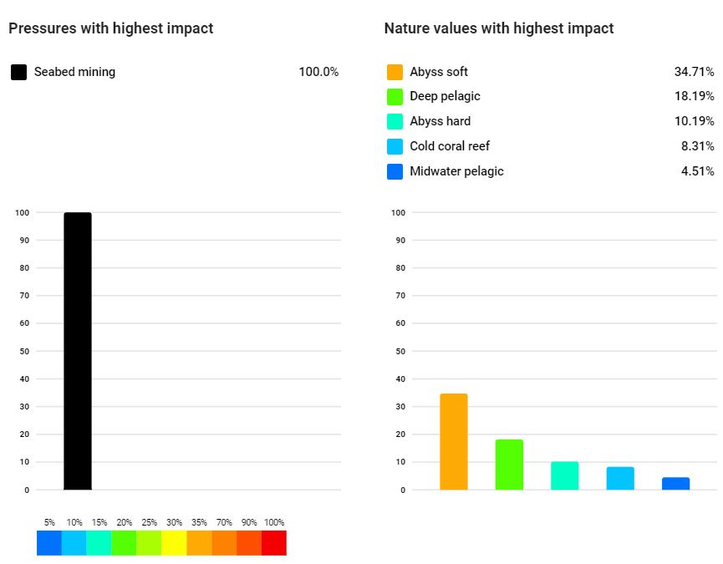

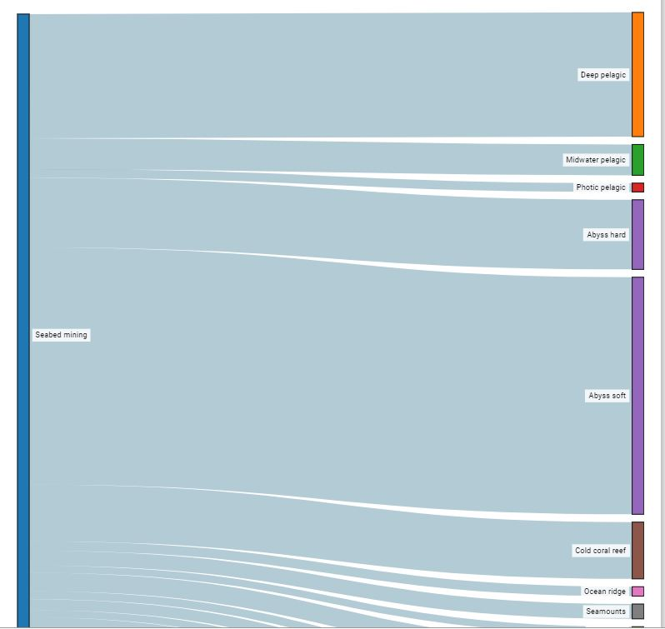
The Calculation Report with the Sankey diagram and table may provide a first idea of expected impacts. But keep in mind that this result is for the whole area, whilst not only in the most suitable parts of the area. Additional analyses can be computed for the suitable locations, to learn more.

6.4 Choose and Edit Matrix
The default matrix is the standard. However, there is an option to choose between different preloaded matrices; Revised, Original, or Exponential. When pressing the Scenario area, you can click the Alternative matrix button and choose between the three different ones. Hence, in a scenario with several areas, you can apply different matrices to each area within the same scenario.
Some scenario simulations in MSP can be quite detailed. Perhaps the marine plan proposes to permit continued fishing, but with mandatory by-catch reducing measures. Then, the specific fishing pressure would not be altered or removed, as it is still endorsed and perhaps even increased in intensity. Regulatory changes, or general technical development, can instead be simulated by changing the sensitivity scores. In this case, the sensitivity between, say, artisanal fishing and by-catch ecosystem components such as turtles, rays, sharks, dolphins, and sea birds would be reduced. Perhaps, you may reduce sensitivity with 50% if mitigation expects to be 50% effective.
Select your area of interest  go to Scenarios tab  press the plus button  press on the Scenario area (Chagos)  Scroll down and select User-defined matrix  select which matrix you wish to edit by clicking the arrow button  press EDIT MATRIX.

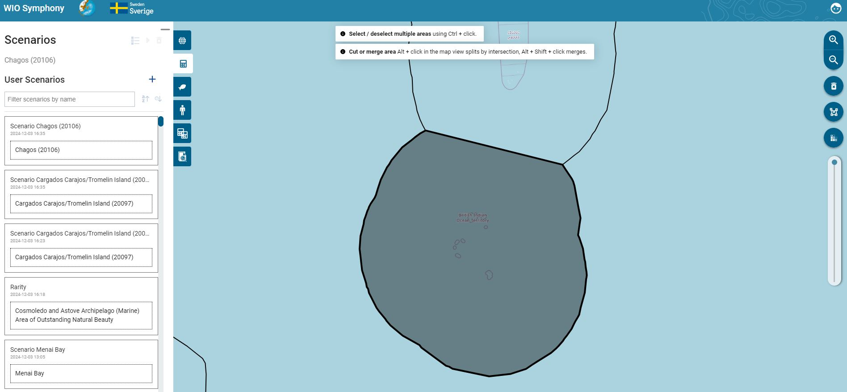

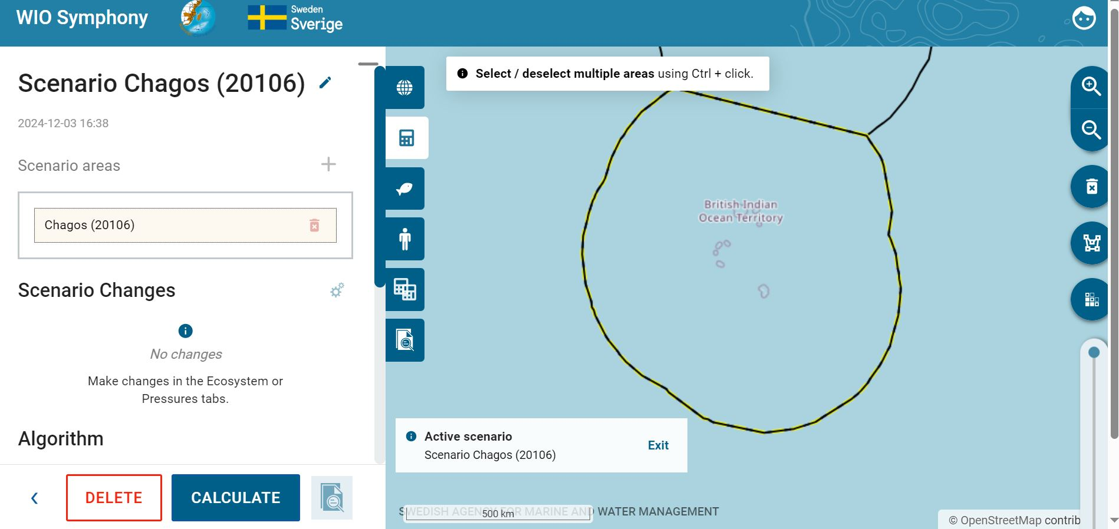
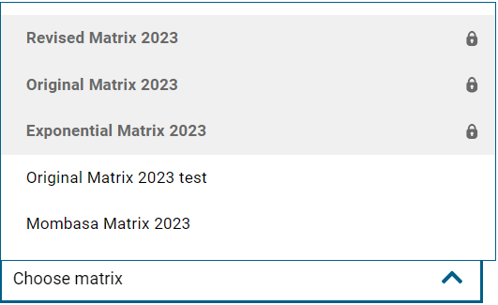
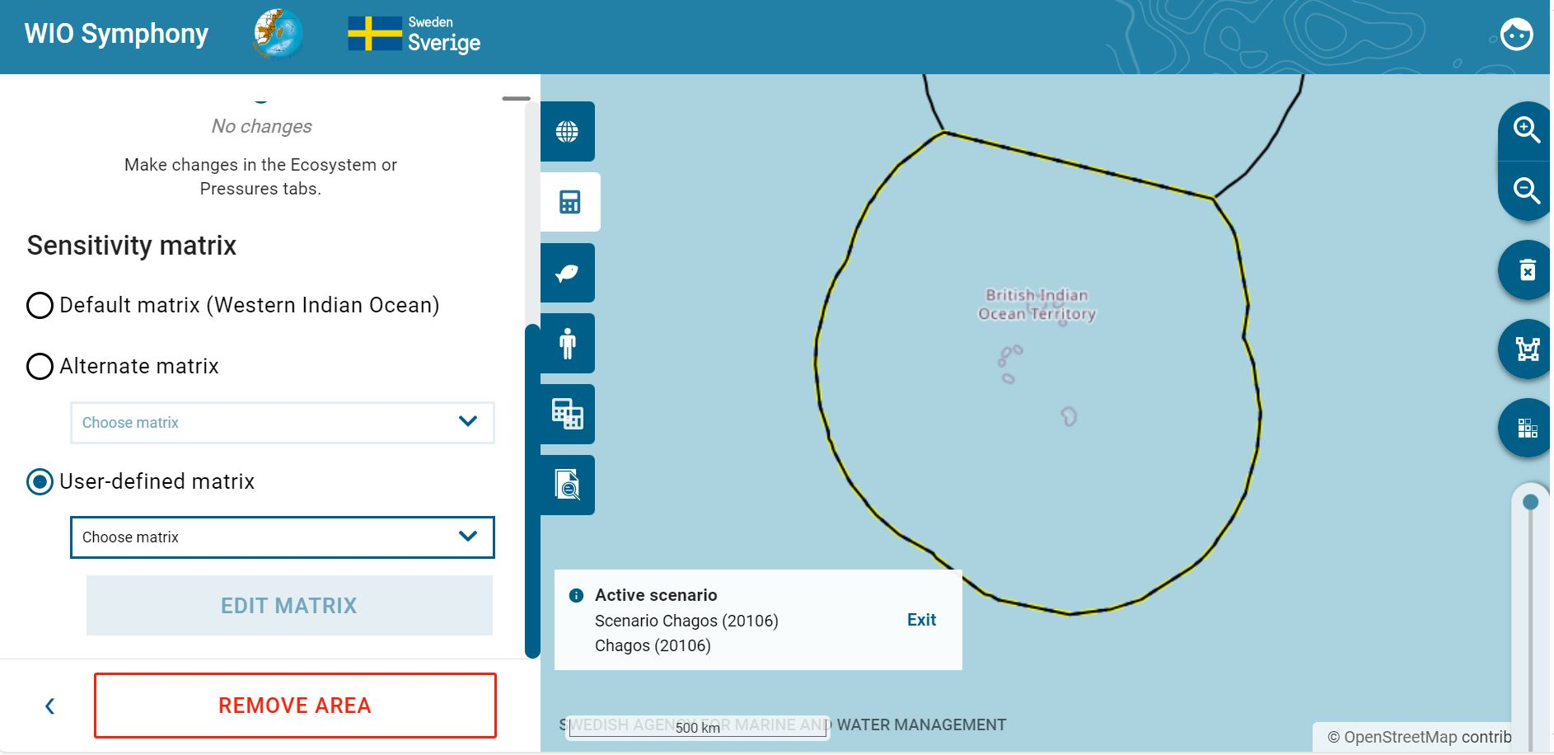
In the matrix, first select the Revised Matrix 2023  click Edit matrix  rename your adjust matrix for example MSP Revised Matrix 2024 adjust the sensitivities according to the measures you are simulating (reduce the pressure of Temperature rise to 0.5 for Photic pelagic (0.6 to 0.5), Upwelling pelagic (0.6 to 0.5). Ocean acidification for Cold coral reef (0.4 to 0.8) by editing the numbers)  SAVE AS NEW MATRIX  click Close. Back in the Scenarios tab, choose your new matrix “MSP Revised Matrix 2024”  you may rename your scenario with Test new matrix  press CALCULATE.
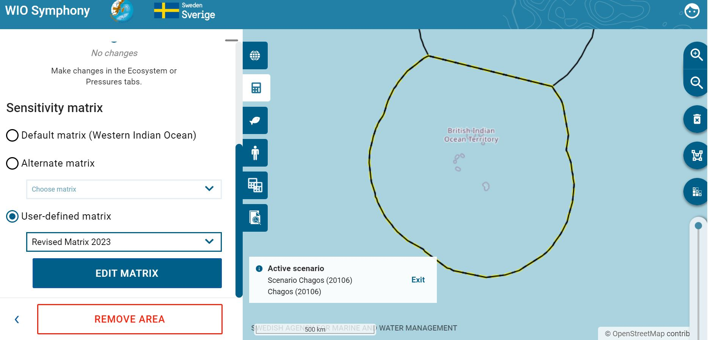
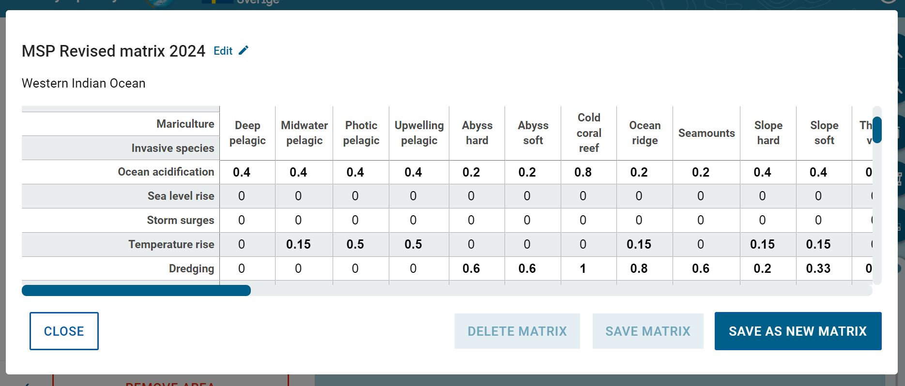

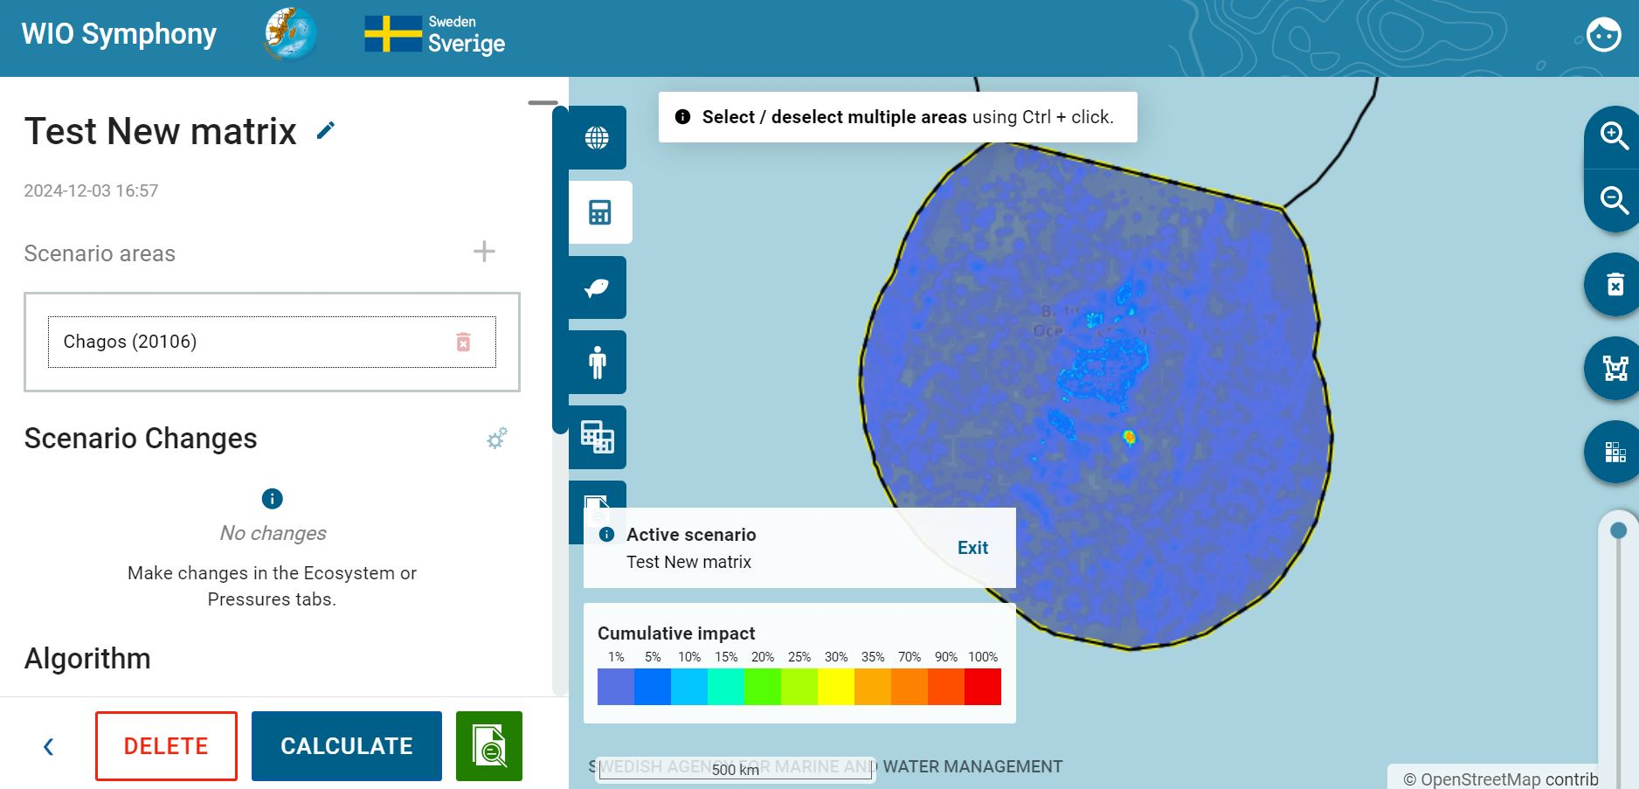
Note that you can only save or delete your matrix once you have saved an original matrix as a new one. Changing sensitivity matrix manually can also be relevant when new scientific information of environmental impact appears and you wish to update the sensitivity
score accordingly.

7. Updating and new data
WIO Symphony updates to data layers will always be needed. The Nairobi Convention Secretariat is responsible to lead this work, although the scientific work will be undertaken by partners and end-users on their request.
Users or scientists willing to provide new data or models, or willing to review and comment, are encouraged to contact the Secretariat for further directions.
The software tool will be updated by the Secretariat when new versions are available on the GitHub repository. These upgrades may be provided by the parallel Swedish development of Symphony, and by other users of the software who shares new functionalities by uploading a new fork to the repository.
Only through continuous efforts of management and upgrades, the WIO Symphony tool will stay relevant for its users.
Contact us
Web: www.nairobiconvention.org/wio-symphony
Email: wiosym@nairobiconvention.org.

8. References
Andersen, J., Al-Hamdani, Z., Harvey, E., Kallenbach, E., Murray, C., Stock, A., 2020. Relative impacts of multiple human stressors in estuaries and coastal waters in the North Sea - Baltic Sea transition zone. Sci. Total Environ. 704, 135316. https://doi.org/10.1016/J SCITOTENV.2019.135316.
Bange, H. W., Bathmann, U., Behrens, J., Dahlke, F., Ebinghaus, R., Ekau, W., ... & Ziemek, H. P. (2017). World Ocean Review 2015: living with the oceans 5. Coasts-a vital habitat under pressure. maribus.
Depellegrin, D., Menegon, S., Farella, G., Ghezzo, M., Gissi, E., Sarretta, A., Venier, C., Barbanti, A., 2017. Multi-objective spatial tools to inform maritime spatial planning in the Adriatic Sea. Sci. Total Environ. 609, 1627–1639. https://doi.org/10.1016/J SCITOTENV.2017.07.264.
European Commission. 1999. Integrating environment concerns into development and economic cooperation. Draft version 1.0. Brussels.
Fernandes, M. da L., Esteves, T.C., Oliveira, E.R., Alves, F.L., 2017. How does the cumulative impacts approach support maritime spatial planning? Ecol. Indic. 73, 189–202. https://doi.org/10.1016/j.ecolind.2016.09.014
Halpern, B. S., Walbridge, S., Selkoe, K. A., Kappel, C. V., Micheli, F., d'Agrosa, C., ... & Watson, R. (2008). A global map of human impact on marine ecosystems. science, 319(5865), 948-952.
Hammar, L., Molander, S., Pålsson, J., Schmidtbauer Crona, J., Carneiro, G., Johansson, T., Hume, D., Kågesten, G., Mattsson, D., Törnqvist, O., Zillén, L., Mattsson, M., Bergström, U., Perry, D., Caldow, C., & Andersen, J., 2020. Cumulative impact assessment for ecosystem-based marine spatial planning. Science of The Total Environment, 734, 139024.
HELCOM, 2018. State of the Baltic Sea – second HELCOM holistic assessment 2011-2016. Balt. Sea Environ. Proc. 155, 155.
Korpinen, S., & Andersen, J. H. (2016). A global review of cumulative pressure and impact assessments in marine environments. Frontiers in Marine Science, 3, 153.
Spalding et al. 2007. Marine Ecoregions of the World: A Bioregionalization of Coastal and Shelf Areas. BioScience 57(7): 573-583. Available: https://doi.org/10.1641/B570707
UNEP-WCMC (2023). Protected Area Profile for Africa from the World Database on Protected Areas, November 2023. Available at: www.protectedplanet.net
About SwAM
SwAM is the Swedish Agency for Marine and Water Management. We work on behalf of the Swedish parliament and government.
Together with our partners, we strengthen the capacity to plan the future of the ocean, to take care of the ocean and to use the ocean – for the joy and benefit
of all.
Get our results at www.havochvatten.se/swam-ocean.


Financed by the Government Offices of Sweden and Sida, the Swedish International Development Cooperation Agency. The contents does not necessarily reflect the opinion of either.

